Contents

Manual | i. Addressing & Street Naming Manual
Day-to-Day Forms | ii. Application for New Address  iii. Application for Address Change  iv. Application for Street Name Change  v. Address Change Notification
Legal Documents | vi. MOU Overview  vii. Basic Addressing MOU  viii. Complex Addressing MOU  ix. Addressing Ordinance
Reports | x. Local Addressing Systems


Video Walkthrough
About the Handbook

The New Mexico 911 Bureau (NM911), in collaboration with Spatial Focus, has developed an Addressing Handbook to support addressing authorities throughout the state. This resource is designed to equip addressing personnel with practical guidance and to establish consistent, authoritative standards for addressing in New Mexico.

NM911 created this handbook to address a significant gap – that is, most addressing authorities receive little to no formal training despite the complexity and critical importance of their responsibilities. Inaccurate or inconsistent addressing can lead to a range of issues, with the most serious being delays in emergency response that can result in loss of life. NM911 created the handbook to help local governments improve addressing practices and mitigate these issues.

The handbook contains an addressing manual, template documents for both routine operations and legal use, and individualized assessments tailored to each jurisdiction within New Mexico.

NM911 will also perform an annual review and update of the handbook and invite local staff to participate in this process.

How to Use

The handbook is formatted for use in Microsoft Word. Users may navigate the document easily by enabling the Navigation Pane, which may be accessed using the View tab.

To use the templates, users may click on the highlighted sections and follow the associated prompts to enter the appropriate information.

For additional information, please contact the NM911 GIS Coordinator.

Tyler Fossett
NM911 GIS Coordinator
505-500-5587
Tyler.Fossett@dfa.nm.gov

- Addressing & Street Naming Manual
--- Last updated 4/28/2025 ---
Addressing & Street Naming Manual

Table of Contents
1 Purpose 6
2 Introduction 6
2.1 Organization of this Manual 7
2.2 Maintaining the Manual 7
3 Administration 8
3.1 Authority and Responsibility 8
3.2 Address Coordinator 9
3.3 Addressing Technical Committee 9
4 Definitions 10
5 Address Reference System 13
5.1 What is an Address Reference System? 13
5.2 Using the Address Reference System 13
5.3 Address Reference System Boundaries (Extent) 14
5.4 Address Reference System Name 14
5.5 Address Reference System Type 14
5.6 Block Ranges 16
6 Street Naming Rules 17
6.1 Introduction 17
6.2 What is to be Named 17
6.3 Complete Street Name Elements 18
6.4 Street Name Requirements 18
6.5 Other Street Name Components 20
6.5.1 Street Type 20
6.5.2 Directional Prefixes and Suffixes 22
6.5.3 Modifiers 22
6.5.4 Separators 23
6.6 Street Name Integrity 23
6.7 Street Geometry 23
7 Address Number Rules 25
7.1 Address Numbering Rules 25
7.1.1 What is Addressed? 25
7.1.2 Address Referernce System (ARS) 26
7.1.3 Address Number Format 26
7.1.4 Distance interval 27
7.1.5 Incremental value 27
7.1.6 Order 28
7.1.7 Parity 29
7.2 Vacant or Undeveloped Property Addressing Rules 30
7.3 Residential Addressing Rules 31
7.3.1 Single Family 31
7.3.2 Multi-family Residential (duplexes, quadplexes, apartments, condominiums) 31
7.3.3 Residential Corner or Multiple Frontage Lots 32
7.3.4 Rear-facing Properties 33
7.3.5 Accessory Structures 34
7.3.6 Mobile Home Parks 35
7.4 Non-residential & Mixed-Use Addressing Rules 35
7.4.1 Single Property, Single Structure with One Tenant 36
7.4.2 Single Property, Single Structure with Multiple Tenants 36
7.4.3 Single Property, Multiple Structures 37
7.4.4 Multiple Parcels, Multiple Structures that Form a Larger, Identifiable Whole 39
7.4.5 Mixed Use Developments 39
7.4.6 Strip Development 40
7.4.7 Enclosed Malls 41
7.4.8 Public Uses (schools, parks, stadiums, arenas, theaters, large churches, convention centers, etc.) 41
7.4.9 Modular Classrooms, Construction Trailers, and other Portable Buildings 42
7.4.10 Parking Decks and Garages 42
7.4.11 Buildings Joined by a Breezeway, Canopy or Other Connector 43
7.4.12 Non-Residential Corner and Multi-Frontage Lots 44
7.5 Other Numbering Situations & Addressing Rules 45
7.5.1 Addressing of Infrastructure and Utility Features 45
7.5.2 Common Driveways 45
7.5.3 Developed Properties with no Driveway 45
7.5.4 Flag Lots 46
7.5.5 Landlocked property 46
7.5.6 Addressing on Interstates and Other Roadways that Have Limited Access 47
7.5.7 Addressing on Trails 48
7.5.8 Last Mile Transportation Features 48
7.5.9 Insufficient Numbers Available 48
7.6 Address Number Prefixes and Suffixes 49
7.6.1 Other exceptions 49
7.7 Place Name Rules 49
7.8 ZIP Codes® 50
7.9 Subaddress Rules 50
7.9.1 When to Assign a Primary Address and When to Use a Subaddress 50
7.9.2 Subaddressing within Structures 51
7.9.3 Subaddressing Multiple-Structure Facilities 51
7.9.4 Residential Occupancies 52
7.9.5 Non-Residential Occupancies 53
7.9.6 Subaddress Types 55
7.9.7 Subaddress Identifier 55
7.9.8 Basements, Mezzanines, and Penthouses 55
7.9.9 Signage 56
7.10 Landmark addresses 56
8 Addressing Workflows 56
8.1 New Street 57
8.2 New Address 58
9 Data Management 59

Table of Figures

Figure 1: Address Numbering in a Block Grid System 15
Figure 2: Address Numbering in a Coordinate Grid System 16
Figure 3: Address Numbering in a Linear System 14
Figure 4: Street Geometry 24
Figure 5: Roundabout 24
Figure 6: Potential Address Points (example) 28
Figure 7: Parity 29
Figure 8: Consistent numbering pattern 30
Figure 9: Alternate Address Placements 33
Figure 10: Additional Habitable Structures (ADU's) 35
Figure 11: Multi-Tenant Non-Residential Addressing 37
Figure 12: Multi-Use Complexes 40
Figure 13: - Strip Mall Addressing 41
Figure 14: Multiple Buildings with Breezeways 44
Figure 15: Flag Lots 46
Figure 16: Landlocked Property Addressing 47
Figure 17: Subaddressing Buildings 52
Figure 18: Occupancy Addressing 53
Figure 19: U-Shaped Building Occupancy Addressing 55
Figure 20: Example of New Street Name Workflow 57
Figure 21: Example of Address Number Assignment 58

Purpose

The purpose of this Addressing and Street Naming Manual is to consolidate all documentation related to the practice of street name and address assignment into one guidebook in order to provide citizens, developers, real estate professionals and local addressing authorities with the detailed information they need to effectively work together to implement and maintain a consistent, safe, useful and standardized addressing system. These enhanced addressing procedures have the following objectives:

- Ensure that first responders have a predictable addressing system that will enable them to respond to all residential and business emergencies as administered through the Emergency 911 system.
- Provide a mechanism for the efficient delivery of mail, goods, and services to New Mexico residents and businesses.
- Ensure that addresses and street names in New Mexico are assigned in a manner that is consistent and transparent.

The Addressing and Street Naming Manual, (hereinafter Manual) contains all relevant information about the assignment of street names, address numbers, and subaddress identifiers for New Mexico local governments, including changes to street names or address information due to changes in land use, errors, public safety issues or other reasons. Examples and diagrams are included throughout to better explain addressing concepts.

New Mexico’s 911 Bureau (NM911) has adopted as a primary guideline for addressing practices and address data management, the Federal Geographic Data Committee (FGDC) United States Thoroughfare, Landmark and Postal Address Data Standard (hereinafter, the FGDC Address Standard). This standard was adopted by the Federal Government, including the US Postal Service and Census Bureau, as the standard for address and street name formatting, data construction and maintenance, and data sharing. Therefore, wherever possible and practical, the NM911 program’s rules follow the FGDC Address Standard. NM911 must also adhere to the Civic Location Data Exchange Format (CLDXF) standards used in the National Emergency Number Association (NENA) NextGen 911 GIS Data Model, so these NextGen standards have also been considered within this Manual.

Introduction

An address is used to describe the specific location of a building, a tenancy within a building, or a parcel of land. The most commonly used way to locate a specific feature or property is the assigned premise address. Premise addresses are used daily by private citizens, the postal service, delivery services, utility companies, police, fire and rescue services, and general government services to locate specific places. In general, street names are the reference point, and the assigned numbers create unique identifiers for each structure or occupancy.

Uniformity and consistency are basic requirements so that any given property can be quickly and easily located. In New Mexico, it is important that local addressing systems be fully documented so that addresses are consistently represented. Local communities’ safety and welfare depend on the ability of emergency services and other service providers to locate every property quickly and accurately.
Addressing must be given a high priority during the development review process to assure consistency. A good address system should be predictable, easy to implement, and easy to use. A system that defines ranges of numbers by distance allows flexibility for future development while maintaining the order of existing and approved development. Further, distance-based address number assignment requires minimal change with respect to existing addresses.

Addressing assignment and notification best practices should be designed to create a uniform address system across the jurisdiction, but some past addressing practices may have resulted in street names and addressing patterns that do not follow best practices, and that can create conflicts or inconsistencies. Some of these conflicts or inconsistencies, also termed anomalies, may be resolvable without significant disruption to citizens and business, while others may not. In general, when issues are identified, they are evaluated in terms of their impact on public safety and welfare, and an addressing change is only required where there are significant life and property safety issues involved.

Organization of this Manual

This Manual is designed to cover all major aspects of addressing in New Mexico, including the administration of addressing, relevant Address Reference Systems, addressing workflows, and address data management.

The Administration of addressing section describes potential frameworks for designating addressing authority and responsibility at the local level.

The Address Reference System section provide the rules and policies that govern address and street name assignments and changes. Addressing is a system with embedded logic and order that makes it possible for people to locate specific places through the address. The rules and policies must be enforced in the process of assignment and changes to elements of the addressing system, so that the logic and order are maintained.

The Address Workflows section describes the individual workflows in which street names and addresses are assigned or changed.

The Data Management section discusses processes for additions, updates, and changes to addresses, street names, and other elements such as place names, location coordinates, status, etc. within the central address repository.

Maintaining the Manual

This Manual is reviewed on an annual basis and amended as necessary to respond to changing land use patterns and addressing needs. New Mexico 911 Bureau maintains an Appendix of Examples designed to allow staff throughout the state to post specific case studies, such as plans or specific address assignments or street naming issues, including images of the plans, descriptions of what was done, what alternatives were considered, etc. These examples are reviewed annually by the NM911 GIS Coordinator to determine if there are items which should be presented to an addressing workgroup for further discussion and potentially added to the Manual itself. For example, if the same type of issue arises multiple times during the year, it is reviewed and any common rules that can be extracted from it will be added to the Manual as general rules for similar types of development. Likewise, where a rule in the Manual may not be clear in application, the examples can be referenced, so that Team members can see how a specific rule was applied. This assists the Team in addressing similar situations in a consistent and comparable manner.

If upon review it is determined the Manual needs to be updated, the NM911 GIS Coordinator will draft the changes and provide them to the addressing workgroup for review and approval. Upon approval by the addressing workgroup, the approved changes are made to the Manual and the Revision History table is updated with the revision number, date of approval and a brief description of changes made. The revised Manual is then distributed to appropriate staff and placed on the NM911 GIS website.

Administration

Authority and Responsibility

Local governments may grant authority for addressing and street naming to different positions or departments based on their needs. Addressing generally is linked to the process of land development and building construction. This fact suggests that the creation of street names and address numbers should be tied to the development/construction processes (such as the approval of subdivision plats, land divisions, building permits, etc.). Many local governments place this authority within the Planning, Community Development or Permitting Departments. However, in some jurisdictions, other departments are selected, such as GIS, Public Safety (including PSAPs, or utility departments are assigned this responsibility. In no case should two or more departments have authority to assign addresses to specific properties, as this leads to duplication and confusion.

Local addressing authorities oversee requests for address assignments, address changes, revisions to addressing plans, and address verifications, as well as requests for street name approvals, assignments, or changes. Requests may be approved if the request falls within the guidelines of this Manual in accordance with the Laws of New Mexico and the local addressing ordinance.

Notice of address and street name assignments shall be provided to various City, County, and State of New Mexico agencies, the U.S. Postal Service, and other public service entities.

The assignment of an official building or feature address number provides a convenient reference to a property, dwelling, infrastructure feature or other object as a reference for its location. It neither creates a property interest that does not otherwise exist, nor does it act as a waiver of any regulatory requirement to build on a property that is otherwise necessary under the law.

Address Coordinator

The Address Coordinator is responsible for the assignment and notification of all new street name and address information. The Address Coordinator is also responsible for facilitating changes to existing street names and address numbers.

The primary duties of the Address Coordinator are:

- Assign street names and addresses, according to this Manual
- Maintain a central address database defining official street names and addresses
- Chair the Addressing Technical Committee
- Align local addressing ordinances and standard operating procedures with those put forth in this manual
- Issue address and street naming notifications to property owners.
- Resolve problems and coordinate address notification among addressing entities, such as city departments, the county, the state, and the U.S. Postal Service (USPS).
- Resolve address and street name problems and respond to inquiries made by the public, city and county departments, state and federal departments, and the USPS.

Addressing Technical Committee

The Addressing Technical Committee is an advisory body and sounding board for addressing policies and practices. Recommendations from the committee are an essential element in maintaining this Manual and the implementation of the policies and practices it promotes.

The departments listed below are commonly represented on Addressing Technical Committees (ATC) to support and endorse the local addressing policies and procedures. The appropriate stakeholders for this committee may vary from place to place but should generally include:

- Emergency Services (police, fire, emergency medical services, disaster/emergency management)
- Tax Assessor
- Planning/Zoning/Community Development
- Building Permitting/Business Licenses/Code Enforcement
- Public Works/Transportation
- Public Utilities
- Information Technology/Geographic Information Services
- Other departments or agencies including the court system, Public Health, Parks and Recreation, Economic Development, and others may also be included
Members are responsible for representing their agency on matters to be considered by the ATC and actively communicating any address related issues. Ultimately, business applications utilized by each of these Departments and perhaps others may be linked to the central address database to assist in validation of addresses submitted by residents, businesses, and others.

Primary duties of the Addressing Technical Committee are:

- Coordination of policies and procedures for addressing among local government departments.
- Discussion and resolution of address and street name assignment conflicts and unusual or new addressing situations.
- Coordination of changes to addressing when an area is annexed into a City within a County and the Address Reference System’s (ARS) are different.
- Advocating to the public, elected officials, and member agencies for improvements to addressing systems and practices, including supporting requests for fiscal resources and staff.

Definitions

Address Number: The numeric identifier for a land parcel, structure, or other location along a thoroughfare or within a community. This is an integer. The address is not part of the legal description of the property.
Address Number Prefix: The portion of the Complete Address Number which precedes the Address Number itself. An Address Number Prefix would be the “4” in “4-1110 Smith Road”, which is used in some communities. Address number prefixes may be permitted, prohibited, or required – this is a local business rule and should be explicit.
Address Number Suffix: The portion of the Complete Address Number which follows the Address Number itself. Use of address suffixes is covered in Section 7.6.
Address Reference System: A grid or other system of organizing address numbering and designation of streets into a logical and consistent pattern over a defined area. This may include all or a portion of an individual municipal or county jurisdiction.
Address Repository: An address repository is a geospatial and relational database that encompasses individual records for each address within one or more Address Reference Systems. The address repository provides both the elements of the address (number, street name, place name), its geospatial location, and attributes that provide record-level metadata and links to related geographic features including parcels, structures, and transportation elements. It also incorporates the Address Reference System rules and provides for systematic testing of address data to ensure conformance with those rules.

Alley: a service road that runs between, and generally parallel to, two streets. An alley is often narrower than a public street and is not intended for heavy traffic.
Building: a permanent structure built as a dwelling, shelter, or place for human activities, or for storage. (See also: Structure)
Common Driveway: a private thoroughfare that provides access to a limited number of structures or properties and is owned and maintained by the property owner(s).
Complete Address: The unique combination of an address number, street name, place name, state name and ZIP Code™ that identifies a location within the local jurisdiction.
Complete Address Number: An Address Number, alone or with an Address Number Prefix and/or Address Number Suffix, which identifies a location along a thoroughfare or within a community.
Complete Street Name: Official name of a street as assigned by a governing authority, or an alternate (alias) name that is used and recognized.
Directional: A word preceding or following the Street Name that indicates the direction or position of the thoroughfare relative to an arbitrary starting point or line, or the sector where it is located.
Driveway: a thoroughfare that provides access to a single structure, owned, and maintained for access to that specific structure.
Flag Lot: A flag lot is one with a long narrow “stem” or “pole” that connects the main part of the property to a public street.
Freeway: a major highway with limited access via ramps.
Internal Access Thoroughfare: a travel way, typically within shopping centers, apartment complexes, and other similar development patterns, deemed necessary to name by the Address Coordinator for public safety purposes. The local government has no ownership interest or maintenance responsibility for these streets.
Interstate: a restricted access thoroughfare with on and off ramps that connects multiple states.
Land Locked Property: A landlocked property is one that does not have legal access from a public or private street, walkway, driveway or other public or private thoroughfare.
Major Highway: a main thoroughfare, especially one connecting towns or cities; highways generally allow for normal side road entry, and they have regular stop lights.
Mixed Use Structure: A mixed use structure is a building that contains different types of residential and non-residential uses.
When the ground floor consists of retail establishments with external entrances, but the upper floors consist of residential or office units with interior entrances from corridors or hallways, different addressing strategies may be needed to clearly identify where individual businesses or units are located. Mixed use developments may also include multiple structures on a campus (shopping centers with outbuildings, schools, medical facilities, etc.)
Modifier: A word or phrase in a Complete Street Name that precedes or follows and modifies the Street Name, but is separated from it by a Street Name Pre- or Post- Type or a Street Name Pre- or Post- Directional or both.
Municipal Names: The municipal name is the name of an incorporated municipal corporation within which the address is located. Municipalities have legal boundaries and provide services to residents within those areas. They also assess property taxes, and other fees and taxes upon property and/or activities carried out within their boundaries. This name may be different than the postal name of the area.
Municipality: A chartered or incorporated municipal corporation organized under the laws of the State of New Mexico.
Neighborhood/Subdivision and Community Place Names: Neighborhood, subdivision and community place names are often used to further identify an area where an address may be found. While these are informal designations, they provide useful information that can improve dispatch and routing of emergency and non-emergency vehicles.
Parcel of Land: Any lot, parcel, or other area of land or water that is geographically defined and used to identify an ownership or other land rights interest.
Parking Garage: A structure dedicated to the parking or storage of vehicles, including below or above ground structures, both publicly or privately owned or operated. Use of the parking spaces within such a structure may be open to the public (with or without fees) or restricted to tenants, occupants, or owners of an associated structure. The parking garage may be part of a larger structure that contains residential or non-residential uses that utilize the parking garage for employees, customers, or residents, or it may be a stand-alone structure solely dedicated to providing parking spaces.
Parking Lot: a paved or unpaved area outside of a thoroughfare that is designated for the parking of vehicles. It may be associated with a residential or non-residential (commercial, industrial, public or mixed) use, and it may be open to the public or restricted to tenants or owners of the structure or use it is associated with.
Place: The name of a city, postal jurisdiction, or community in which an address is located.
Postal Community Names: Postal community names are the names that are used by the U.S. Postal Service in carrying out the delivery of mail and packages. The USPS does not legally assign names to communities or municipalities, but it uses them for mail services. The Postal Community name may be different than the legal municipal name. For the purpose of mailing, it is important to use the Postal Community name, so that mail is promptly and correctly delivered.
Private thoroughfare: a thoroughfare that is owned and maintained by a private owner or group of owners with or without limitations on use.
Public thoroughfare: a thoroughfare that is owned and maintained by a governmental agency with the right of passage to all.
Right-of-way: Publicly owned land designated for use as a thoroughfare and for distribution of public or private utilities to individual properties.
Roundabout or Traffic Circle: a circular intersection where drivers enter the intersection, travel counterclockwise around a center island, and exit at their desired thoroughfare.
Street: A type of thoroughfare, usually a paved or unpaved travel way that provides access via motor vehicles, bicycles, and/or pedestrians to one or more properties or locations. Additional definitions of types of streets and other aspects of street geometry and addressing components are found in the street naming section of this Manual.
Street name: The portion of the Complete Street Name that identifies the particular thoroughfare (as opposed to the Street Name Pre-Modifier, Street Name Post Modifier, Street Name Pre-Directional, Street Name Post Directional, Street Name Pre-Type, Street Name Post Type, and Separator Element (if any) in the Complete Street Name.)
Street type: A word or phrase that precedes or follows the Street Name and identifies a type of thoroughfare in a complete Street Name. Street types include Street, Avenue, Boulevard, Court, Circle, Way, Highway, Trail, and many others. For a comprehensive list, see Appendix C, U.S. Postal Service Publication 28, Postal Address Standards. This list also provides the approved abbreviations for the types to be used for mailing. Where the type is Highway, State Highway, State Route, Interstate, or Interstate Highway, the Pre-Type will be used. Where any other type is used, it shall normally be a Post Type.
Structure: For the purpose of this document, a structure is a man-made object which may or may not be a building—for example, a telephone pole, pump station or other object for which a street address may be provided.
Subaddress: The portion of the address that uniquely identifies a portion of a complex of structures, or a separate occupied area or tenancy within a building or structure.
Thoroughfare: a street, walkway, stairway, waterway, or other travel way that provides access to one or more properties or locations
Walkway: a narrow linear travel way designed for pedestrian movement. May be separated from a street or run parallel to it (often defined as a sidewalk). May be paved or unpaved. Provides access to one or more properties or locations.

Address Reference System

What is an Address Reference System?

The term “Address Reference System” (ARS) refers to the set of rules that are in effect within a given jurisdiction for assigning addresses, and it is described in greater detail within the FGDC Address Standard. It defines the boundaries in which the rules are applied. It defines a beginning point, grid, or set of axis lines that define address ranges and numbering. It also includes rules for numbering, rules for street name components, and other locally defined rules concerning the assignment of addresses. Without standard rules for creating new addresses, the necessary logic, consistency and order of address numbering and street naming may be lost, defeating the navigational purposes of the addressing.

An ARS is also important because it is the basis for creating address quality testing. It is also critical because it provides a framework in which addresses can be consistently assigned over a long period of time regardless of who is doing the assignment. Some components of an Address Reference System are geospatial, and others are tabular data-based rules.

Using the Address Reference System

The ARS provides guidance for the assignment of address numbers and selection of street names.
In the Address Repository, many of the rules conveyed by the ARS are embedded either in the domains of values in the Repository itself (street names, allowable types and directionals), or in the GIS (grids, boundaries, axes, and numbering rules).

A software application may be used to assign and maintain addresses within the Address Repository It can be customized to use the ARS rules for numbering and provides a candidate address for every location selected by the Address Coordinator. This includes new addresses for residential and non-residential uses, utility features, mile markers and other features requiring a location address. The use of a software application to assist with the assignment of address numbers ensures that new addresses are logical, match the current addressing fabric, and are assigned across the jurisdiction in a consistent manner that follows the ARS rules.

Address Reference System Boundaries (Extent)

The boundaries of an ARS may be legal jurisdictional boundaries, one or more jurisdictions, or other areas.

Address Reference System Name

Address Reference Systems may be named after the local jurisdiction or given a different name when spanning multiple jurisdictions or part of a jurisdiction.

Address Reference System Types

An ARS may feature an axial, non-axial, or area pattern, on which address number assignments shall be based. Local addressing systems may feature one or more of the approaches described below, or more commonly, variations of those approaches. Considering addressing patterns within this framework can serve as a starting point for making informed decisions, because learning how and why local addressing patterns deviate from the approaches outlined below helps reveal which factors must be considered when making addressing decisions.

Non-Axial

Non-axial systems, called Linear systems, use incremental numbering patterns along individual roads for determining address numbers. With this method, address numbers start at road origins and increase toward road end points at consistent intervals, typically intervals of 100 or 1,000 numbers per mile. As seen in Figure 1, linear systems may coincide with mile markers to provide additional information for locating addresses.

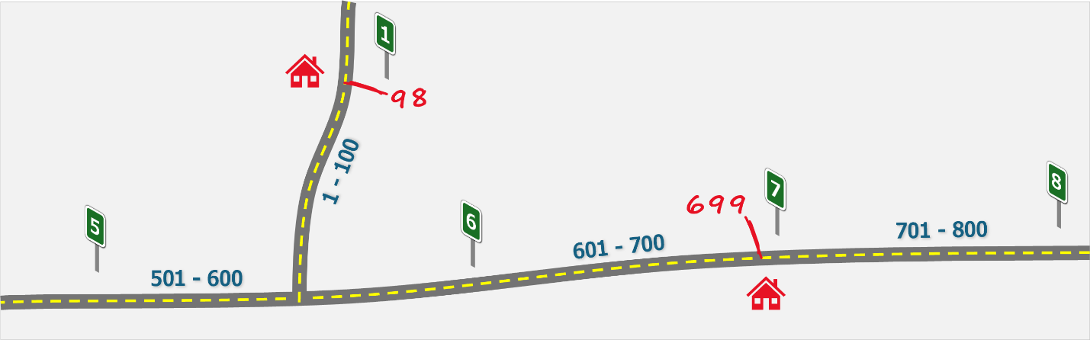
Figure 1: Address Numbering in a Linear System

Linear systems are well-suited for roads that change direction frequently, such as roads following contours, because address numbers in linear systems indicate where addresses are located along the roads themselves. However, address numbers in linear systems do not convey information regarding where addresses are located within an entire jurisdiction.

Axial

Axial addressing systems use a grid-based approach for determining address numbers.

Block Grid

A block grid system may use many separate, smaller grids for determining address numbers throughout a jurisdiction, as seen in Figure 2. With this approach, address numbers are based almost entirely on local numbering patterns, with number parity being the notable exception which should remain consistent throughout an entire jurisdiction.

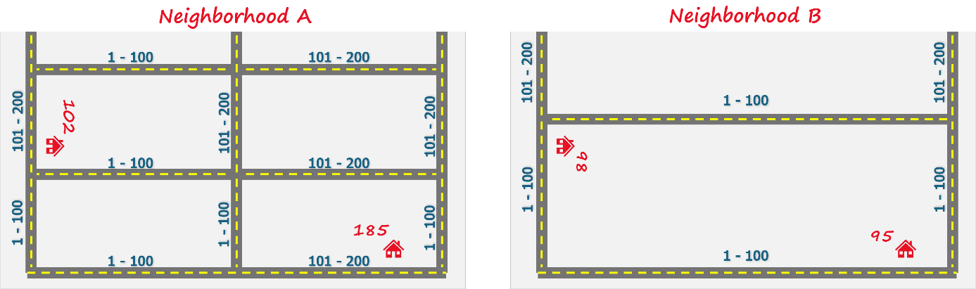
Figure 2: Address Numbering in a Block Grid System

Block grids are well-suited for areas with small and consistent lot sizes, where it is more important for address numbers to convey where addresses are located within a given area, rather than where addresses are located within an entire jurisdiction.

Coordinate Grid

A coordinate grid addressing system determines address numbers by plotting address locations on a numbered grid, similar to plotting data points on a graph. A single grid may be placed over an entire jurisdiction with numbers that start in one corner and increase along the X and Y axes, as shown in Figure 3. In these systems, address numbers are assigned based on their position along the X or Y axes, with road orientation determining which axis the numbers are derived from. Note, Figures 1 and 3 display the same area with different addressing systems.

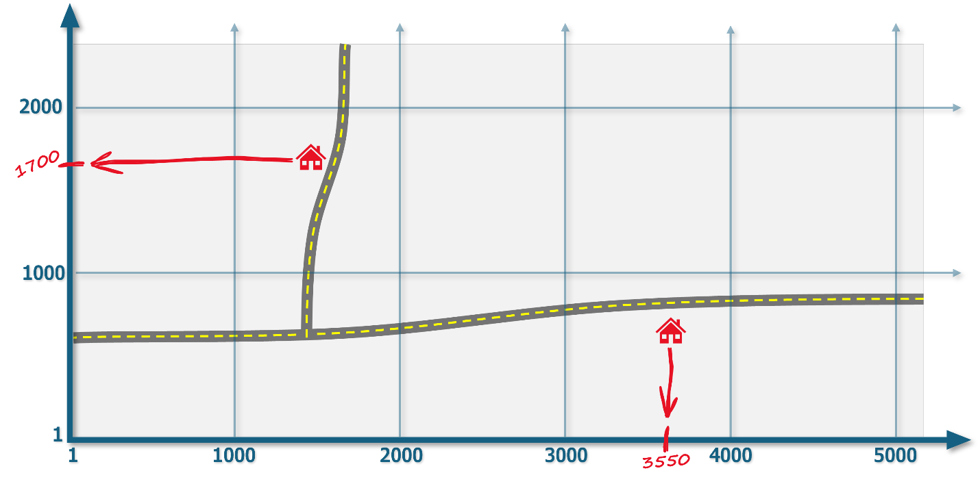
Figure 3: Address Numbering in a Coordinate Grid System

Coordinate grid addressing systems are well-suited for large rural areas with consistent road orientations, because address numbers in coordinate grid systems indicate where addresses are located within an entire jurisdiction, rather than where they are located within a localized area.

Area

Unlike axial and non-axial addressing systems, area-based addressing systems do not determine address numbers in relation to roads. Instead, various methods may be used in area-based systems for determining address numbers in small, designated areas, such as mobile home parks or campgrounds.

Area-based systems should only be used in small areas when axial and linear systems are not practical, as area-based systems convey less information about address locations.

Block Ranges

A block is defined as the extent of a single street segment between its intersection with other streets. Alleys are usually not considered to break the block scheme.

Block ranges for new streets will be determined based upon the beginning point of the new street within the ARS grid.

Street Naming Rules

Introduction

The standards in this section were designed to facilitate the proper naming of streets within New Mexico. Streets must be named in a logical, easy-to-understand manner in order to help citizens, service delivery, and emergency personnel quickly locate people, places, and events.

What is to be Named

The basic criteria for any addressing decision is whether or not the address provides a person with the information necessary to locate a specific structure or person in case of an emergency. The naming of streets throughout a local jurisdiction provides a structure that local residents understand, and that visitors can comprehend and use to follow directions to a specific place.

The Census Bureau suggests naming all planned or existing public or private streets, common driveways, alleys, or internal access streets that serve as the primary means of ingress or egress for 3 or more residences, agricultural structures such as barns, industrial, commercial, public, or semi-public buildings, or other facilities shall be given a name.

Local governments may choose a different number of sites required for naming a road if needed. In many rural areas there are long driveways (more than 100 yards) that lead to one or more dwellings or other structures. Some of these structures are not visible from the public road, and differentiating one driveway from another, or knowing how many buildings may be accessed from a given driveway makes locating residents, occupants, or even the buildings themselves more difficult and may delay emergency response. On the other hand, a common driveway serving a four-unit structure or a small strip mall where all the units are visible from the named street does not require a name. Local governments should review their land use patterns and determine whether or not each presently unnamed road or driveway requires a name from the standpoint of whether structures accessed by the unnamed road are visible from the named road that the unnamed road is connected to, how long the unnamed road is, and the number of structures that utilize the unnamed road for primary access, and availability of alternate access from another named road.

A shopping center, apartment complex, industrial or office park that has internal streets that are private, but which provide access to the individual buildings within the complex shall have names for the individual streets.

Walkways, paths, and sidewalks that provide the sole means of access to more than one property shall be named.

A driveway is customarily a paved or unpaved travelway providing access to one dwelling or one non-residential structure. It does not have a dedicated right-of-way but traverses the distance from a public or private road within a right-of-way or easement allowing access to a structure located on private property. A driveway serving a single-family residence or single non-residential building shall not be given a street name. A parking lot which is open and visible from a public or private street shall not be given a street name (if the parking lot includes internal access streets serving out parcels, the internal access street shall be named).

The ownership of the right-of-way or land on which the street is constructed (public or private) does not change the naming requirement.

Complete Street Name Elements

The FGDC and CLDXF Address Standards define street name elements, or components, for addressing and the order in which they should be displayed. There are eight elements described in both address standards, as shown below, that when combined create a Complete Street Name. The NM911 program requires local governments to provide NextGen 911 compliant GIS data, which may only be achieved by parsing street names into the categories listed below.

Street names shall be comprised of the following elements, in the following order:

- Street Name Pre-Modifier - e.g., “Alternate” in Alternate Route 8
- Street Name Pre-Directional - e.g., “North” in North Fairfax Drive
- Street Name Pre-Type - e.g., “Avenue” in Avenue A
- Separator Element - e.g., “of the” in Avenue of the Americas
- Street Name - e.g., “Fairfax” in North Fairfax Avenue
- Street Name Post Type - e.g., “Avenue” in North Fairfax Avenue
- Street Name Post Directional - e.g., “East” in Seventh Street East
- Street Name Post Modifier - e.g., “Extension” in East End Avenue Extension

Note, neither the FGDC nor CLDXF allow the use of abbreviations for Street Name Type or Street Name Directional elements, because they introduce uncertainty and confusion. For example, does “TR” as a street type represent “Trail”, “Track”, “Trace”? This uncertainty presents unique challenges for 911 dispatchers, because abbreviations often vary between neighboring jurisdictions, and 911 datasets are built using data from many jurisdictions. This means abbreviations still cause problems in areas where they are used consistently within each jurisdiction.

The minimum acceptable elements for a street name are typically a Street Name and a Street Name Type (i.e., Pre-Type or Post-Type). Most Street Name Types are considered Post Types because they follow the Street Name (e.g., Main Avenue). However, many street types in New Mexico are considered Pre-Types because they often precede the Street Name in Spanish Street Names (e.g., Calle de Grillo).

Street Name Requirements

The rules listed in this section are considered best practices for ensuring street names are compatible with dispatching emergency services in a timely manner. For this reason, the NM911 Program considers the rules below to be authoritative and encourages local governments to comply with these rules unless otherwise stated in local addressing ordinances or Standard Operating Procedures (SOPs). If there is a valid reason to disregard any of the rules, the local jurisdiction should carefully consider the implications. Additionally, street names may also be required to conform to additional local rules if any are adopted. These rules may be omitted or modified to better suit local needs:
Street names are required to conform to the following rules that are enforced to ensure clarity and public safety.

- New street names shall not duplicate any existing street name in a given jurisdiction, The street name, for purposes of evaluating whether a duplicate exists, does not include the street type. For example, Aspen Lane and Aspen Drive are duplicates under this definition. North Main Street and South Main Street are considered a single road with directionals. Names that are merely minor spelling variations of the same word are also prohibited, such as “Ashley” and “Ashlee.”
*NM911 suggests expanding the scope of street names being considered to include all jurisdictions served by the local 911 center, such as all jurisdictions in a county.
- New street names that sound like an existing street name, or another proposed name, or that create difficulties in pronunciation are prohibited. For example, Bear Street and Bare Street are duplicates under this definition.
- Street names that are deemed offensive, obscene, lewd, profane, offensive, or derogatory of any class, race, religion, ethnic group, gender, age, or other group are prohibited. An obscene term is a word or phrase that refers to or describes sexual conduct as defined by the State of New Mexico or the local jurisdiction.
- Street names shall not contain more than 25 characters, including the directional (if any).
- No street name shall have less than 3 characters. Existing streets that consist of less than 3 characters may remain.
- Street names shall not contain punctuation or special characters including apostrophes, commas, hyphens, periods, or other similar characters.
- Street names shall not exceed 2 words, excluding the directional and street type.
- Street names shall not contain directional words or street type words. Existing streets that consist of these words may remain.
- No street name shall be allowed that is a brand name for a company or specific product or fictional character. Such names are considered advertising for the company, product or character, and as such, cannot be approved as street names.
- The use of a person’s name for a street is permitted only if the person has been deceased for a minimum of 5 years, and shall have been a person of local historical, cultural, or social importance, and made significant contributions to the local community, the State of New Mexico, or the United States. Such names should preferably not include titles (Dr., Mr., Ms., etc.), or middle initials. Biographical information must be submitted in support of such naming. When naming a street for an individual, consideration should be given to putting the name on a major thoroughfare.
- Street names shall not contain numerals. For example, Second Street is not permitted to be named as “2nd Street”, where the official name is “2nd.”
- Spelling of words in street names shall conform to the spelling found in standard dictionaries of the English or Spanish language, or tribal languages in use in New Mexico . Words that are that are difficult to spell or pronounce shall not be permitted.`
- Street names should not use non-standard spelling (such as “Olde” for “Old”). Existing street names containing these types of words can remain.
- The words “Old” and “New” should not be used to designate a section of road unless the section so designated runs parallel or near a road with the same name and is connected to the road of the same name.
- In selecting names for streets or in renaming streets, consideration should be given to the use of names that are historically, culturally, or environmentally significant to the immediate area.
- Street names shall be consistent as the street crosses municipal and County boundaries to the greatest extent possible.

Other Street Name Components

While the primary component of a complete street name is the name itself, there are several other parts to street names that require standardization and consistency. These include street type, directionals, and modifiers. These three elements may appear either before or after a street name, or in some cases, in both positions. One component that may appear in some names is a “separator” element. It is not common, but where used creates some issues with the listings of street names.

Street Type

Street type designations such as Street, Avenue, Road, Boulevard, etc. are assigned as part of the street naming process. Street types should be indicative of the type of street they will be assigned to per the guidelines provided below.

Local governments may establish a list of allowable street name types, and they may link street types to functional road classifications. Local governments may also consider NextGen 911 data requirements which limit potential street name types to those listed in a NENA-maintained registry, though the NM911 Program does not require local governments adhere to this NENA requirement.

Local governments may also limit the use of street types within street names themselves (e.g., Court in Johnson Court Drive). Rules such as these may be applied to new street names but likely do not warrant renaming existing street names using these words.

Postal standard abbreviations are taken from U.S Postal Service (USPS) Publication 28: Postal Addressing Standards, Appendix C-1 (for English language types), and Appendix H for Spanish Language Addresses). (https://pe.usps.com/cpim/ftp/pubs/Pub28/pub28.pdf). Neither FGDC nor NENA Standards allow for the use of abbreviations, due to potential confusion as well as the fact that there are several “standard” sets of abbreviations used by different software programs. However, a list of standard abbreviations may be maintained in the Address Repository and utilized when exporting data to an application that requires them.

Street Type Allocation by Functional Road Class

Street types should be selected as appropriate to the type of street to be named. They are subject to approval by the Address Coordinator. Street types must be written out in full to avoid ambiguity and misinterpretation and to comply with NextGen 911 requirements. The NM911 Program may provide a table supporting abbreviations for street types to be utilized in supporting different business applications and requirements.

Note, local governments are not required to associate street name types with functional classes of streets. This is up to local determination. Consultation with the State Department of Transportation is advised relative to naming roads with State or U.S. Highway/Route numbers.

The list below indicates an appropriate allocation of street types, although local addressing authorities may approve any type deemed appropriate in a given situation.

- Interstate: Numbered Federal Interstate Highways (I-XXX, I-XX, for example)
- State and Federal Highway designators: Usually expressed as a pre-type of “New Mexico Route/Highway”, “State Highway”, or “U.S. Highway” with the number designation following as the Street Name, e.g., U.S Highway 66, New Mexico Route 24, etc. This format always uses a street name pre-type.
- Freeway, Highway, Parkway, Pike: Major highways or arterials through the jurisdiction often with limited access and multiple travel lanes in each direction.
- Boulevard, Avenue, Street, Road: Major roads within more urbanized areas and neighborhoods.
- Drive, Lane, Path, Trail, Way: Neighborhood roads, more than one segment in length, connected at both ends to another street.
- Court, Mews: Cul-de-sacs and other roads with only one end connected to another street and no other intersections with other cross streets along its length. (“Court” should not be used for a street that is expected to be extended and connected with other streets in the future.)
- Circle, Crescent, Loop, Oval, Turn: Short roads that connect at both ends with a segment of the same street.
- Plaza, Promenade, Square: Should be used for commercial streets in shopping centers, office parks, and in downtown areas.
- Bridge, Extension, Overpass, Underpass, Skyway, Tunnel: Should be used with these specific types of street features.
- Walk: Named pedestrian walkway.
- Other types listed should be used in neighborhood contexts.
- Alley: Used for alleys (see definition).

There are also several systems of abbreviations for street types that are in common use in local government in addition to the U.S. Postal Service, such as those provided by software vendors for computer-aided dispatch, criminal justice information systems, fire insurance systems, etc. Data management through the Address Repository ensures that each user receives the correct set of abbreviations expected for their specific environment.

Directional Prefixes and Suffixes

A directional prefix or suffix is a word preceding or following the Street Name and Street Pre- or Post-Type that indicates the direction or position of the thoroughfare relative to an arbitrary starting point or line, or the sector where it is located.

Local governments may permit, prohibit, require, or otherwise regulate the use of directionals, and such decisions should be informed by a review of existing conditions. They may choose to regulate the use of the element itself, such as prohibiting Pre-Directionals entirely, or they may choose to regulate the allowable words. They should also clarify how to handle existing streets which do not comply – the recommended approach is to allow existing street names to remain in use.

The only permitted directional prefixes and suffixes are the four cardinal directions (North, South, East, and West), and the four quadrant designators (Northwest, Southwest, Northeast, and Southeast) and their equivalents in Spanish or local tribal languages.

If a directional is used for a portion of a street, its opposite directional must also be used to maintain clarity and ensure that the two numbering sets are differentiated appropriately. For example, a city should not contain both a ‘North Main Street’ and ‘Main Street’. Rather, it should contain a ‘North Main Street’ and ‘South Main Street’.

Modifiers

Modifiers are a word or phrase in a Complete Street Name that precedes or follows and modifies the Street Name, but is separated from it by a Street Name Pre- or Post- Type or a Street Name Pre- or Post-Directional or both These often occur when the word “Old” or “New” are added to the beginning of a street name, and the street type or directional occur between them and the street name itself, as in “Old North Main Street.” Likewise, they may occur when the modifier is added at the end of the name, as in “Main Street South Extension.” The modifier is only used where there is an intervening directional or type word, so if “Main Street” became “Old Main Street” the street name itself would change from “Main” to “Old Main.”

Per the FGDC and NENA Standards, modifiers should be stored outside of the street name column for ease in data sorting and presentation. If this field is utilized, a domain of values for it will be created to assist in quality testing in the Master Address Repository.

Separators

The Separator Element was created to manage street names that consist of a Prefix Type followed by a word or phrase followed by the Street Name. Common examples are “Avenue of the Americas” or “Boulevard of the Allies.” It is more commonly found in names expressed in Spanish, French or other languages such as “Avenida de los Flores” or “Rue du Madeleine.” In each case the word or words between the Type (Avenue, Boulevard, Avenida, Rue) and the actual name (Americas, Allies, Flores, Madeleine) is the Separator. Again, these are common in the sense that almost all jurisdictions have one or two, but most do not have more than that. The separator allows the alphabetization of the street name using the main word, rather than “of” or “de.”
The NM911 Program requires local governments to parse elements into this category due to NextGen 911 requirements. NM911 may provide a schema which limits the allowable separators to those permitted by NextGen 911 standards.

Street Name Integrity

The name of a street must be maintained from one end to the other. Streets should not change names along their length, except for streets with a directional, which automatically changes where the street crosses an axis.

If an existing street is extended or realigned, the street shall have the same name as the original street.

Renaming portions of existing streets between intersections is prohibited. If an existing street is disconnected or realigned due to development, freeway construction or the like, one portion shall be renamed to identify it as a separate street.

Where two or more names are used for a single continuous stretch of road, the change of names shall occur at the intersection of another street, and not in the middle of a block or segment. If a street is extended, and connected to another street with a different name, then the change of name must take place at an intersection. If one of the two streets must have a change of name from the point of junction back to the nearest intersection, the change should be done on the portion of one street that affects the least number of existing addressed structures.

Street Geometry

All streets may only have one beginning point and one ending point. Branches, side streets, cul-de-sacs that have their own end points must also have their own names.

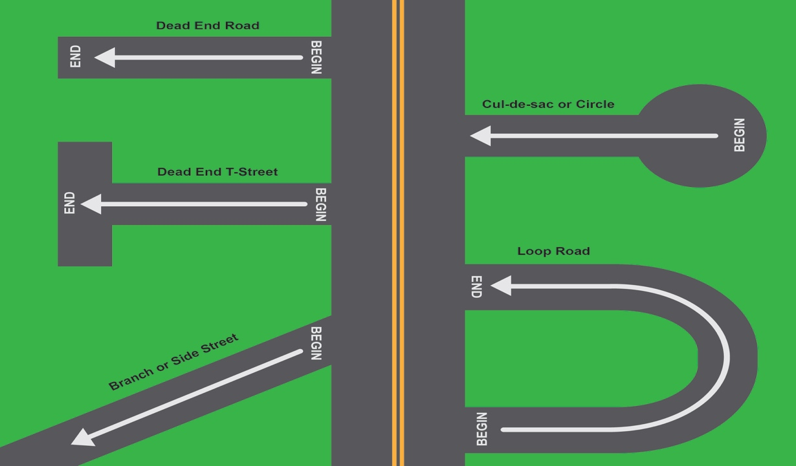
Figure 4: Street Geometry
Continuously named streets may not cross themselves or loop back to create an intersection where both intersecting streets have the same name.

If a roundabout or traffic circle is utilized, no name shall be assigned. It shall be considered a portion of the highest-classification street passing through it. When addressable features are placed in or on the traffic circle, they shall be addressed using the name of the highest-classification street passing through it.

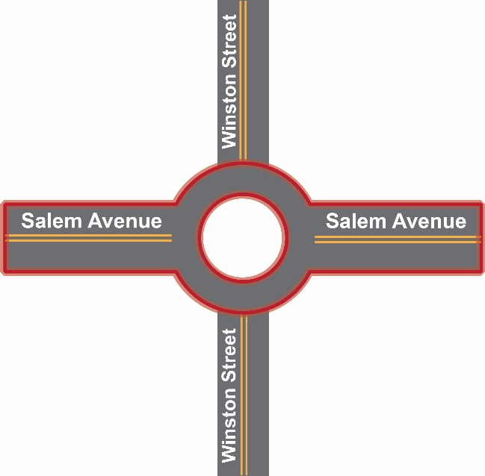
Figure 5: Roundabout

Address Number Rules

Address number rules are applied to the assignment or amendment of address numbers for specific structures, property parcels, or infrastructure features. Addresses are assigned per the rules outlined in the following sections.

Address Numbering Rules

Address numbers are the numbers that identify individual properties, buildings, tenancies, or other features. The following rules provide guidance in the selection of an appropriate address number.

What is Addressed?

Every property parcel shall have an address except properties so small that no structure or infrastructure element could be placed on it. All vacant properties need an address, as many emergency calls are tracked to these locations. Properties with multiple structures on them may contain many addresses, and in some cases, one address may be used with a structure that occupies more than one property parcel.

Each residential or nonresidential building or other facility and each individual unit or separate occupancy within any such structure shall be assigned an address number.

Every occupiable structure, or any structure that has electrical service, or a wired telephone line, and non-residential structures such as barns, animal barns, agricultural structures, boat docks and boat houses, large detached garages, etc., that are used for raising or housing animals or the storage and maintenance of vehicles such as cars, trucks, boats, etc., shall have its own address.

Small garden sheds adjacent to private residences, playhouses in private residential areas, or similar facilities of less than 100 square feet (approximately 10 feet by 10 feet) shall not require a separate address, unless that building requires an address by reason of having either a separate electrical or telephone service.

Any building, regardless of size, which requires a permit for the storage of hazardous materials of any sort shall have a separate address as required for the permit for such storage.

Utility features or structures (even those smaller than 100 square feet in size) that require electrical services and/or telephone services shall be assigned address numbers. Standalone utility features that do not require electrical or telephone service but do require a separate utility bill shall be assigned an address number.

“Maybe” responses in Table 1 indicate that each individual situation should be reviewed. If the accessory buildings are distant from the main structure on the property, they should be addressed. If they are very close to the main structure, they can be given a subaddress or left unaddressed if they are small.
Table 1: What Should Be Addressed
Type of Feature | Address | Subaddress
Habitable building (residential, commercial, industrial, public) | Yes | Maybe
Garden shed, playhouse, detached garage, small greenhouse | No
Utility pole, cell tower | Yes
Pump or lift station (water, sewer), transformer box | Yes
Electric substation | Yes
Stand-alone kiosk on sidewalk | Yes
Guest house, pool house |  | Maybe
Stable, barn, other large agricultural structure, not associated with residence | Yes | Maybe
Individual buildings on school campuses, other group quarters and multi-occupant buildings | Yes | Maybe
Playgrounds, picnic shelters, restroom buildings, concession stands in parks or recreational facilities | Yes | Maybe
Trail markers and facilities (trailheads) | Yes
Mile markers on freeways and controlled access highways | Yes
Temporary trailers, mobile offices and classrooms | Yes | Maybe
Short term uses (Christmas tree lots, open air markets) | Yes

Address Reference System (ARS)

Address numbering of all structures and other features shall be assigned based upon the established Address Reference System, and in accordance with the standards defined in this document. No other numbers shall be created or permitted.
Where an existing number is incorrect based upon these rules, the local addressing and 911 authorities should determine whether keeping that number creates a public safety hazard, or other detriment to public welfare. If it does, then the number should be changed as rapidly as possible through the change provisions in this Manual. Where it does not, it must be noted as an anomaly, and properly identified in the Address Repository.

Address Number Format

Address numbers shall be assigned as whole numbers in Arabic numerals. No decimals, fractions, or alpha characters are permitted.

No new alphabetic address number suffixes or fractions will be assigned to existing buildings except in existing areas where there are no available numbers, in which case an alphabetic character shall be used as an address number suffix. Existing historic fractions or alphabetic address number suffixes will be permitted to continue to exist.

Where there are some available numbers, but not enough to address the new structures, one of the candidate addresses should be assigned to the building, and the individual occupancies shall be given a subaddresses. All of the units within the building shall be addressed in the same manner, either all primary addresses or all with subaddresses, when this condition occurs.

Where there are multiple occupancies in a single structure, separate primary addresses or subaddresses should be assigned. Rules for determining which type of address or subaddress to use are contained in this Manual. A subaddress is formatted as a Subaddress Type, such as unit, apartment, suite, etc., and a Subaddress Identifier, such as 101.

Historical address numbers that contain alphabetic characters, or which are out of sequence, parity, or otherwise anomalies, may be retained provided that the local E-911 Coordinator verifies that the maintenance of the anomalous number does not cause a significant hazard to life or property.

Distance interval

In general, address numbers shall increase every 10.56 feet on each side of the street, thus allowing for a total of 1,000 address numbers per mile, or 100 numbers per 0.1 (one-tenth) of a mile. It should be noted that in some historic districts, and areas of extreme topography, this interval may need to be adjusted slightly to accommodate local conditions. These areas of different intervals shall be documented with maps, and business rules in the Address Repository to ensure consistency of assignment of new or changed addresses.

Incremental value

Numbers increase in a measured way, and where possible adequate intervals should always be left between address numbers to allow for future growth. The use of a small distance increment, such as 10.56 feet (0.02 mile), provides adequate numbers for most block segments. Potential address numbers can be generated for each road segment. The point that is closest to the structure’s location is selected for assignment of an address. This practice normally provides for some unused points that are then available if more dense development occurs or for other purposes.

The example below helps demonstrate what this approach may look like in practice. The NM911 Program may assist local addressors in implementing this approach if needed.

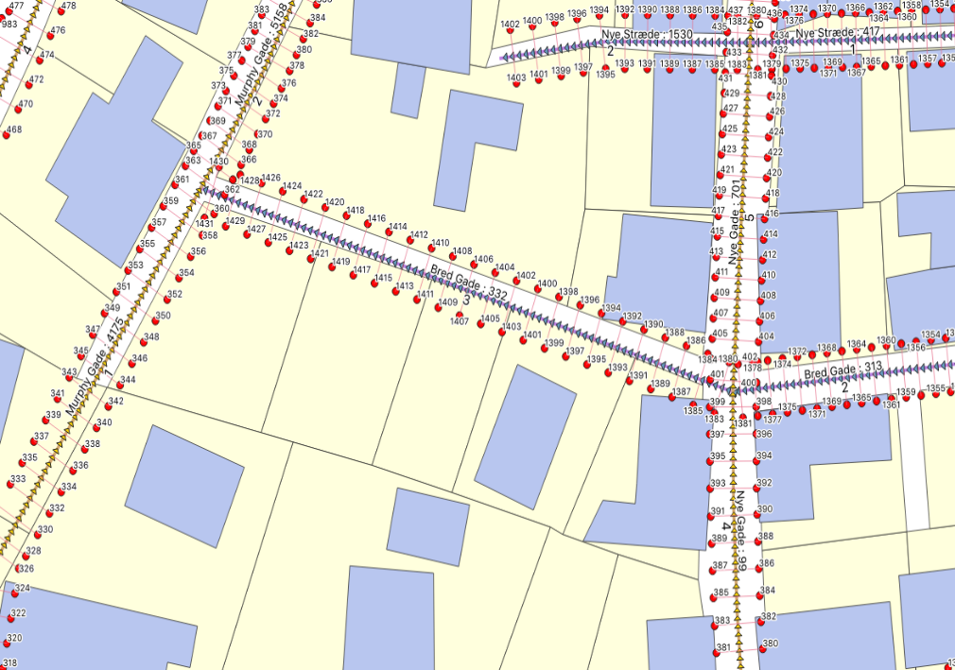
This illustration shows how potential points are arranged on streets based on a gridded ARS. If a new building is added on one of the vacant lots, the local addressor can view these points, pick the one that most closely aligns with the structure’s entrance or other selected address point location, and be very sure of assigning the correct address number.
Figure 6: Potential Address Points (example)

Using the potential addresses generated by the ARS, select and apply the potential address that most closely approximates the location of the addressable point. The addressable point may be the driveway entrance, the front door, the centroid of the building, or other approach. Local addressing ordinances must make this explicit, and existing addresses should be considered when establishing this rule to ensure address assignment is done in a standard manner for all addresses.

The local jurisdiction should consider the land use patterns within its territory. If there are many houses that have long driveways, using the driveway access point on a public road is often the best solution. Where there are no driveways, and buildings front on the sidewalk as sometimes is found in older western towns in their downtown area, then the front entrance to the building is more appropriate. A driveway or door location is better where the property parcels are large and the use of the property or building centroid does not give a precise location.

Address numbers on opposite sides of the street should be aligned with each other, as much as possible. This is particularly important on curved roads and is required to keep the logical sequencing along the entire street. This may mean adjusting the number increment in some cases.

Order

All address numbers shall be assigned in sequential numeric order, always increasing from the ARS point of origin, and should be numerically balanced on both sides of the street.

Parity

Numbers are assigned using odd numbers for one side of the street, and even numbers for the opposite side. Even/odd address numbers will be assigned consistently on each side of the street and are not to be mixed on the same side of the street.

Note, the left and right sides of the street are determined from the perspective of facing the street in the direction the numbers increase. Numbers increase as the street extends away from the point of origin.

Local addressing ordinances must declare which side of the street should be odd versus even. Such a decision should be based on existing conditions to ensure consistent parity throughout the area.

Odd/even patterns on streets with existing assigned address numbers are required to be maintained when assigning new address numbers, even in older areas where the current odd/even side of the street rules were not used. Existing address numbers that are all odd or all even on both sides of a street or mixed with even and odd numbers on both sides of the street, may require correction to re-establish proper parity. However, the negative effects of renumbering may outweigh the benefits of so doing in established neighborhoods.

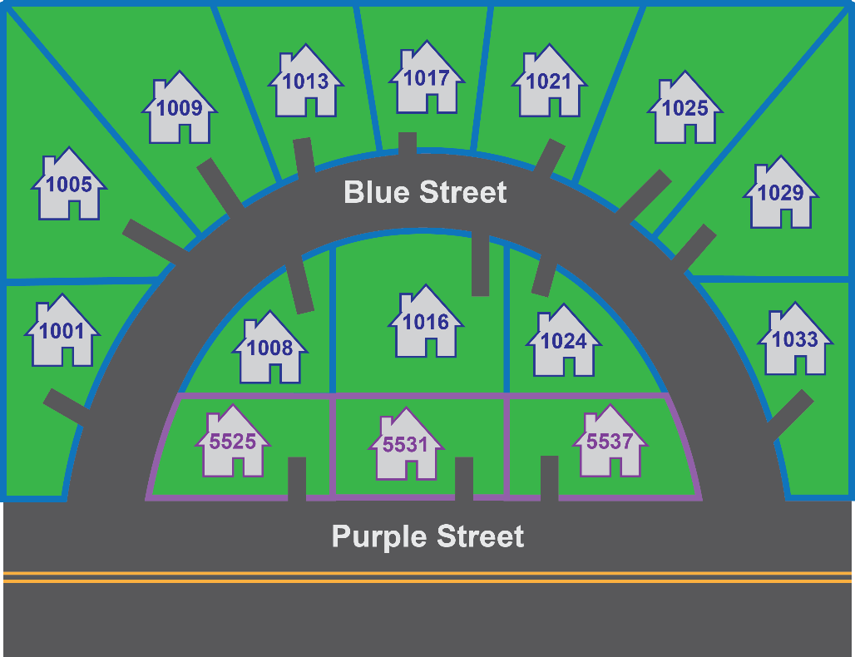
Figure 7: Parity

Loop road numbering shall start at the low number end of the street that the loop intersects and shall end at the high number end. The parity shall not change along the length of the loop even though this creates the appearance of an incorrect parity at the high number end of the road. The diagram below illustrates this pattern.

Cul-de-sac roads shall maintain parity and numbering sequence along their length. A structure located at the end of the cul-de-sac should be numbered based on the numbering rules, using the Address Coordinator's best judgment as to the parity of the number selected. It is important that cul-de-sacs and other dead-end roads maintain the directionality of the ARS. This means that some cul-de-sacs are numbered from the end of the cul-de-sac toward the intersecting street, while others are numbered from the intersecting street toward the end.

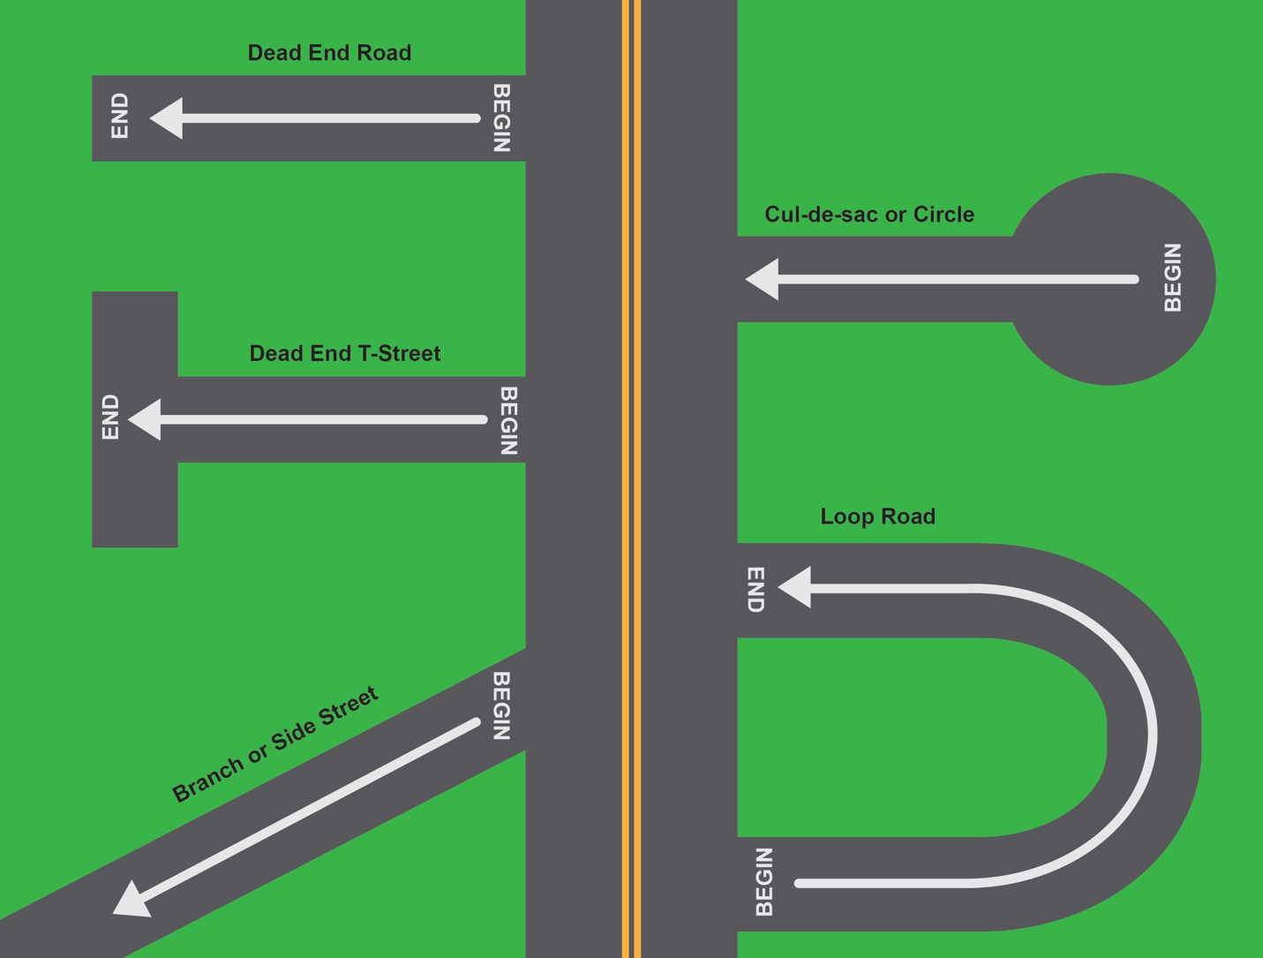
Figure 8: Consistent numbering pattern

Vacant or Undeveloped Property Addressing Rules

All vacant properties shall be assigned an address.

If the property parcel is later divided, the address assigned may be retired, and new addresses assigned to the individual new parcels created. It is critical that addresses be assigned as early in the approval and development process as possible. If an accident happens while the property is being graded or cleared, or if construction materials are being delivered to a new development, or workers are attempting to get to a site to work, or a workman is injured, an address is essential. Waiting until a home or non-residential building is completed and ready for occupancy is far too late in the process. There is no problem with retiring an address number for an acreage parcel and replacing it with numbers assigned to smaller properties.

Please note, modern technology and workflows are well-suited for assigning addresses which may need to be changed later during the development process. Considering the negative impacts of delaying address assignments (described above), the potential need to change addresses in the future should not deter local addressors from assigning addresses early during the development process.

As property is developed, addresses are assigned during the development review process. This will require the assignment of addresses to newly created vacant properties or open space lots. Section 8 of this Manual provides workflows for the assignment of street names and address numbers to new developments.

In general, a property parcel or open space lot should be given an address number based on the center of the parcel's frontage on each frontage side. It is recognized that this may mean that a parcel may have two or more addresses assigned.

Residential Addressing Rules

All residential structures and occupancies shall have an address.

Single Family

One single family residence on a lot will receive one street address. Single family residential addresses shall be assigned based upon the rules stated below for the location of the address number.

The number used shall be the potential address, in keeping with required spacing requirements, which is closest to the selected address location point for the residence (driveway, front door, or other location); or, if the location of the address point cannot be determined at the time the address is assigned, the Address Coordinator shall select the number that most nearly represents the center of the frontage for the property.

If a single-family residential structure does not front on a public or private access road, then it should be addressed from the point of access by an emergency vehicle or can be addressed from a common access walkway or similar feature.

For the purposes of addressing, townhouses and row houses located on their own parcel with frontage on the street are treated as single family residential property. In areas of infill development where there are not enough numbers available for each townhome to have a separate address, the Address Coordinator may use a multi-family addressing scheme with a primary building address and subaddresses in order to keep from readdressing an entire street.

Multi-family Residential (duplexes, quadplexes, apartments, condominiums)

Duplexes, triplexes and quadplexes with individual exterior doors are assigned separate addresses using the potential points. A duplex, triplex or quadplex with a common exterior entrance door is assigned one address number and then interior subaddresses are assigned for the individual units.

If an existing single-family dwelling is divided into two or more units, all units in the structure will be assigned subaddresses per the subaddressing rules. If a second dwelling is placed on the same parcel, the existing unit maintains the primary address, while the second dwelling is assigned an available number if there is an available potential point, or an address number suffix, if there is not.

For the purposes of addressing, condominiums and apartments are treated as multi-family residential property. Townhouse or row house style homes located on a single property (not their own parcel) are treated as multi-family residential properties. While these units may have different forms of ownership, it is irrelevant for addressing purposes whether a unit is rented or owner-occupied.

Each building within a multi-family development must have its own primary address. The interior streets within such a development shall be named, and the buildings addressed using those street names. In cases where all the unit entrances are exterior on each building every unit should be given a separate address. Where entrances to individual units are within interior hallways, corridors, or on balconies, the building should receive a primary address, and the units shall be identified by subaddresses. See Section i. 7.9, Subaddress Rules for the rules pertaining to subaddress assignment.

Additional guidance for addressing multi-family residential properties in mixed use developments or complexes can be found in Section i. 7.4, Non-residential & Mixed-Use Addressing Rules.

Residential Corner or Multiple Frontage Lots

A corner lot is a property parcel that fronts on two streets. At the time it is created, it may not be known where the front door of the building will be located; therefore, an address shall be assigned for each street. The Address Coordinator should select the potential address closest to the center of the property frontage for each street, in keeping with the spacing and parity rules. Both addresses are considered “reserved” until such time as a building permit is requested for the property that shows the specific location of the front door. Once the location of the front door is known, the status for the corresponding “reserved” address should be updated to “active” while the other street's address status can be changed back to "potential".

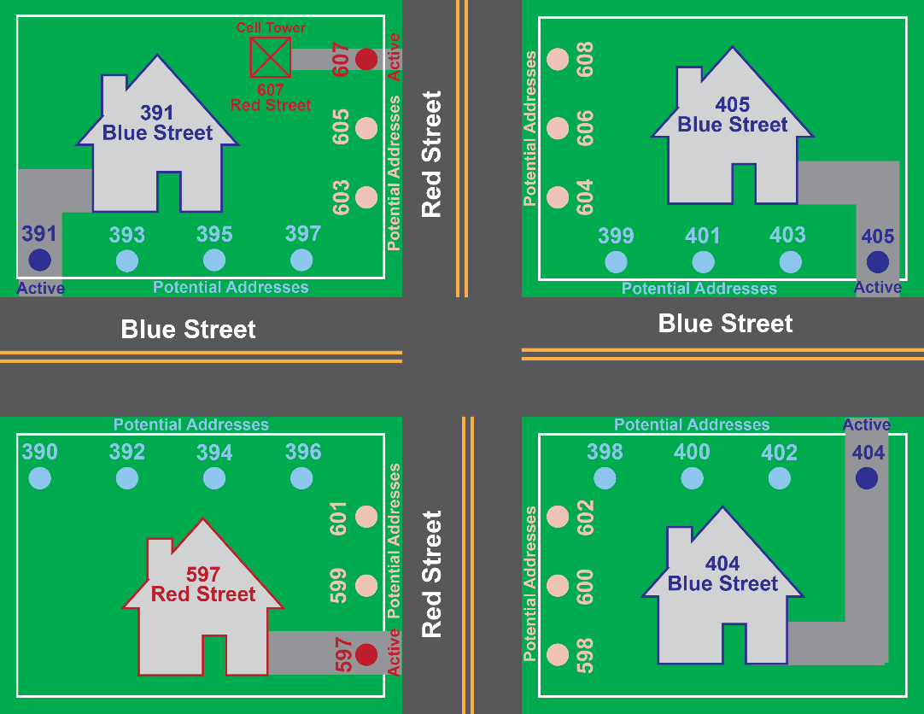
Figure 9: Alternate Address Placements

In the case of apartment complexes, condominium complexes, etc., on corner lots, the Addressing Coordinator should determine whether one or more access roads to the building(s) within the complex will be constructed. If there are or will be access roads from the boundary streets, each building shall be addressed from the named access street per the Multi-family Residential addressing rules. If the complex does not have internal roads, but buildings front on the two streets, then each building should be addressed to the street on which the front entry faces. If both conditions (internal street facing, and external street facing structures in the same complex, each structure should be addressed based on the street the front door of that structure faces.

In certain instances, structures are located with the front entrance facing the corner directly. In this case, the Address Coordinator shall select an address number on the street with the higher functional classification. For example, the structure faces the corner of an arterial street and a collector or neighborhood street, the structure shall use the street name of the arterial and select the correct address from the potential points along the arterial's frontage.

If there are multiple separate entrances, each entrance shall be given its own unique address using the potential address points located along the frontage where access occurs. See Section 7.1.5 for more information on using potential address points.

Rear-facing Properties
In cases where a structure is built with the front door facing a greenway with a walkway or sidewalk and the rear of the structure faces on a public or private street, or alley, the priority for the structures address will be for emergency or vehicular access. In these cases, the address number is determined in the following manner:

- If the front door faces green space with no street, and the structure has a driveway, then the address shall be assigned based upon the driveway access.

- If the front door faces green space with no street, the structure does not have a driveway, and there is a sidewalk that goes to the front door and connects to a street, then the sidewalk will be named, and the address number is assigned.

- If the front door faces a green space with no street, the structure does not have a driveway, and there is not a sidewalk to the front door, then the location will be marked as an exception and addressed to the closest street as a last resort.

Accessory Structures

If an additional habitable structure (dwelling, garage apartment, or manufactured or mobile home) is added to a lot with an existing single-family dwelling, it shall be given a new address in sequence with the existing structure. If no address numbers are available, the secondary unit on the lot will be assigned the same street address number and a subaddress type and a subaddress identifier. For example, a new garage apartment, in the case where no new numbers are available, will receive an address like “1015 Oak Forest Drive, Unit A” or “1015 Smith Road, Apartment 1”.

A small non-habitable structure, such as a garage, storage shed, playhouse, gazebo, etc., shall not be provided with a separate address or a subaddress, unless it has separate power or telephone service.

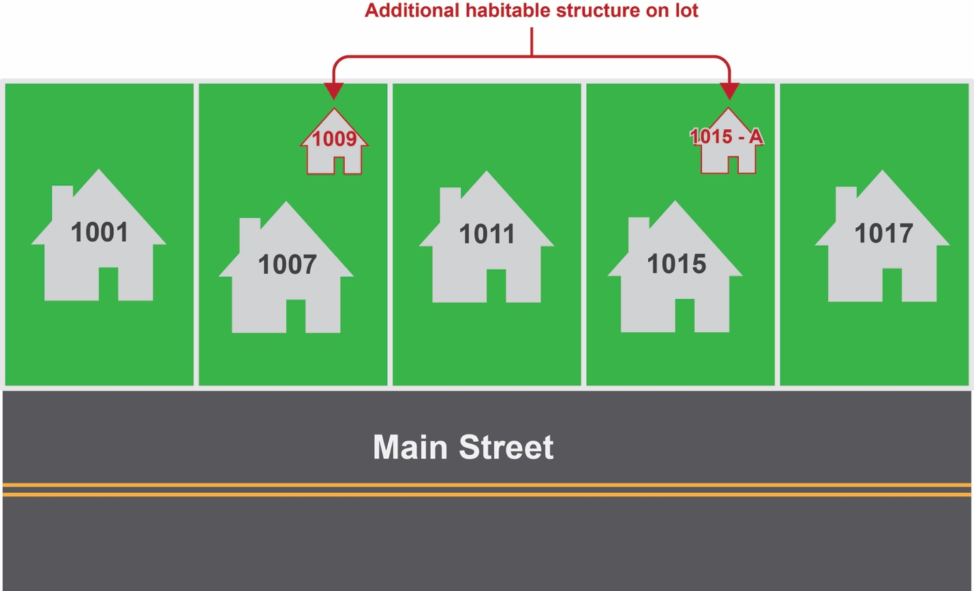
Figure 10: Additional Habitable Structures (ADU's)
In the case of a large rural property with a remote building such as a barn, greenhouse, livestock or poultry house, or other agricultural building that is accessed separately from the access to the main residence, a separate address shall be assigned for safety.

Mobile Home Parks

The roads inside a mobile home park are required to be named and each individual lot is assigned an address number in accordance with the addressing rules outlined in this document.

Non-residential & Mixed-Use Addressing Rules

Non-residential and mixed-use properties are treated somewhat differently than solely residential ones. Sub-addresses in commercial buildings, offices, shopping centers, etc. change frequently as businesses move in and out, and the configuration of the interior space is changed for the new tenants. Likewise, the internal configurations of many larger non-residential buildings are unknown at the time of permitting and approval, as not all tenants have been secured. Thus, some subaddressing decisions must be made as the building is leased, and some will change over time.

Multiple tenant buildings, large complexes and campuses with multiple buildings and many separate rooms and tenancies create complex addressing schemas. However, detailed, and specific addressing significantly assists emergency rescue personnel and all users of such facilities in locating a specific office, classroom, or unit within such complexes.

Best practices for working with these complex situations begin with reviewing the existing situations that are already addressed in a specific jurisdiction. As has been stated earlier, consistency in the address assignment process over time is essential. Thus, if a particular type of situation listed below has been addressed differently in a given jurisdiction, then the local Addressing and Street Naming Manual should identify the local method, and disregard the information provided in the State Manual.

Consistency in this assignment process is critical to the success of addressing systems. The rules in Section 7.4 should be very carefully reviewed and edited to reflect the conditions found in the city, county or region. It is not possible to provide a state-level set of rules, since most New Mexico cities and counties have existing addressing systems, and the choices that underlie existing addresses likely differ from jurisdiction to jurisdiction.

Non-residential structures are generally addressed from the point of access to the structure or property. If a single structure is not visible from a public or private road, then the point where the driveway intersects the public or private road which provides access to that structure shall be used as the address.

Single Property, Single Structure with One Tenant

Properties with one structure on a lot will receive one street address based upon the primary access location. If the building faces one street and the primary driveway access to the building is from another street, then the address assigned will be based upon existing local practice. If no such examples exist, then the local addressor should choose the required location, and incorporate it into the local addressing manual. May use front door, access (driveway or walkway) point, or other (building centroid, frontage center) location for the address. No matter what location is chosen, it must be used consistently for all addresses.

Single Property, Single Structure with Multiple Tenants

Properties with one structure on a lot will receive one street address based upon the primary access location. If the building faces one street and the primary driveway access to the building is from another street, then the address assigned will be based upon existing local practice. If no such examples exist, then the local Addressor should choose the required location, and incorporate it into the local addressing manual. May use front door, access (driveway or walkway) point, or other (building centroid, frontage center) location for the address. No matter what location is chosen, it must be used consistently for all addresses.

All interior occupiable spaces within a building with multiple tenants, regardless of where they are located, including basements, shall be given a subaddress within the building. See Section 7.9 for the rules pertaining to subaddress assignment.

In some cases, particularly in more urban areas, there are single buildings on single property parcels that do not have driveway access, but instead have their primary access through a street level main entrance. In these cases, the primary address assigned to the building will be based upon the location of the main entrance.

In some cases, there are street fronting businesses that have doorways onto the street separate from the main entrance. Some of these businesses may also have doorways into the interior building lobby. Some of these entrances may be on different streets than the main addressed entrance, and it would cause significant confusion for them to use the primary building address with a subaddress number. Therefore, where a tenant has a separate street front entrance from the main building entrance, a separate street address should be assigned to the storefront business.

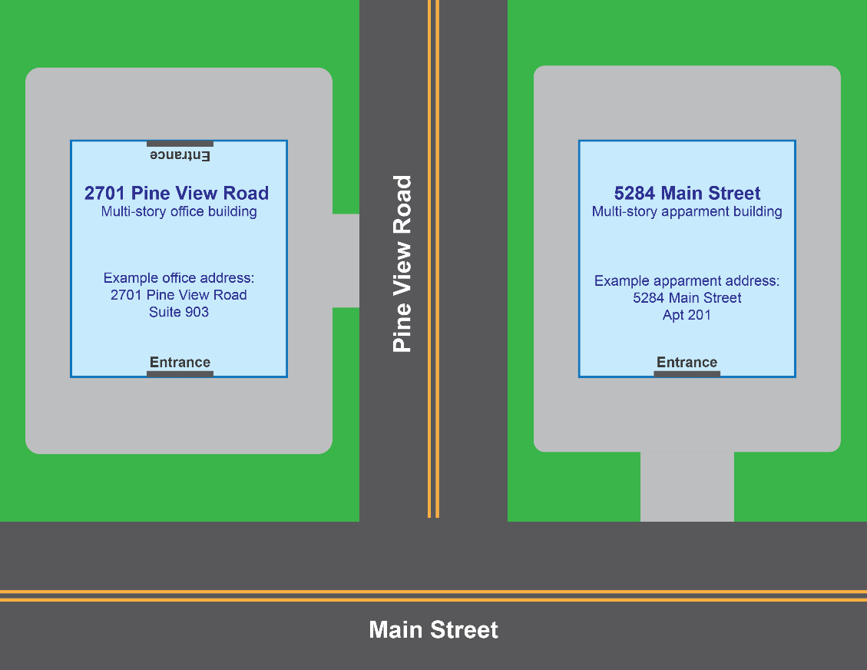
Figure 11: Multi-Tenant Non-Residential Addressing

Single Property, Multiple Structures

If there are multiple structures on a single parcel, each structure shall have its own street address. If the structures are all accessed from the existing main fronting or side street, they shall be addressed from that street. Where there is an internal road on the land parcel, serving multiple buildings, the street shall be named, and the structures that front on the internal road shall be addressed from the internal street. Structures on the parcel which face the existing exterior street(s) shall be addressed on the street from which they take access.

This rule applies to schools, churches, university campuses, office parks, industrial parks, mixed use developments, apartment complexes and the like.

Every occupiable structure, or any structure that has electrical service, or a wired telephone line, and non-residential structures such as barns, animal barns, agricultural structures, boat docks and boat houses, large detached garages, etc., that are used for raising or housing animals or the storage and maintenance of vehicles such as cars, trucks, boats, etc., or for storage or use of hazardous materials, shall have its own address.

Where there are multiple structures on a single piece of property, the Addressing Coordinator shall determine whether to address the auxiliary buildings using subaddresses to the main structure, or to provide each with an individual street address using an available number from the fronting street(s). This determination shall be based on whether all of the structures on the property are under the same types of uses, what the internal subaddressing needs of the buildings are (such as apartments, office spaces, commercial spaces, etc.) and the availability of sufficient primary address numbers to support the number of structures on the property and to leave sufficient available numbers for other properties within the address range in which the subject property is located.

Single Property, Multiple Structures with No Internal Roadways

In some cases, there are multiple structures located on a single parcel, and each of the buildings faces on an existing street - there are no internal driveways or roads within the land parcel to be named. In this case if there is one common exterior entrance door for each building, one address number is assigned for the structure and each unit or suite within that building is given a subaddress. Where there are individual exterior doors, separate addresses are assigned for each. If there are more occupancies than available numbers for the street frontage, then the building should receive an address number and each individual door should receive a subaddress to keep from readdressing an entire street.

This situation often happens with college campuses, camps, prisons, airports, and other large facilities in urban areas.

Single Property, Multiple Structures with Internal Roadways

In some cases, especially for large semi-public properties, such as schools, colleges and universities, churches, industrial and office parks, and some shopping malls, there are numerous buildings on a single parcel. These buildings and the spaces within them are sometimes rented or used by different tenants.

When there is a property with multiple buildings and internal roadways or common driveways, whether residential or non-residential, the street (or driveway) should be named, and each structure must have its own address on the internal street.

Commercial complexes are generally addressed by assigning a street address (using either an existing public street, or an internal street within the complex, depending on where access is obtained), to each building, and using subaddresses to identify the individual occupancies within each building.

The Addressor should work with the owners, and with the Fire Marshall and emergency personnel to determine how to address any buildings which have their primary entrances on pedestrian ways (for example, fronting on the “quad” of a campus, or where a group of buildings face towards an interior courtyard.) Addresses for this type of complex need to reflect a location that provides for emergency access, even if that address is not the designated front entrance to the building. Named buildings may be treated as landmark addresses within the campus but must also have a thoroughfare type address showing where the structure is actually located. This is especially critical when the front, or primary entrance, is not accessible by vehicles.

Multiple Parcels, Multiple Structures that Form a Larger, Identifiable Whole

This situation occurs with many larger developments including college campuses, large church facilities, camps, industrial and office parks, shopping centers, etc. These should be treated as if they are a single land parcel with multiple buildings. Each structure must have its own address.

The street naming and address numbering rules that apply to single properties with multiple structures also apply in this situation, see the section above for details and guidance.

Mixed Use Developments

Mixed use developments often present addressing challenges and different addressing strategies may be needed to clearly identify where individual businesses or units are located. Mixed use developments may also include multiple structures on a campus (shopping centers with outbuildings, schools, medical facilities, etc.)

It is important that these development plans be reviewed early in the development process to ensure that addresses can be assigned logically and consistently throughout the project. When later phases are expected, the whole project’s street layout and address ranges should be reviewed to ensure that the addresses are not set up in a way that makes continuation into later phases difficult. Section 8 of this Manual provides workflow diagrams for these processes. Each needs to be customized to match those of the Address Authority.

Mixed use complexes, incorporating both residential and nonresidential uses, are types of development found both in urban and suburban settings. In the more traditional urban core, these are typically high-rise buildings that may incorporate a structured parking garage below grade, retail and service businesses at the ground/street level, office spaces and residential spaces (both private residential units such as condominiums, townhouses, lofts or apartments, and commercial residential space such as hotels). In these cases, the building receives an address which is the base for subaddresses on upper floors. Individual businesses that are on the ground floor and have access from the street are given individual street addresses. The parking deck typically has a separate street entrance and is given a unique address which is the base for subaddresses if they are needed for individual parking spaces or electric charging stations.

In suburban settings, these often include two to three story buildings, where the ground floor faces a street-side parking area or lot, and contains retail shops such as restaurants, small grocery stores, boutiques, and service businesses, while the upper floor residential units have garages and main entries on the rear facing side of the buildings, sometimes utilizing a gated entry to access the residential entrance area. The access street should be named, and individual units given addresses on that residential street where their main entrances are located. Commercial users, in the same physical structure, are given the street address of the building along with a specific subaddress containing a type (e.g., unit, space, etc.) and a unit number. This is done in non-residential settings because the configuration of shopping centers and malls frequently change. See Figure 10 below.

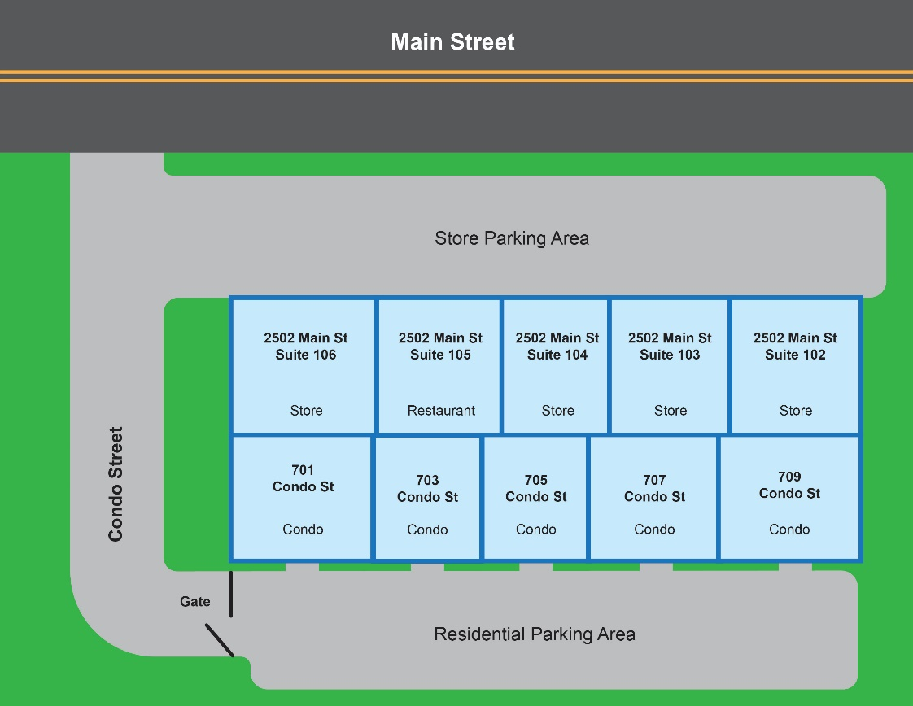
Figure 12: Multi-Use Complexes

Strip Development

For nonresidential developments located in a strip or in a strip mall, a primary address number will be assigned to the building and subaddresses will be assigned to individual exterior entrances. Extended spacing in address number assignment for each suite may be required depending upon the configuration as the units may be subdivided or combined over time.

Subaddress numbers shall be assigned with the numbers increasing in the same direction as the numbering on the street on which the building is located.
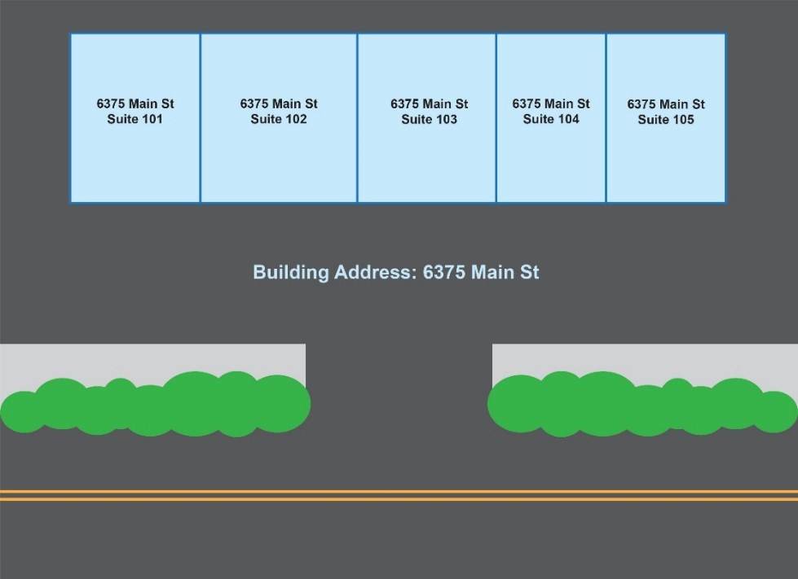
Figure 13: - Strip Mall Addressing

Enclosed Malls

An enclosed mall shall be assigned a primary address based upon the primary access to the building. If there are multiple entrances, the entrance considered the main entrance should be used for addressing purposes. The interior units without exterior entrances are assigned subaddress numbers linked to the main address assigned to the entire mall. The interior subaddress numbers are assigned using extended spacing (a minimum of one unassigned address number between each address) as the units may be subdivided or combined over time.

If a separate structure is located on the same property as the mall, it shall have a separate address based upon the location of its entrance. If there is an internal access road within the mall property, it shall be named and each structure with access from that road will be addressed from it.

Public Uses (schools, parks, stadiums, arenas, theaters, large churches, convention centers, etc.)

Public buildings and other places where there are large crowds or assemblies need to be well addressed. Schools often are located by their names as a landmark address, but it is also critical to provide for access by emergency vehicles of all types (fire, police, ambulances, HazMat clean up vehicles, strategic teams for other types of situations, etc.)

Each exterior entrance for every building must be addressed in a logical way that meets the requirements of the emergency services providers. Additionally, spaces within the buildings, or on a campus with many buildings, need additional addressing and signage to make the specific location of an emergency immediately clear to first responders.

Modular Classrooms, Construction Trailers, and other Portable Buildings

Modular buildings are commonly found at schools, churches, and other public and semi-public sites, as well as on construction sites and temporary locations such as Christmas tree lots, fairs, and festivals, etc.

Where a modular building is expected to remain in a location for longer than 30 days, it should be given an address.

Each separate building should have an address. This address can be a separate address number from a permanent structure on the property or it can be a subaddress of the primary structure with a Subaddress Type of Building.

On a school campus, these are addressed using a subaddress of the main school building, for example, 2600 Rock Quarry Road, Building 230. Where a group of modular classrooms are linked to make a larger room or space, the identifier of the unit where the main access to the space is located is used as the subaddress.

For construction buildings, such as a sales office or construction trailer, which are temporary in nature, the potential address closest to the location of the temporary structure that will not be used for the address of a future property parcel or structure should be used. This address is to be used solely for the temporary structure and will not be used for future permanent structures or infrastructure.

For temporary use, such as a Christmas tree lot, or in support of a festival in a park, for example, assign a temporary address to the portable building to aid in dispatching should an emergency occur at the site. The temporary address may then be put back into the pool of available addresses when the portable building is removed.

For temporary uses of less than 30 days, the Fire Marshall and E-911 coordinator should review the proposed use of the portable building to determine the level of risk and should advise the Address Coordinator as to the need for a temporary address.

Parking Decks and Garages

A parking deck that is a separate independent structure shall be given an address based on the main entrance to the structure. If there are multiple entrances on different streets, then the Address Coordinator shall determine which is the main entrance for addressing purposes. This entrance shall be given the primary address.

A parking deck that is a part of another building, such as underground decks below office buildings or within the structure of a shopping center shall be assigned a unique address based upon the location of the entrance. Individual parking spaces and other features within the deck will be assigned subaddresses using the base entrance address. For example, if there are two below-grade levels of parking these can be addressed with basement level numbering.

Vehicle charging spaces within parking decks should be individually numbered when required by developer or utility provider. The individual spaces are considered subaddresses and should be addressed in a similar way.

Buildings Joined by a Breezeway, Canopy or Other Connector

In many instances, a developer will create a group of buildings on a single property parcel connected with covered or enclosed walkways. This is often found with office parks, medical office parks, and small shopping malls. It may also occur where two high-rise buildings are connected via an above-grade "bridge" or tunnel, or a parking structure of several levels is connected via an enclosed passageway to the office or residential building that it serves.

Buildings that are joined by a breezeway, canopy, or other connector should be considered as separate buildings and given separate addresses, unless one of the buildings does not have any direct access at ground level to the outside. Buildings with an above grade “ramp” or bridge or which are connected by a below-grade tunnel between them shall be considered as separate buildings for the purpose of addressing.

If the property parcel has two or more frontages, then each building may be addressed based on the way the main entrance to the building faces. The diagram below indicates an addressing plan for a complex of this type.

If both buildings are located on the same property, buildings in this situation may be given a subaddress (123 Main Street, Building 1 and 123 Main Street, Building 2), or they may be given separate street addresses (123 Main Street, and 125 Main Street). The determination should be made on the basis of whether each building is visible from the street from which it is addressed, the total number of buildings in the complex, and the number of available numbers on the frontage.

Breezeways, connectors, bridges, and tunnels between buildings should be identified with a subaddress number. Two numbers can be assigned to each one, using the appropriate number for the doorway or entry to the passageway that would occur in the subaddress numbering scheme of that building. This guides emergency personnel to the end of the passageway located in the building from which they access the passageway.

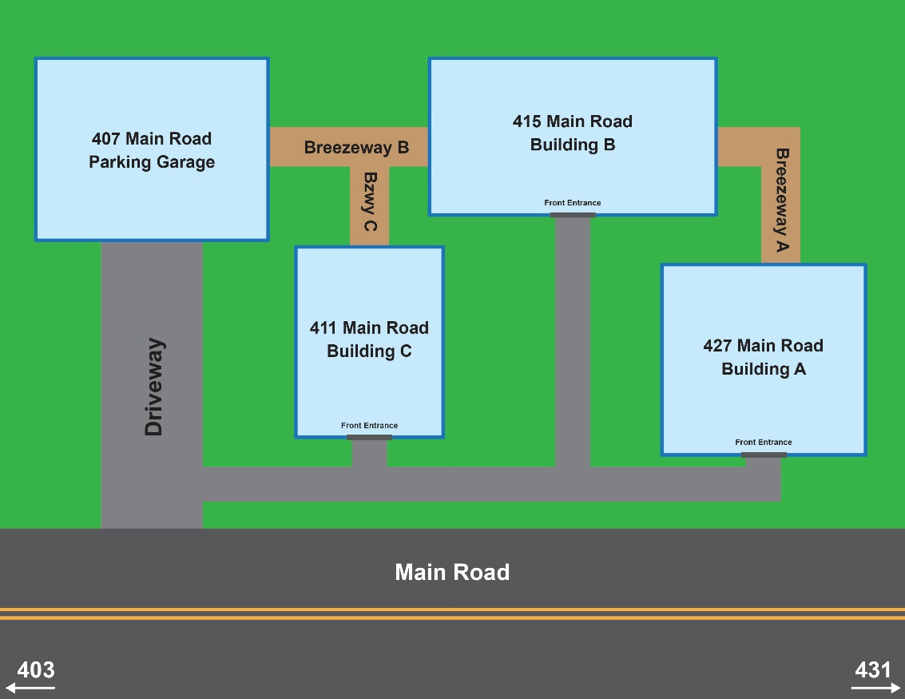
Figure 14: Multiple Buildings with Breezeways

Non-Residential Corner and Multi-Frontage Lots

Some properties have several road frontages. In the cases of shopping centers, large office or commercial buildings, and public uses, a single use may occupy a full block, with all four frontages. Large acreage properties may also have multiple frontages on different streets. These create some difficult addressing situations.

In the case of non-residential uses on a corner lot, the Address Coordinator shall determine whether there are internal access streets. A single parking lot that is accessed by a driveway or multiple driveways from the fronting public or private streets shall not be considered an internal street. If there are internal access streets, the internal streets shall be named, and the building(s) shall be addressed using these street names. If there are no internal streets (other than a driveway into a parking lot), then the building(s) shall be addressed from the street from which primary access occurs.

If a structure occupies an entire property, fronting on all adjacent streets, the address for the structure is based on the location of the main access to the property, or if there is no vehicular access to the property, at the location of the front entrance of the building. Supplemental addresses may be assigned as follows:

- Additional entrances for tenants within the building that front on any of the bounding streets may be addressed. This would include storefronts on the ground floor of a larger building. These stores may or may not have access to the internal lobby of the building. The store is primarily accessed or known by the address that is on the street. As these entrances may not be on the same street frontage as the primary building entrance, they need to have their own address based on where the storefront is located.
- When there are multiple buildings, but no internal roadways or driveways on a lot with multiple frontages, each building shall be addressed based on the location of the main or front entrance, using the name of the street that it faces.

Other Numbering Situations & Addressing Rules

Addressing of Infrastructure and Utility Features

An address is required for all infrastructure facilities which require either electrical services or telephone services (wired lines). Infrastructure features include utility structures, such as pump and lift stations, red light cameras, cell towers, electric charging stations and other similar facilities.

The address assigned to these facilities and features must be different from the address for any other buildings on the property on which they are located. Addresses for these features should not be assigned as subaddresses, but as individual numbers.

An infrastructure feature shall be addressed based on the closest available potential address, taking into account whether there is a separate driveway or access route to the feature.

Addresses assigned to these facilities should include the “mailable address” attribute that indicates no mail should be sent to this feature.

Common Driveways

Common driveways are used to serve two or more structures or properties. Based on the rules of the US Census Bureau, any driveway that serves three or more homes shall be named as a street. However, there are instances where a duplex residential structure may have a common driveway serving the two units, and the naming of such a driveway would create unnecessary confusion. Where the driveway is less than 50' in length, and no more than two addresses are in use, and both front directly on and are visible from the public or private street they face, the common driveway is not named as a street.

Developed Properties with no Driveway

Residential: In many older neighborhoods, and some newer communities, a house fronts on a public street but there is no driveway. There may be no garage or off-street parking, or there may be a garage which is accessible only from an alley. In such cases, the house should be addressed based on the location of the main front door. Where the front door does not front on a public or private thoroughfare, a separate address should be created at the named alley or thoroughfare from which the property can be accessed by emergency vehicles (garage, rear door, etc.).
Commercial and Non-residential: Many commercial buildings in the downtown area of cities do not have driveways or parking facilities associated with them. For these properties, the main front entrance to the building should be used as the point for determining the address. However, for large buildings that have frontage on more than one street, additional addresses may be assigned to loading docks, service entrances, or auxiliary entrances on any street from which the building may be accessed.

Flag Lots

A flag lot is one with a long narrow “stem” or “pole” that connects the main part of the property to a public street (see diagram). In general, the narrow portion of the lot is used for a driveway. As property is addressed at the point where the driveway connects to the public or private street, the address should be assigned based on the center of the “flagpole” part of the lot, where it meets the public street. In some cases, due to lot geometry, the house or structure on the lot may appear to be out of sequence if the address point is placed on the structure itself, rather than at the access point. An alias address or location description may be needed where the structure location places the address number out of sequence, or where the structure is not visible from the street.

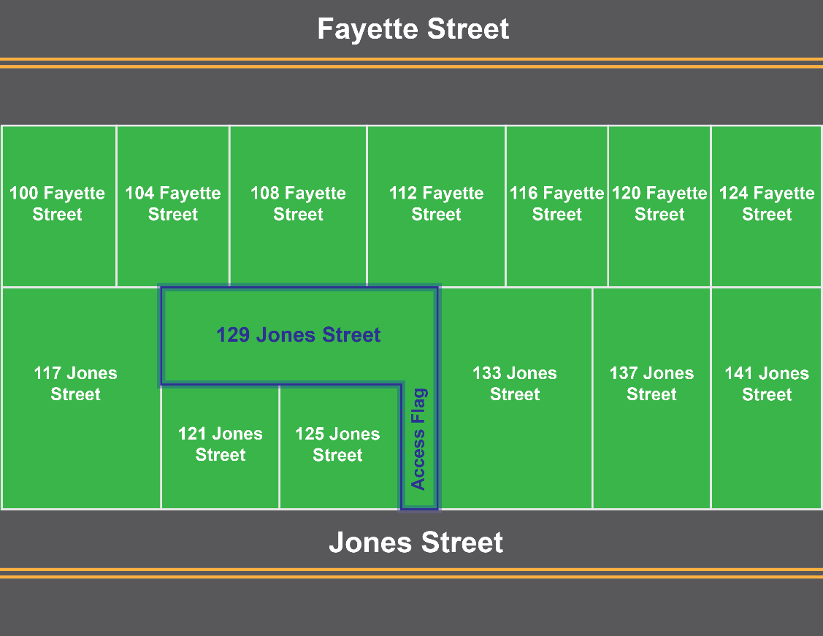
Figure 15: Flag Lots

Landlocked property

A landlocked property is one that does not have legal access from a public or private street, walkway, driveway or other public or private thoroughfare. While landlocked parcels should never be permitted based on zoning and planning regulations, there may be some that were created prior to the adoption of the regulations, or which are created because of construction of freeways, or other actions that separate a section of a larger parcel from its access.

In this case, the Address Coordinator shall determine the method of access to a structure on the property and utilize an address number that identifies this point of ingress and egress. If it cannot be determined, the property should be given an address using the nearest possible thoroughfare that could physically provide access, until such time as the property obtains legal access via a new thoroughfare or an access easement.

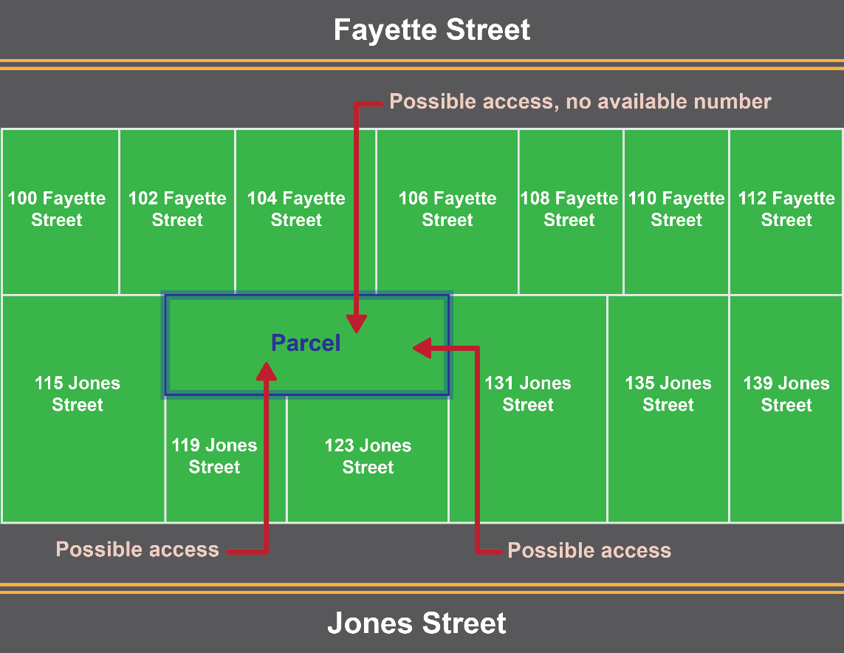
Figure 16: Landlocked Property Addressing

Addressing on Interstates and Other Roadways that Have Limited Access

Interstate highways, and certain other roadways, have restricted access for vehicles. Thus, address ranges are usually not assigned to them, as there are no homes or businesses with direct access to the highway. However, for many purposes, it is useful to create address ranges for Interstates and other Limited/Restricted Access roadways. First, accidents and other incidents do occur on them, and it is helpful to know where on an interstate such an incident may be. Second, there are infrastructure features on interstates and other limited access roads that can be addressed to assist service personnel in locating them. These include lighting fixtures, signs, drainage, and traffic control features.

Interstates are addressed using the mile markers placed by the New Mexico Department of Transportation (NMDOT). Addresses are created by using the mile number followed by two decimal places (hundredths and tenths) to create a three-, four-, or five-digit address. The number is determined by multiplying the mile marker number by 100 or by moving the decimal point two digits to the right. Thus, a light fixture at mile 169.5 on I-25 Northbound would be given an “address” of 16950 I-25 Northbound or another feature at mile marker 2.5 on I-10 Eastbound would be given an address of 250 I-10 Eastbound. Maintenance personnel, and dispatchers can then be trained to recognize these addresses as specifying distance and direction from a given milepost.

It is important when addressing features along a median or barrier divided highway to indicate the “bound” direction, as it is often impossible for an emergency or maintenance vehicle to cross the median except at interchanges and a few emergency crossways. The NENA standard provides for the use of “bound” directions for these cases such as I-25 northbound, or U.S. Highway 20 westbound for the segments where such a median or barrier exists.

Addressing on Trails

Trails, like limited access highways, need to be addressed for many of the same reasons – accidents and other incidents occur on them and there are infrastructure features that may need to be addressed. Trails can be addressed using a combination of their trail name and mile markers placed along the length of the trails – signs should be posted at regular intervals along trails inaccessible to roads.

The trail name will be used and displayed as the thoroughfare, or street name.

Address numbers are created using the mile number and two decimal places (hundredths and tenths) to create a two-, three- or four-digit address. The number is determined by multiplying the mile marker number by 100 or by moving the decimal point two digits to the right. Thus, mile marker 4.25 on the
Osha Trail would be given an address of 425 Osha Trail or mile marker .25 on the Trail would be given an address of 25 Osha Trail.

Last Mile Transportation Features

Last mile transportation features, such as electric bicycle or scooter stations, are permanent features providing access to additional transportation options. These may be located throughout a local jurisdiction, typically in the right-of-way or on an easement.

The address assigned to these facilities must be different from the address for any other buildings or features. The address assigned should be an individual, street number address based upon the closest available potential address; however, in some cases the location of the facility may be in an area of dense development and a separate address number may be unavailable. In this case, the facility may be given the address of an existing structure or feature with a subaddress.

Insufficient Numbers Available

In some instances, due to building densities or the way in which addresses have been assigned along a given block, there is a shortage of numbers within a range to assign to a new structure.

If there are no numbers available within the range, renumbering of the street should be considered. If that is not possible, then an address number suffix, other than a fraction, may be utilized as a last resort.

This could occur if all the numbers within a block range are already active addresses. For example, if the existing high number on the odd side of the block was 199, and a new structure was built closer to the end of the block. If the next block's lowest odd number was 201, then no potential address is available for the new structure between 199 and 201. In this case, the preferable solution would be to assign 199A as an address for the new structure.

Address Number Prefixes and Suffixes

In some instances, it may be difficult to determine whether to assign an address number or a subaddress. In no case should an address number suffix be permitted unless all the numbers within a given range have been used, and no other option is available, and the proposed feature that requires an address is not a part of any other structure or feature found on the property at that location. In most instances, an additional use on a property should be provided with a subaddress (See Section 7.9 of this Manual on Subaddressing Rules). The use of subaddresses rather than address numbers or address number suffixes is strongly encouraged in cases where the use of the structure or portions of it are likely to change rapidly. This is common with small shopping centers, office buildings, retail complexes, etc. In these situations, the building should have an address number, and the tenant spaces within it should have subaddresses.

It is most common to use an address number suffix where there are no available numbers in a sequence, and renumbering is not desirable. Note, local governments may permit, prohibit, or require address number prefixes. It may also be beneficial to prohibit them if none currently exist.

Other exceptions

Many other types of exceptions will likely be noted in the development process over time. For each of them, the Addressing Coordinator should review the proposed structure or project and determine the most suitable addressing assignments based as closely as possible on the Address Reference System for the area in which the structure or project is located. It is critical that the logical arrangement of address numbers be retained to the greatest extent possible, as this is a matter of life and property safety.

Place Name Rules

Addresses are associated with the name of a place. This may be a community, a city or town, a Post Office, or a County, or all of these. It is important in managing addresses that all the place names for each address be maintained, as they are needed for different business use cases throughout the organization. For example, if sample ballots are mailed to all registered voters, the Post Office address is necessary for delivery. On the other hand, if someone is asking for services from a town it is important to know whether the address is within the jurisdiction of the Town.

The address data should contain the State name (New Mexico), the incorporated city’s name (where applicable), the County’s name, the Post Office name, and any additional community or neighborhood names that are in common use. The Country Name field can also be provided within the Master Address Repository, as this is sometimes needed in mailing lists. These are placed in domains of values in the Master Address Repository so that when they are exported to users, the correct values and standardized spelling and content are maintained. The use of Post Office names alone creates significant issues in terms of correct distribution of taxes, response to service requests, and voter registration. Many people whose property is outside of any town or city use a postal city name in their addresses, even though they do not live within or have their business in that municipality.

ZIP Codes®

The Zip Codes® are created and maintained by the U.S. Postal Service (USPS). They represent a group of postal delivery locations, and have 5-digit, 9-digit and 11-digit variations. These represent areas where postal delivery is made to individual residential and non-residential points. They can be changed at any time by the U.S. Postal Service to adjust for changes to delivery routes and other factors. A table of valid ZIPCodes® is maintained within the Address Repository and a map containing the approximate boundaries of existing ZIPCodes® should also be maintained. The USPS does not generate nor provide boundaries for ZIPCodes®

Subaddress Rules

Subaddresses are the part of the address that uniquely identifies a single building in a complex of buildings, or a separate occupied area or tenancy within a building or structure. The addressing of apartments, suites, and individual tenancies in office buildings, retail stores, or large commercial, industrial, or other non-residential buildings is important for maintaining adequate public safety for all residents of New Mexico.

The Address Authority of a local jurisdiction shall assign all apartment, suite, or unit numbers to residential and commercial structures. The addressor may perform this task in conference with the property owner or developer, but this task shall not be performed by developers nor property managers. If local addressing ordinances allow developers to perform this task, the local addressing ordinance should be modified to ensure this responsibility lies with the local addressing authority.

The assignment should be done as early as possible in the development approval process, or at the time the building permit is requested by the owner. It must be done consistently throughout the development, and in accordance with local rules that may be adopted by the Address Authority.

A subaddress element is made up of a subaddress type, such as “building,” “floor,” “unit,” “room,” “space”, etc. and a subaddress identifier (a letter, number, or combination of letters and numbers) that uniquely identifies a single separately occupied element of an addressable feature. As there are many types of subaddress types, they are stored in a domain of values comprising the most common types and others that are locally useful.

When to Assign a Primary Address and When to Use a Subaddress

A subaddress is generally used to identify the interior spaces of a building that are separately occupied. Ownership is not relevant to this determination. For example, there is no real difference in addressing a structure if it contains apartments (to be rented or leased) or condominiums (intended to be sold). Many buildings initially created as rental-type units are later converted to ownership units, and many condominium-ownership type units are operated as rentals. Addressing should remain constant.

If a building has exterior doors that provide access to individual units, and all units are accessible through an individual exterior door, then primary address numbers should be utilized. If the building provides access to individual units through an interior corridor, or above grade balconies or walkways, then the building should be addressed, and subaddresses given to the individual occupancies.

Likewise, many properties that contain more than one building operated as a single entity, such as a college, hospital, military base, prison facility, apartment complex, etc. In this instance, it is important to identify each building individually with either a primary address along an internal street, or a building subaddress (e.g., University of New Mexico, Zimmerman Library). Within these identified buildings, individual rooms or groups of rooms may be given further subaddresses (e.g., University of New Mexico, Zimmerman Library, Suite 302).

Subaddressing within Structures

Within a building, subaddressing should be consistent from floor to floor. That is numbering should begin either at one end of a linear building, or at the point of access via an elevator bank or stairwell. All separate rooms or suites should be addressed individually including restrooms, break rooms, electrical, plumbing or computer equipment closets, janitorial closets, locker rooms, and storage rooms.

Subaddressing Multiple-Structure Facilities

When determining whether to identify a set of buildings as a single “campus” or to treat them as individual buildings, it is useful to understand the underlying use of the structures, their links with other buildings and structures on the property, and the usefulness of working with the entire group of structures as a unit. Additionally, there are many “campus” areas where there are buildings that have been given names. While these names are well known to students or employees, they may not be familiar to visitors, emergency responders, and others. It is important to have a thoroughfare address for each building on a campus that can be easily identified by anyone on the campus, and used by GPS routing systems. The Addressing Coordinator should review the entire plan of the facility and work with the facility manager to come up with a logical and comprehensive plan, and to ensure that all buildings and their internal spaces are sufficiently identified to support emergency response and wayfinding.

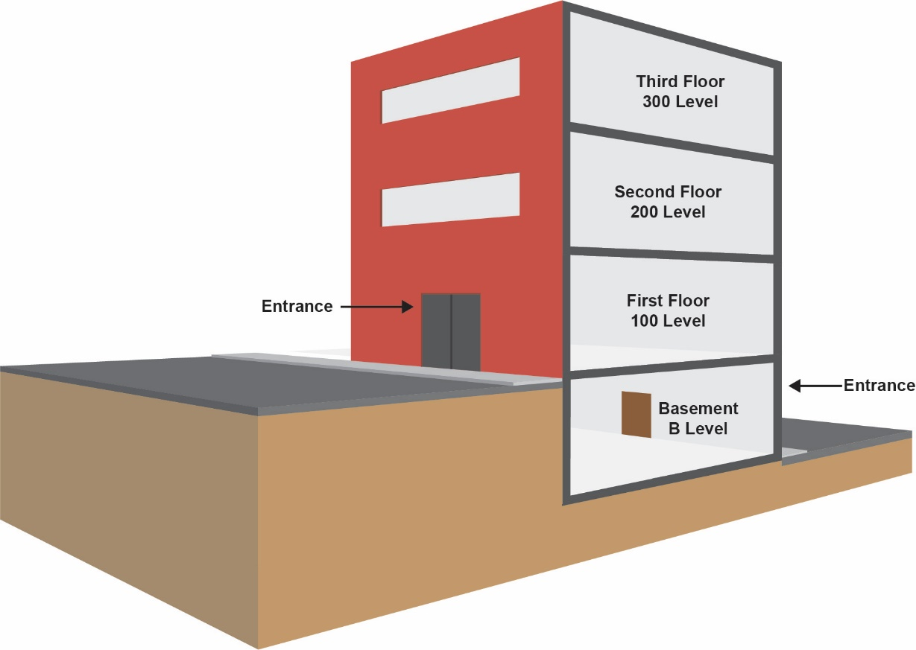
Figure 17: Subaddressing Buildings

Residential Occupancies

Residential occupancies (apartments, condominiums, hotels, motels, etc.) are assigned subaddresses at the time of construction of the building in which they are located.

Proposed units or apartments must be clearly shown on building plans submitted for construction permits. The proposed unit layout is required for addresses to be assigned and will be required when a permit is requested for any interior space, floor, or suite. This includes any permits for renovation or reconfiguration of existing spaces so that existing subaddresses may be verified and corrected if necessary.

Each structure within a residential complex should have its own address, using the name of the internal street (whether public or private). Each unit should have its own unit number.

Unit numbers should reflect the floor level as a part of the number. Units on the first floor should be numbered as 1xx, second floor as 2xx, etc. Basement level units should be numbered as XX. Where there are multiple basement levels, these may be designated by a “B” in the unit identifier, as “102 Main Street, Space B101” or “102 Main Street, Space B201” using the letter “B” to identify a basement level, and the first number to identify which basement level the unit is on.

Interior hallway buildings should provide numbering that starts at one end of the hall, and continues, with even numbers on one side, and odd numbers on the opposite side. All floors should be numbered in the same way, starting at the same place. For buildings without an interior hall, unit numbers should be consecutive (101, 102, 103) and run from one end of the building to the other. All levels of a building should be addressed in the same way, and within a complex, to the degree possible, all numbering should be oriented the same way (with low numbers at the same end of each building, preferably at the end of the building closest to the front entrance to the complex). The numbers should increase in the same direction as numbers increase along the fronting thoroughfare as this helps users maintain their sense of direction along the corridors.

An imaginary centerline can be used within a building to assist with determining the internal suite addressing scheme. This may be helpful in complex structures with multiple hallways and internal intersections. Examples of this type of addressing are shown below. The choice of which side of the hallway is given even or odd numbers is based on local determination. However, it is preferable that the choice of sides is the same as for primary addresses on thoroughfares in the jurisdiction.

All rooms should be numbered, including rest rooms, utility closets, laundries, storage rooms, electrical closets, break rooms, etc.

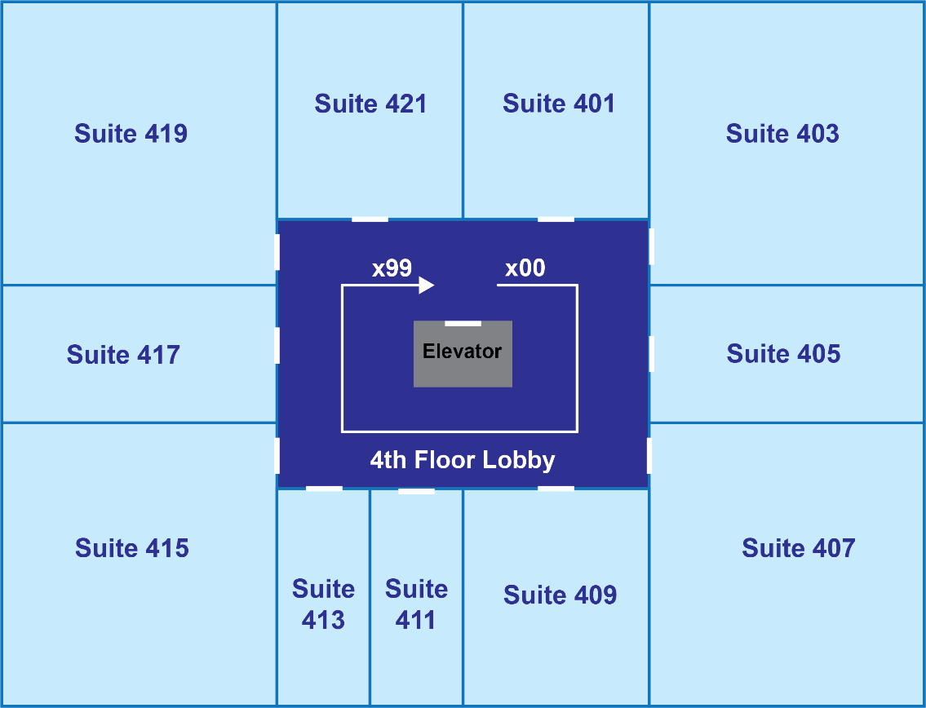
Figure 18: Occupancy Addressing

Non-Residential Occupancies

The numbering of non-residential occupancies in structures such as office buildings, strip malls, shopping centers, schools, churches, and other large public or semi-public facilities can be challenging. The tenants in many non-residential settings are much less permanent than those in residential apartments, and the configuration of space on a floor of an office building, or in a strip mall, may change rather frequently. However, from the standpoint of emergency response, it is critical to uniquely identify every separate subaddress within these types of structures, and to provide clear guidance by consistent addressing practice.

Proposed units or suites must be clearly shown on building plans submitted for construction permits. The final suite layout for an entire structure may not be known at the time a building or building shell permit is requested, particularly in structures such as office buildings and high-rise structures where suites are created as space is leased to tenants. However, the proposed suites must be shown for addresses to be assigned and will be required when a permit is requested for any interior space, floor, or suite. This includes any permits for renovation or reconfiguration of existing spaces so that existing subaddresses may be verified and corrected if necessary.

When reviewing the plans for non-residential structures designed for multiple occupancies, the Addressing Coordinator shall work with the owner to determine the minimum size of a space that will be created for a tenant and identify the total number of spaces that could be created on each floor.

Each floor must be addressed from the same starting point (usually the front of the structure or primary access stairwell or elevator) and shall have even or odd numbers on the right and left side of the hall (as established in the local addressing ordinance) facing in the direction that the numbers increase. It is preferable that the numbers increase in a direction that is similar to the direction in which numbers increase along the street frontage of the building

Each building within a non-residential complex shall have its own address, using the name of the internal street (whether public or private). Each unit or interior space shall have its own unit number.

Unit numbers should reflect the floor level as a part of the number. Units on the first floor should be numbered as 1xx, second floor as 2xx, etc. Basement level units should be numbered as XX. Building with more than one basement level or sub-basements, should use an identified beginning with “B” followed by the basement level identifier (e.g., B-1, B-2, etc.) and additional numbers for units on each of the levels, “B101”, “B206,”where the B1 or B2 represent the basement level, and the 2 (or more) remaining digits represent the unit identifier.

An imaginary centerline can be used within a building to assist with determining the internal suite addressing scheme. This may be helpful in complex structures with multiple hallways and internal intersections.

All rooms should be numbered, including rest rooms, utility closets, laundries, storage rooms, electrical closets, break rooms, etc.

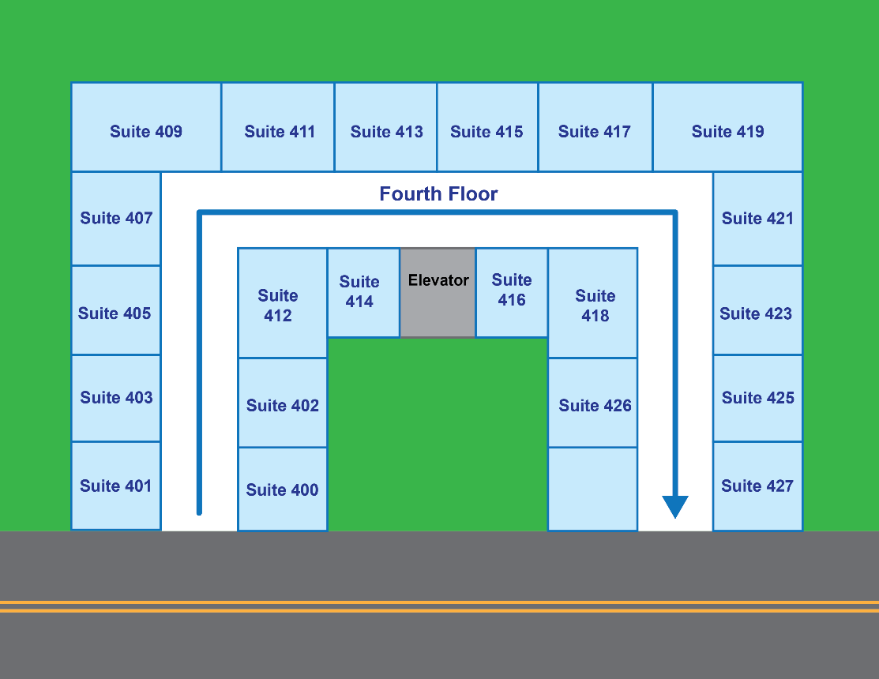
Figure 19: U-Shaped Building Occupancy Addressing

Subaddress Types

The Subaddress Type is a word used to identify the type of space or location being addressed. These include building, unit, apartment, suite, space, pier/dock, floor, wing, stairwell, and other similar terms. In certain cases, a subaddress type is not used, such as for a mezzanine or penthouse. These terms are used in place of a letter or number in the subaddress identifier.

Subaddress Identifier

The subaddress identifier is a letter, number, or a combination of letters and numbers that uniquely identify a specific tenancy or space within a multi-tenant building or use.

In some jurisdictions, only numbers may be used as the subaddress identifier. In some cases, specific words are used, without a subaddress type, such as Mezzanine and Penthouse. Existing alphabetic or combination subaddresses may remain in use. This is a local decision.

Basements, Mezzanines, and Penthouses

Some buildings contain floors that are not identified by numbers, such as basements, sub-basements, mezzanines, and penthouses. These can utilize a form of the subaddress that consists of only a subaddress identifier (e.g., 500 Boundary Street, Mezzanine).

Basements that contain multiple rooms or occupancies shall be identified by a subaddress type and identifier for each space. Similarly, mezzanines, penthouses, lofts or other named areas may function as Subaddress Types, and subareas of those named spaces may be given numbers to identify them using the name as the Subaddress Type. For example, Penthouse 2, or Mezzanine 104.

Signage

Signs indicating the suite numbers for each floor and the direction from the elevator or access stairs shall be placed in all multi-tenant buildings on each floor.

Suites and apartments shall have their numbers posted in accordance with local addressing ordinances on or immediately above or to the side of the main door. Additionally, each building shall have a number prominently displayed.

The local department or agency responsible for signage must ensure that this signage is available at the time the first certificate of subaddress occupancy is issued for any building within the complex.

Landmark Addresses

The FGDC Address Data Standard describes numerous classes of addresses. While “thoroughfare,” or street addresses, are the most common, many places within the community are identified by a name. While these locations may also have a thoroughfare address, it is important to many address consumers and users to be able to locate a feature, when the description does not include a street-type address.

Emergency dispatchers often receive calls that cannot provide an address number or even a street name, and response may be delayed by this. Many emergency dispatch systems maintain a “common place” file listing these landmark type addresses, and their equivalent thoroughfare address.

Landmark class addresses as defined in the FGDC Standard include names of buildings, campuses, and other features that are locally identifiable by a name, such as a school, church, shopping center, apartment complex or office building. Many public buildings and places of assembly, such as arenas, theaters, museums, etc., also fall within this classification. Park features may also be included, such as picnic shelters, playgrounds, or other facilities. These names and their locations, and relationship to a thoroughfare address should be maintained in the Address Repository.

Addressing Workflows

Addressing workflows provide a clear set of steps for the assignment of, change of, and retirement of street names and addresses and their component elements. The examples shown below may serve as starting points for local governments to create their own. Additional workflows are needed for changing an existing address or street name, retiring an address, and other less common practices.

New Address

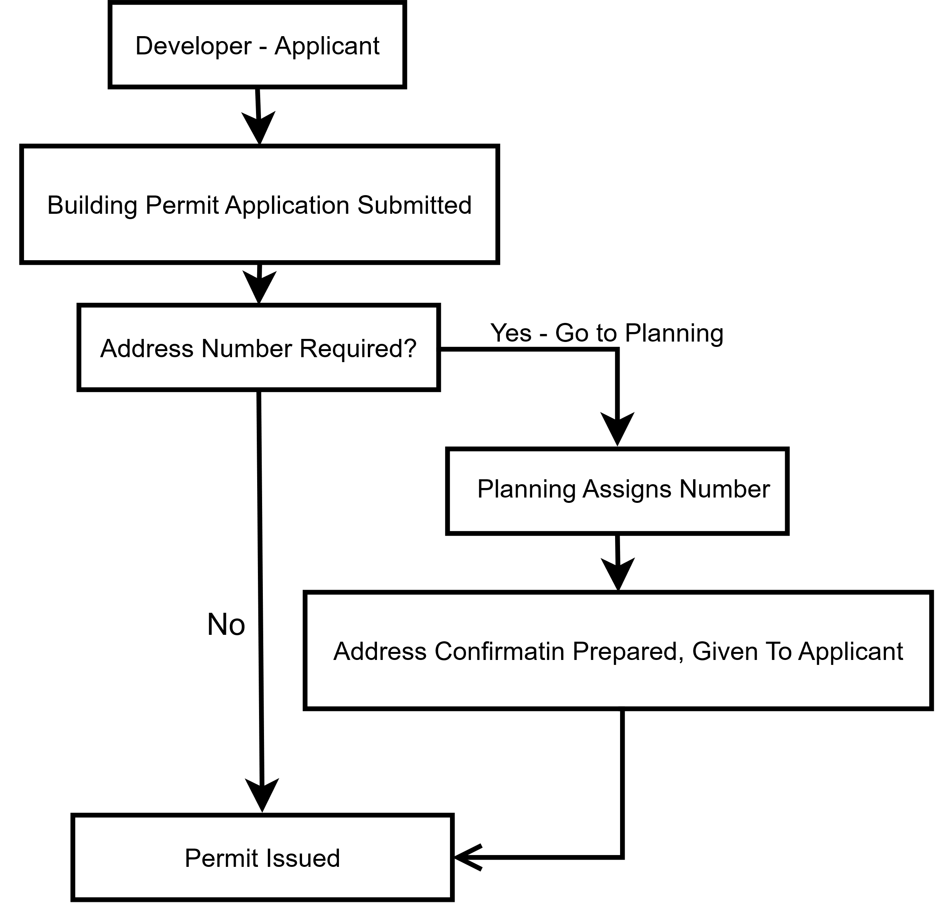

Figure 20: Example of Address Assignment Workflow

New Street

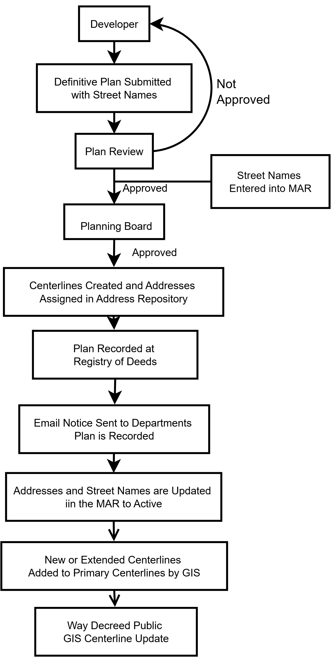
Figure 21: Example of New Street Name Workflow

Data Management

Data management includes the technical information about the database and GIS environment in which address data are stored and maintained. This is provided when a community’s addresses are organized and housed within a digital system. These systems vary significantly, depending on the software in use, the user requirements and capabilities.

The State of New Mexico may provide database schemas for use by local governments in managing their address data. Specific tools are available that simplify address maintenance in GIS and database environments. They are based on the rules contained in this document, and other local parameters determined by the local entity.

This section will be expanded at a later date to reflect the address management and maintenance protocols, at both the state and local levels, that are being used.

- Application for New Address

TEMPLATE
Application for New Address
--- Last updated 4/28/2025 ---
Click or tap here to enter text.

Application for Assignment of New Address(es) or Street Name(s)

APPLICANT
Name of Applicant:
Address (Mailing)
Company Name (if applicable):
Address Number, Street Name or PO Box :
Suite/Unit Number (if applicable):
City, State, ZIP:

PROPERTY OWNER
Name of Applicant:
Address (Mailing)
Company Name (if applicable):
Address Number, Street Name or PO Box :
Suite/Unit Number (if applicable):
City, State, ZIP:

PROPERTY IDENTIFICATION
Assessor’s Property Identification:
Subdivision Plat Approval identifier:
Name on Site or Subdivision Plan:
Other information to identify location:

Attachments (Describe) | File Name

For Departmental Use Only:

Action | Date | Reviewer | Comments
Received:
Reviewed for street names:
Street names approved:
Address ranges completed:
Potential points created and QC’d:
Reviewed with applicant:
Revisions submitted (if applicable):
Revisions reviewed:
Approval/Denial:
Distribution to List (see below):

Documents | Status | File Name
Approved plan:
Written comments:
Other documents (specify):

Distribution List: (names of departments, email of individual to receive this information. This should include Police, Fire, EMT, Assessor, Planning, Utilities, Public Works, Elections, Schools, Courts, Parks/Recreation, Waste Management, Post Office, etc. as locally appropriate.)

- Application for Address Change

TEMPLATE

Application for Address Change

--- Last updated 4/28/2025 ---

Click or tap here to enter text.

Application for Change of Address or Street Name – Property Owner Request

Application #: | Date Submitted: | Accepted for Review Date:

Instructions: A single point of contact should be provided for this request. If more than one property owner is affected by this Application, all those affected MUST be listed on the form.

APPLICANT
Name of Applicant:
Address
Company Name (if applicable):
Address Number, Street Name:
Suite/Unit Number (if applicable):
City, State, ZIP:

AFFECTED PROPERTY OWNER(S)
(If more than one, please use additional sheets to provide information for reach)
Name:
Address (Mailing)
Address Number, Street Name, or PO Box:
Suite/Unit Number (if applicable):
City, State, ZIP:

PROPERTY IDENTIFICATION
Assessor’s Property Identification:
Subdivision Plat Approval identifier:
Name on Site or Subdivision Plan:
Other information to identify location:

Attachments | File Name(s)
Map of location showing affected property and structures:
Written justification for the change of address number(s):
Documents from other property owners supporting or objecting to change:

For Departmental Use Only:

Action | Date | Reviewer | Comments
Received:
Request reviewed:
Street name correct?
Address range( s) checked:
Address number requested is allowed by ARS rules: |  |  | (i.e., parity, sequence of numbers, and other considerations)
Reviewed with applicant:
Revisions submitted (if applicable):
Revisions reviewed:
Approval/Denial:
Distribution to List (see below):

Documents | Status | File Name
Approved map showing change:
Written comments:
Other documents (specify):

Distribution List: (names of departments, email of individual to receive this information. This should include Police, Fire, EMT, Assessor, Planning, Utilities, Public Works, Elections, Schools, Courts, Parks/Recreation, Waste Management, Post Office, etc. as locally appropriate.)

- Application for Street Name Change
TEMPLATE
--- Last updated 4/28/2025 ---
Application for Street Name Change

Click or tap here to enter text.

Application for Change of Street Name(s)

APPLICANT
(Single point of contact for those promoting street name change)
Name of Applicant:
Address (Mailing)
Company Name (if applicable):
Address Number, Street Name or PO Box:
Suite/Unit Number (if applicable):
City, State, ZIP:

PROPERTY OWNER – Must have property abutting or accessed from street in question
(If there are more owners, please provide the additional names and information on a separate sheet.)
Name:
Present address (Number/Street Name)
Address (Mailing):
Address Number, Street Name, or PO Box:
Suite/Unit Number (if applicable):
City, State, ZIP:
PROPERTY OWNER
Name:
Present address (Number/Street Name)
Address (Mailing):
Address Number, Street Name, or PO Box:
Suite/Unit Number (if applicable):
City, State, ZIP:
PROPERTY OWNER
Name:
Present address (Number/Street Name):
Address (Mailing):
Address Number, Street Name, or PO Box:
Suite/Unit Number (if applicable):
City, State, ZIP:
PROPERTY OWNER
Name:
Present address (Number/Street Name)
Address (Mailing):
Address Number, Street Name, or PO Box:
Suite/Unit Number (if applicable):
City, State, ZIP:

Present Name of Street:
Proposed New Name of Street:
Total segments of Street:
Segments to be Renamed:
Justification of Renaming:

Attachments | File Name
Map showing location of street:
Support or Objection Letters:
Additional justification or reason for renaming:

For Departmental Use Only:

Action | Date | Reviewer | Comments
Received:
Reviewed for compliance with ARS Rules: |  |  | (e.g., not a duplicate, sound-alike, offensive, meets other defined rules)
All of street being renamed?
Proposed name is acceptable to Click or tap here to enter text.% of affected owners: |  |  | Written confirmation from owners
Extent of change is correctly identified on maps:
Address ranges confirmed:
Renumbering done if needed:
Approval/Denial:
Distribution to List (see below):

Documents: | Status | File Name
Approved plan map:
Written comments:
Other documents (specify):

Distribution List: (names of departments, email of individual to receive this information. This should include Police, Fire, EMT, Assessor, Planning, Utilities, Public Works, Elections, Schools, Courts, Parks/Recreation, Waste Management, Post Office, etc. as locally appropriate.) Street Signs need to be changed, notify Sign Shop or other agency that makes and installs street signs.

All property owners affected by the change should be notified by mail and email of the change with an official letter (template provided).

- Address Change Notification
TEMPLATE
--- Last updated 4/28/2025 ---
Address Change Notification

Click or tap here to enter text.

Notice of Address Number or Street Name Change

Click or tap to enter a date.

Dear Resident:

This is to notify you, as the property owner of property previously addressed as Click or tap here to enter text., Click or tap here to enter text., New Mexico, that the address and/or street name identifying your property has been changed.

Your new address is Click or tap here to enter text.
It will be effective as of Click or tap here to enter text.

We have notified all Click or tap here to enter text. departments of this change, as well as the U.S. Post Office, and public utility companies serving this area. Please be sure to let your personal correspondents know of this change so that your mail and packages can be delivered correctly.

If you have any questions about this change, please contact Click or tap here to enter text. at Click or tap here to enter text. or Click or tap here to enter text..

Thank you.

Click or tap here to enter text.
Click or tap here to enter text.
Click or tap here to enter text.

- Addressing MOU Overview
--- Last updated 4/28/2025 ---

Addressing MOU Overview

Memorandums of Agreement between Counties, Municipal Governments, Tribal Governments, Regional Governments, State of New Mexico, or other providers/recipients of address data (geographic or tabular) for Mutual Management of Street Address Data

The outline below identifies the content that should be incorporated into the agreements between municipal, county and tribal governments for the provision of address-related data. Not every provision of this outline is required, and the parties to such Memoranda of Agreement (MOA) should review carefully those which a relevant to a specific agreement. Any proposed MOA should be reviewed by the attorneys for the jurisdictions involved to ensure compliance with local and state law and regulations.

Address data is created under many different procedures and processes, and for a variety of purposes. For the most part, the lowest level of government (usually a city, town or similar entity) is responsible for addressing property within their jurisdiction. However, many smaller municipalities do not have staff or capabilities to manage this process or the data and mapping that accompany it. They cede their authority to the County in which they are located. Increasingly, counties are working through regional governments or councils to support the Next Generation 911 requirements.

Likewise, address data is used by virtually every department of a local government, and thus requirements for cooperative agreements among governments should not limit or prescribe a set of standards that may not work well with other users’ needs. While it is possible to create an agreement to share only a specific set of data under a set of rules that is peculiar to that set of data (for example 911 addresses under NENA standards and protocols), this may limit the usefulness of the data to other users who could benefit from the data sharing at very little additional cost.

It is also critical to think about matters of access to the data by both parties, security and privacy issues, costs for managing and maintaining the data (software, hardware/cloud space, personnel, etc.) and expectations as to the condition of the data, accessibility (24/7 or business hours only, or another requirement), liabilities, upgrades, etc.

- Purpose/intent of agreement
- Parties to the agreement
  - Territorial boundaries: who does what within what boundaries?
    - City limits
    - Extraterritorial jurisdictions or spheres of influence
    - Special purpose districts (Fire, Schools, Water, etc.)
    - Tribal entities
- What is to be shared? (Definitions)
  - Data: what data, and in what form
  - Systems: what is the system (database, GIS, other)
    - System software (operating)
    - System software (for address management)
    - Application tools
    - Connectivity to other business applications (beyond 911)
  - Who are the intended users?
    - Is data available to users within each organization, or are there limitations?
    - Does data only flow from municipal government to county or does it go both ways.
  - What software licenses are required?
    - GIS
    - Database
    - Web tools
    - Maintenance or other business applications
  - Who owns or licenses the above software?
    - How does the other party utilize that software/platform?
    - What impact on licenses?
- Where is data stored? (cloud, servers, etc.)
  - Cost responsibility
  - Connectivity to data
- Security and privacy
  - Protection from data loss, ransom, denial of service
  - Data content structure and protection from disclosure of personally identifying information
- Costs of the system
  - Who pays for what?
- What about changes to systems on either side?
  - Software updates
  - Changes in business applications that get address data from an MOU partner
- What are the expectations as to the operational environment?
  - Outages
  - Upgrades
  - Enhancements or extensions of services
  - Up-time
  - Backups and storage capabilities
  - Notification procedures in case of outages, upgrades or other issues
    - Contact information for both parties
- What is the duration of the agreement?
  - Annual renewal, or longer period
- The usual contract provisions
  - Liability
  - Insurance or indemnification
  - Force majeure
  - Severability
  - Termination
  - Remedies
  - Etc.

Sample MOA’s are attached to this document. Again, they provide some “boiler-plate” language that should be reviewed for conformance to State and local codes and regulations. One document provides for services to be provided by a jurisdiction to a neighboring jurisdiction without cost, just a free exchange of data with both parties benefitting. The second document is more complex, providing for fees for the services provided from one jurisdiction to another. Multi-party agreements may also be created, especially by regional entities that have capacity to assist a group of constituent governments that are too small, or have scant population to fulfill needs for critical data sets, especially for regional NG-911 operations, or other specific needs. A general purpose MOA, with several participants is an efficient way to ensure consistency across a larger area.

- Basic Addressing MOU
TEMPLATE
--- Last updated 4/28/2025 ---
Basic Addressing MOU

NOTES: This is a fairly simple MOU between two parties (perhaps a county and a municipality or tribal government), in which one government (Party 1) has the capabilities, expertise and personnel to perform certain GIS and data-related addressing functions, and the other (Party 2) does not, but can supply information needed for PSAP operations, or other governmental functions of both Parties. It is not contemplated in this MOU that any money would be paid by either party to the other. As always, a MOU should provide clear information about 1) the parties involved, 2) the purpose of the engagement, 3) the activities to be performed by each party, 4) costs, if any, to be paid by either party, 4) conditions of the agreement, including term of agreement and renewal, termination process, and legal items needed by local and/or state law.

THIS AGREEMENT is entered into between Click or tap here to enter text. and Click or tap here to enter text..
WHEREAS, the Local Government Division, State of New Mexico, provides funding to regional Public Safety Answering Points (PSAPs) to provide Enhanced 911 Landline service and Wireless Phase I and Il service. This includes components such as upgraded addressing, equipment, and GIS databases and training;
WHEREAS, Click or tap here to enter text. provides Click or tap here to enter text. with Click or tap here to enter text..
WHEREAS, Click or tap here to enter text. uses Addressing, Geographical Information Systems (GIS), mapping, Master Street Address Guide (MSAG) information and updates from its Click or tap here to enter text.; and

NOW THEREFORE, the parties hereby agree as follows:
1. Scope of Agreement:
- Develop and maintain a GIS addressing database;
- Click or tap here to enter text. will provide to Click or tap here to enter text.’s rural addresser updated GIS addressing and MSAG database information on a timely basis;
- Both parties shall work towards maintaining the joint MSAG at a 96% accuracy rate;
- Click or tap here to enter text. shall provide to Click or tap here to enter text.’s rural addresser the point of contact (name, address, number, phone, fax, e-mail) for GIS, PSAP and any other personnel handling address and MSAG updates and;
- Click or tap here to enter text. shall confirm all changes in Click or tap here to enter text.’s data that are to be reported to the regional PSAP for confirmation prior to providing them to the regional PSAP or any other agency. Click or tap here to enter text. shall confirm the correctness of such data within Click or tap here to enter text. business days from receipt from Click or tap here to enter text..
- Sign a nondisclosure agreement as needed.
- Term: This agreement may be modified by written mutual consent of the parties. This agreement may be terminated by either of the parties upon thirty (30) days prior written notice to the other parties. This agreement will become effective on the date all parties have signed. Upon termination, all obligations incurred under this Agreement shall terminate.
- Property: Property as used in this Memorandum of Agreement means the GIS database that will be used to update MSAG and mapping used for the purpose of responding to landline and cell emergency phone calls.
- Appropriations: Performance under this Agreement is contingent upon sufficient authority and appropriations granted by the New Mexico State Legislature.
- Governing Law: This Agreement shall be governed by the laws of the State of New Mexico.
- Non-Disclosure Agreement: Parties to this agreement will be abide by the terms of the Mutual Non-Disclosure Agreement entered into and executed on the same date as this memorandum of agreement this Click or tap here to enter text. and attached as Exhibit A.

IN WITNESS WHEREOF, the parties have executed this Agreement as follows:

Click or tap here to enter text.
Name:
Title:
Date:
Notary (if required):

Click or tap here to enter text.
Name:
Title:
Date:
Notary (if required):

- Complex Addressing MOU
TEMPLATE
--- Last updated 4/28/2025 ---
Complex Addressing MOU

Note: This outline provides for a specific scope of work being provided by one jurisdiction to another. In using this template, it is important to determine exactly which services and data each party will provide, and how this will work. That, in turn, gives the two entities sufficient information on which to base the cost arrangements that must be included in each one’s budget. The tasks should be spelled out, and invoicing between the two jurisdictions should provide clear understanding of time spent on each of the tasks specified in the MOU. These may change from time to time.

AGREEMENT TO PROVIDE GIS ADDRESSING SERVICES
FOR THE Click or tap here to enter text.

BETWEEN

Click or tap here to enter text.
AND
Click or tap here to enter text.

THIS AGREEMENT is entered into by and between Click or tap here to enter text. (hereinafter “Party 1”) and Click or tap here to enter text. (hereinafter “Party 2”) referred to collectively as the (“parties”).

I. RECITALS

WHEREAS, Party 1 and Party 2 are a bodies corporate and politic existing by and under the Constitution and Laws of the State of New Mexico; and,

WHEREAS, the administration of an accurate and current Geographical Information Systems (GIS) addressing system is necessary for the operation of emergency services; and,

WHEREAS, Party 1 administers a GIS rural addressing system, which includes, software, hardware and employees; and,

WHEREAS, Party 2 currently does not have a GIS system or hardware, data and/or employees to manage these systems; and

WHEREAS, the State of New Mexico 9-1-1 Rules and Regulations require that the 9-1-1 databases, including the Master Street Address Guide (MSAG) and Automatic Location Identifier (ALI) be maintained at each Public Safety Answering Point (PSAP) at a 96% or higher accuracy rate; and,

WHEREAS Party 1 and Party 2 have agreed to share resources in order to protect the citizens of the County by ensuring that the citizens of Party 2 are able to be served by emergency services.

NOW THEREFORE the parties hereby agree as follows:

II. AUTHORITY

Is the power to “protect generally the property of its municipality and its inhabitants” and to “preserve peace and order” and, “provide for the safety, preserve the health, promote the prosperity and improve the morals, order, comfort and convenience of … its inhabitants”. See NMSA 1978, § 3-18-1 (1972) and NMSA 1978, § 4-37-1 (1995)

III. SCOPE OF DUTIES

PARTY 1 SHALL

- Bring Party 2’s E-911 road centerline file up to date for use by Party 1s Regional Dispatch Authority for dispatch of Emergency Responders.

- Maintain Party 2’s Master Street Atlas Guide which includes:

  - Plotting or GPS any new roads in the GIS centerline road file and entering this information into the E-911 System.
  - Making any corrections to the E-911 address and telephone records as necessary and submitting corrections with the approval of Party 2.
  - Making the necessary corrections to the address road ranges in the GIS System as determined by Party 2.
  - Plotting any new addresses as assigned by Party 2 into the GIS system.
  - Correcting any spatial errors that may exist based on monthly error reports received from Earth Data Analysis Center (EDAC) & the DFA E-911 Program Director.
  - Providing for accuracy of GIS and GPS data for Wireless E-911 calls.

PARTY 2 SHALL

- Pay to Party 1 the sum of Click or tap here to enter text. per hour for the services described herein.
- Make payment to Party 1 upon invoice for services rendered monthly while this agreement is in effect.
- Provide to Party 1’s rural addresser updated GIS addressing and MSAG database information on a timely basis.
- Work towards maintaining the MSAG at a 98% accuracy rate.
- Provide to Party 1 rural addresser the point of contact (name, address, phone, fax, e-mail) for GIS, PSAP and any other personnel handling MSAG updates.
- Sign a non-disclosure agreement as needed.

IV. TERM
This Agreement becomes effective upon signature by all parties hereto and shall remain in effect for three (3) years or until it is terminated pursuant to the terms of this Agreement.

V. PROPERTY
No property shall be acquired as a result of this Agreement and the disposition of records generated by performance of this agreement shall be decided by the parties upon termination.

VI. STRICT ACCOUNTABILITY OF ALL RECEIPTS AND DISBURSEMENTS
Each party shall be strictly accountable for all receipts and disbursements under this Agreement.

VII. AMENDMENT
This Agreement shall not be altered, modified, or amended except by an instrument in writing executed by both parties hereto.

VIII. ASSIGNMENT
This Agreement may not be assigned by either party hereto without the advance written consent of the other party, which consent may be withheld at the other party’s sole and absolute discretion.

IX. GOVERNING LAW
This Agreement and the rights of the parties hereto shall be governed by and construed in accordance with the Laws of the State of New Mexico.

X. SEVERABILITY
If any provision of this Agreement, or the application of such provisions to any person or circumstances shall be held invalid or unenforceable by a court of competent jurisdiction, the remainder of this Agreement, or the application of its provisions to persons or circumstances other than those to which it is held invalid, shall not be affected thereby and the remainder of this Agreement can be performed in substantial accordance with the original intent of the parties hereto.

XI. INTEGRATION OF AGREEMENT
This Agreement incorporates all of the agreements and understandings between the parties hereto concerning the subject matter hereof, and all such agreements and understandings have been merged into this written Agreement. No prior agreements or understandings, verbal or otherwise, of the parties or their agents are valid or enforceable unless embodied in this Agreement.

XII. NEW MEXICO TORT CLAIMS ACT
By entering into this Agreement, each party agrees that it shall be responsible for liability arising from personal injury or damage to property occasioned by its own agents or employees in the performance of this Agreement, subject in all cases to the immunities and limitation of the New Mexico Tort Claims Act (NMSA 1978, Section 41-4-1, et seq.) and any amendments thereto. This section is intended only to define the liabilities between the parties hereto and it is not intended to modify, in any way, the parties’ liabilities as governed by common law or the New Mexico Tort Claims Act. The parties and their “public employees,” as defined in the New Mexico Tort Claims Act, do not waive sovereign immunity, and do not waive any defense or limitations of liability pursuant to law. No provision in this Agreement modifies and/or waives any provision of the New Mexico Tort Claims Act.

VII. PRIVILEGES, EXEMPTIONS , AND IMMUNITIES
All privileges and immunities from liability, exemptions from laws, ordinances, and rules, which apply to the activity of officers, agents, or employees of any signatory public agency when performing their respective functions within the territorial limits of their respective public agencies, shall apply to them to the same extent while engaged in the performance of any of their functions and duties under the provisions of the Agreement.

XIII. TERMINATION OF AGREEMENT
This Agreement may be terminated by either party upon ninety (90) days written notice delivered to the other.

XIV. CONTACT AND NOTICES
The parties may, from time to time, change their contact person and shall provide prompt notice of such change to the other party. Any notice required under this Agreement shall be deemed given and delivered to, and received by, the receiving party three (3) days after deposit in the U.S. mail, certified mail, return receipt requested, postage prepaid, addressed to the receiving party at the mailing address set forth below:

Party 1’s contact person name and mailing address:
Name: Click or tap here to enter text.
Title: Click or tap here to enter text.
Address: Click or tap here to enter text.
City, State, ZIP: Click or tap here to enter text.
Telephone No: Click or tap here to enter text.

Party 2’s contact person name and mailing address:
Name: Click or tap here to enter text.
Title: Click or tap here to enter text.
Address: Click or tap here to enter text.
City, State, ZIP: Click or tap here to enter text.
Telephone No: Click or tap here to enter text.

XV. APPROPRIATIONS
Performance under this agreement is contingent upon sufficient authority and appropriations.

IN WITNESS WHEREOF, the parties have executed this Agreement which becomes effective as of the date of approval by all parties.

PARTY 1

APPROVED, ADOPTED, AND PASSED on this Click or tap here to enter text. day of Click or tap here to enter text., Click or tap here to enter text..

________________________________
Click or tap here to enter text.
Click or tap here to enter text.

________________________________
Click or tap here to enter text.
Click or tap here to enter text.

Attest:

________________________________
Click or tap here to enter text.

PARTY 2

APPROVED, ADOPTED, AND PASSED on this Click or tap here to enter text. day of Click or tap here to enter text., Click or tap here to enter text..

________________________________
Click or tap here to enter text.
Click or tap here to enter text.

________________________________
Click or tap here to enter text.
Click or tap here to enter text.

Attest:

________________________________
Click or tap here to enter text.

- Addressing Ordinance
TEMPLATE
--- Last updated 4/28/2025 ---
Addressing Ordinance
Article Click or tap here to enter text.: Address Numbers and Street Names

Sec. Click or tap here to enter text.-1. – Purpose of Article

The purpose of this Article is to establish a procedure for the assignment or reassignment of address numbers and street names for property located within the jurisdiction of Click or tap here to enter text..

Sec. Click or tap here to enter text.-2. – Definition

Street is defined to include road, drive, access easement, driveway, right-of-way access area, alley, highway or thoroughfare.

Thoroughfare is defined as a linear feature that provides access to properties, structures and other features on the landscape.

Address is the combination of a set of numbers (one or more), a street name, and a place name (including the local place name, state name and ZIPCode).

Subaddress consists of a subaddress type word or words and subaddress identifier (numbers, letters or a combination of both) that uniquely identify a separately occupied portion of a building or an individual building or structure on a property with a single address and multiple buildings thereon.

Sec. Click or tap here to enter text.-3. – Scope of Article

The scope of this Article shall include the assignment or reassignment of all official address numbers and street names to residential, nonresidential, and other improved and unimproved property, within the boundaries of Click or tap here to enter text.. This will include assignment of unit/suite/apartment numbers for multi-occupant buildings. It shall not include the assignment of parcel identification numbers to real estate.

Sec. Click or tap here to enter text.-4. – Role of the Addressing Coordinator

The Addressing Coordinator, appointed by the Click or tap here to enter text., shall be responsible for the assignment and notification of all new street names and address information. The Addressing Coordinator shall also be responsible for facilitating changes to existing street names, address numbers and subaddresses, when necessary.

- Assignment of address numbers. The Addressing Coordinator shall assign or reassign official address numbers in accordance with this Article.

- Street naming. The Addressing Coordinator shall be responsible for researching, verifying and recommending to the Click or tap here to enter text. the official name, type and directional for streets within the jurisdiction of this Article.

- Database development and maintenance. The Addressing Coordinator shall be responsible for the maintenance of the Master Address Repository (MAR). This MAR shall contain the address numbers, street names, and subaddresses which have been assigned to parcels of land, buildings and their internal occupancies, or other facilities.

- Addressing & Street Naming Manual. The Addressing Coordinator shall be responsible for maintaining the Addressing & Street Naming Manual that sets forth the Address Reference System rules and other guidelines for the assignment of address numbers, street names, and subaddresses throughout the jurisdiction of this Article. The Manual may be derived from New Mexico’s 911 Addressing Manual and may be amended from time to time by the Addressing Coordinator to reflect new land use patterns, changes in addressing conditions and other changes as necessary.

Sec. Click or tap here to enter text.-5. – Address Reference System.

Coordinate grid established. Address number assignments or reassignments shall be based on coordinate systems established within Click or tap here to enter text.. These are the base lines for the purpose of address number assignment and determining whether a street directional is necessary. A directional is used for streets that cross the aforementioned north/south or east/west meridians.

Each street running east and west, or substantially in that course, shall, for the purpose of numbering under this section, begin at the north and south side of the north/south meridian, as the case may be, with number one, increasing east and west from such initial point to the corporate limits of the county, as they now exist or may hereafter be extended.

Each street running north and south, or substantially in that course, shall, for the purpose of numbering under this section, begin at the east and west side of the east/west meridian, as the case may be, with number one, increasing north and south from such initial point to the corporate limits of the county, as they now exist or may hereafter be extended.

Sec. Click or tap here to enter text.-6. – Addressing format.

Address format established. All addresses shall comply with the Federal Geographic Data Committee (FGDC) United States Thoroughfare, Landmark, and Postal Address Data Standard. Each address shall at a minimum be comprised of the following elements, in the following order:

- Address number, conforming to the Address Reference System coordinate grid;
(2) Directional prefix, as necessary, based upon the Address Reference System;
- Street name, conforming to this Article and the Addressing & Street Naming Manual;
- Street type, conforming to the list maintained in the Addressing & Street Naming Manual;
- Subaddress type, as necessary, and conforming to the Addressing & Street Naming Manual;
- Subaddress identifier, as necessary. The subaddress identifier may be comprised of letters, numbers or a combination of the two.

Sec. Click or tap here to enter text.-7. – Street naming standards.

(a) Street names required. Street names are required for planned or existing public or private streets, or for alleys and driveways which serve as the primary means of ingress or egress for two (2) or more buildings or other facilities subject to the rules defined in the Addressing & Street Naming Manual

(b) Signage. All named streets shall be properly marked with signage in accordance with the Addressing & Street Naming Manual.

Sec. Click or tap here to enter text.-8 – Address assignment.

The Addressing Coordinator shall assign or reassign to each vacant parcel, residential or nonresidential building, structure or facility, and each individual occupiable area within any such building or structure an address number or subaddress in accordance with this Article and the Addressing & Street Naming Manual. The Addressing Coordinator shall assign or reassign addresses based on the Address Reference System established and described in Section Click or tap here to enter text.-5 of this Article.

Sec. Click or tap here to enter text.-9 Display of address numbers.

Required address display format. Every owner of a property with a house, building or other structure shall affix to the house, building or other structure and display at all times the official address number assigned or reassigned to such property pursuant to this Article at a place visible from the street on which the property fronts. All address numbers shall be displayed numerically in Arabic numerals and shall not be spelled as words. Whenever new official numbers are assigned or reassigned, they shall be displayed pursuant to the provisions of this section by the owner within thirty (30) days following the notification of such assignment or reassignment.

(1) Size and location of numbers.
a. Single family residential. The official address number affixed to any house, building or other structure shall not be less than four (4) inches in height with a minimum stroke width of 0.5 inch. All official address numbers affixed to any residential structure shall be displayed within three (3) feet of the front entrance and shall be readable from the street. If the front door is inset under a porch roof or overhand, required address numbers shall be affixed to that portion of the street-facing façade that is closest to the street.

b. Multi-family residential units. Official address numbers, letters or other designations on individual units within multifamily residential buildings shall not be less than four (4) inches in height with a minimum stroke width of 0.5 inch, and shall be displayed within three (3) feet of the front entrance of each unit, and shall be readable from the street. The building number on any multifamily building shall be at least six (6) inches in height with a minimum stroke width of 0.5 inch and shall be placed within three (3) feet of the main entrance of the building. If the address numbers are not readable from either a public or private street or from the parking lot which serves the building, the address number shall be additionally posted on the street-facing end of the building. In these instances, if the address number is out of sequence with those on the street on which it is posted, both the address number and street name must be posted to avoid confusion.

c. Nonresidential units. Official unit numbers, letters or other designations on individual nonresidential units in buildings containing multiple units shall not be less than four (4) inches in height with a minimum stroke width of 0.5 inch, and shall be displayed within three (3) feet of the front entrance of each unit, and shall be readable from the public or private street. The building number on any nonresidential building shall be at least six (6) inches in height with a minimum stroke width of 0.5 inch and shall be placed within three (3) feet of the main entrance of the building. If the address numbers are not readable from either a public or private street or from the parking lot which serves the building, the address number shall be additionally posted on the street-facing end of the building.

d. Historic districts. Buildings or structures located within a locally-zoned historic (H) district are exempted from the requirements of section Click or tap here to enter text.-9(a)(1) a., b., and c. Instead these buildings or structures shall display their addresses on a plaque one and one-half (1 ½) inches by four (4) inches located on the lower left corner of the building, below the name of the building or structure.

e. Structures located distant from the street on which they front. Where a house, building or other structure is located more than one hundred (100) feet from the street on which such property fronts, or the topography or vegetation of such property prevents the address numbers from being seen from the street, the assigned address numbers shall not be less than four (4) inches in height; comply with the color requirements in this section, be posted to a sign or post that is at least three and one-half (3.5) feet high and four (4) inches wide and is located no more than ten (10) feet from the intersection of the street and driveway. The placement of the assigned address number on the street curb or mailbox is permissible but may not be used to meet the requirements of this Article.

f. Color of numbers. All displays of official address numbers shall be of a contrasting color (i.e. light numbers on dark surfaces, dark numbers on light surfaces) to the color of the building or structure located on the subject property, and such displays shall be readable when illuminated.

(2) Maintenance. Following the posting of the address number as required, the owner of the property shall maintain such numbers at all times in accordance with the standards of this Article.

(3) Applicability to existing structures. Owners of all houses, buildings or other structures located on improved property within the jurisdiction of the Article as of its effective date shall comply with the provisions contained in this Article upon its adoption.

(4) Noncompliance

(a) If any property owner shall fail or refuse to comply with this Article, the director of Click or tap here to enter text. or his/her designee shall have the authority, upon five (5) days’ written notice to such owner, to initiate enforcement measures in accordance with section Click or tap here to enter text.-10.

(b) If any property owner shall fail or refuse to comply with section Click or tap here to enter text.-9 of this Article, Click or tap here to enter text. shall have the authority, after giving five (5) days’ written notice to the owner, to remove or cause to be removed any unofficial address number displayed on the property of such owner, and to properly display on such property the official address number assigned thereto, all at the expense of the owner.

Sec. Click or tap here to enter text.-10. – Violations and penalties

(a) Enforcement. The property owner shall display the assigned address in accordance with the requirements of this Article. The failure of any person, firm or corporation which is an owner of a house, building or other structure to have affixed thereto or to have otherwise displayed the official address number of such property in accordance with the standards contained in section Click or tap here to enter text.-9 of this Article shall be considered a violation of this Article and an abatable nuisance. In addition to other remedies provided by law, shall have the authority to pursue enforcement of this Article following written notice to the property owner or occupant in control of the property from the. The property owner of the property shall have five (5) days from the date of written notice to correct the deficiencies listed therein.

If the individual who received notice does not correct such deficiencies, Click or tap here to enter text. shall have authority to secure injunctions and abatement orders to insure compliance through Click or tap here to enter text..

(b) Criminal enforcement. Any person who violates this Article or any provisions thereof, shall be guilty of a misdemeanor and may be find not more than five hundred dollars ($500.00).

(c) Civil enforcement. In addition to criminal penalties, any person, firm or corporation violating any provisions of this Article shall be subject to a civil penalty of one hundred dollars ($100.00), which can be recovered by the Click or tap here to enter text. in a civil action in the nature of a debt, if the offender does not pay the penalty within a prescribed period of time after being cited for violation of this Article. No civil penalty shall be assessed until the person alleged to be in violation has been notified of the violation by Click or tap here to enter text.. Failure to correct the violation within five (5) days of the date of service of the notice, or by the end of the period of any extension, may result in the assessment of a civil penalty or other enforcement action. For good cause determined by Click or tap here to enter text., the correction period may be extended by Click or tap here to enter text.. Each day of continuing violation shall constitute a separate violation.

(d) Referral to attorneys. If payment of penalties is not received within five (5) days after written demand for payment is made, Click or tap here to enter text. may refer the matter to the local government’s attorney, who is authorized to institute a civil action in the name of the local government in the appropriate division of the New Mexico Courts for recovery of the penalty.

(e) Other relief. The Click or tap here to enter text.’s attorney may secure, on behalf of the Click or tap here to enter text., in addition to other remedies provided by law, injunctions, mandamus, abatement, or any other appropriate relief to prevent, enjoin, abate or address such unlawful action.

- Local Addressing Systems
--- Last updated 4/28/2025 ---
Local Addressing Systems

This section will contain individual descriptions of the addressing systems used by each local jurisdiction in New Mexico (ETA 2025).

1 Local jurisdictions may wish to make this rule more specific to local conditions. It is important that this rule be drafted broadly enough to encompass languages that are used in the jurisdiction or in neighboring areas. It is likewise critical that a speaker of the language in which a street name is proposed review that proposed name to ensure that it meets all the rules in this section, especially those related to offensive words, so that cultural norms and traditions are observed.
This paragraph is only needed if the jurisdiction uses the driveway as the point for addressing. If the front door or other criteria are used, this paragraph should be deleted.
This paragraph may need to be altered, based on the choice by the jurisdiction of where the address point is located. Once that decision is made, this section can be updated, and if the driveway location is not selected for the address, then Figure 6 will need to be changed as well.

