Uniform Funding Criteria Questionnaire Instructions (Tribal)
General Information………………………………………………………….1
Responses to Questions……………………………………………................2
Risk Assessment & Initial UFC Determination……………………….2
Final UFC Determination……………………………………………...3
Submission to IPDD…………………………………………………...3
Fiscal Agent Determinations per the Public Finance Accountability Act…….4
Final UFC Determination……………………………………………...4
Submission to IPDD…………………………………………………...5

General Information
- Grantee Name: entity whose audit is being reviewed
- Agency Name: administering or lead agency (Indian Affairs Department)
- Audit Year: the fiscal year of the audit being reviewed and evaluated. Do not indicate the year of the appropriation.

Questions 1-4
Read the question in the column on the left and then respond with the appropriate answer
- In the second column, highlight, bold, italicize, circle, etc. the appropriate answer to indicate the response to the question. In the third column, enter the number of points associated with the selected answer. Example:
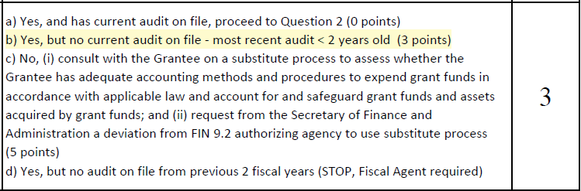

Risk Assessment and Initial UFC Determination
- Once all 4 questions have been answered and points are assigned, the “Total Points” field will be automatically calculated. Based on the risk scale, make the most appropriate “Initial UFC Determination” from the dropdown menu, add recommended special conditions or fiscal agent recommendation (if applicable), print, sign and date. Example:

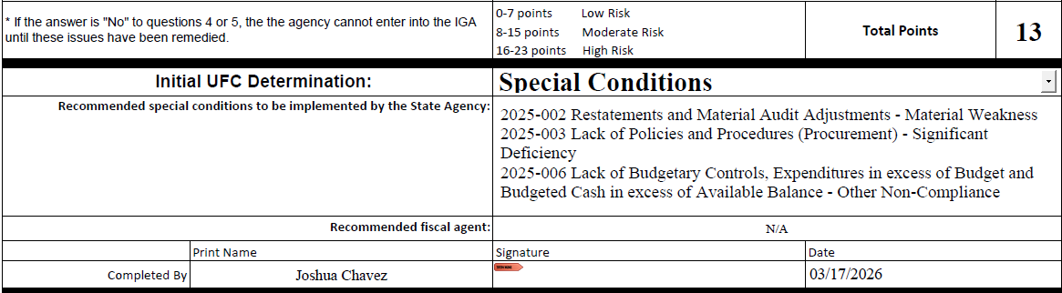

Final UFC Determination
- After the risk assessment and initial UFC determination, the form then goes to the Agency CFO for the Final UFC Determination. At the State Agency’s discretion, an individual may be assigned after the CFO to make the Final UFC Determination. Individual(s) will either:
  - Concur with the initial determination, list special conditions or fiscal agent recommendation (if applicable), print, sign and date. Example:
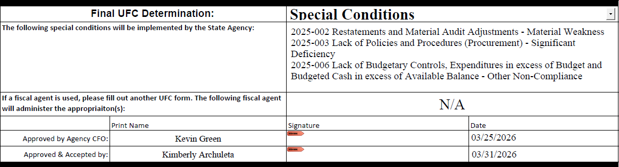
  - OR overrule the initial determination, list special conditions or fiscal agent recommendation (if applicable), print, sign and date. Example:
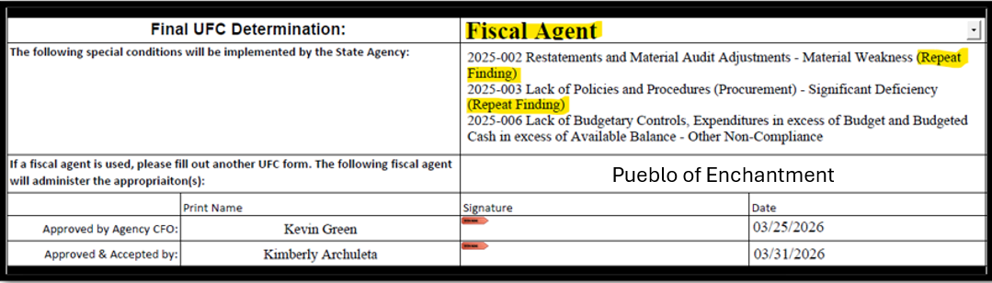

Submission to IPDD
- Once the final UFC determination has been made and is signed by the final approver, the form must be submitted to the Infrastructure Planning and Development Division (IPDD) of DFA. Submissions can be made by uploading the document into MS Teams or submitted by email to IPDD staff. Once received, IPDD staff will sign, date and upload into the share drive in MS Teams.

Fiscal Agent Determinations per the Public Finance Accountability Act
- If at any time, the appropriate response includes “STOP, Fiscal Agent Required” you do not need to add points or continue answering questions. You may skip past question 4 and change the “Initial UFC Determination” from “<Select>” to “Fiscal Agent” from the dropdown menu. Example:
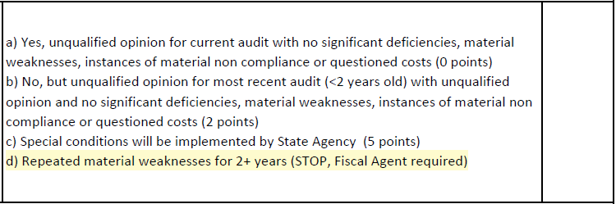
- After the determination has been changed to “Fiscal Agent,” add recommended fiscal agent recommendation, print, sign and date. Example:
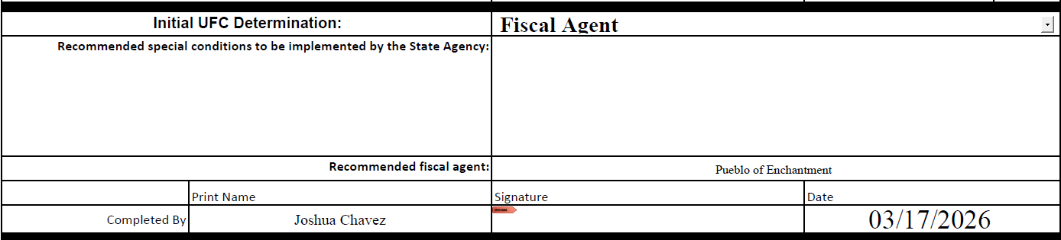
Final UFC Determination
- Then the form then goes to the Agency CFO for the Final UFC Determination. At the State Agency’s discretion, an individual may be assigned after the CFO to make the Final UFC Determination. Individual(s) will concur with the initial determination for fiscal agent, print, sign and date. Example:
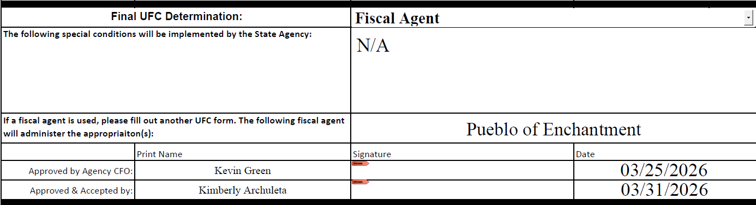
Submission to IPDD
- Once the final UFC determination has been made and is signed by the final approver, the form must be submitted to the Infrastructure Planning and Development Division (IPDD) of DFA. Submissions can be made by uploading the document into MS Teams or submitted by email to IPDD staff. Once received, IPDD staff will sign, date and upload into the share drive in MS Teams.

