Action Plan for Drought Management

Short-term Strategy

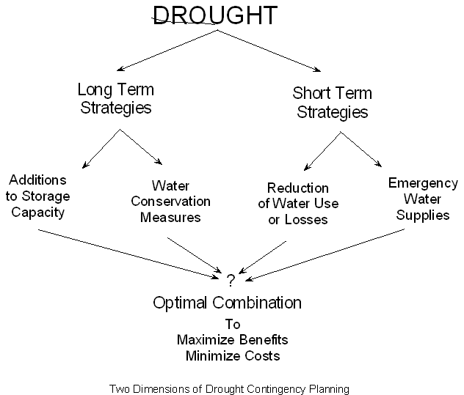

Table of Contents

Part 1. Historical Data.
Information about the community and how the water system reacted to the last known/felt drought conditions, economically how is the community impacted during a drought or dry periods.

Part 2. Water Supply System Profile
Describes infrastructure components and the condition of the infrastructure, including size, pumping capacity, limitations on production, treatment, storage and distribution of water.

Part 3. Community Profile/ Water Demand
Describes the water demand needs: how many customers, customer classes, who are the large water users, the per capita consumption, water billed versus pumped, peak demand.

Part 4. Criteria to Define Drought Situation, Actions to be Taken and Response

Part 5. Plan Implementation and Termination Procedures

Historical Data
This information is useful to learn how your community responds and is impacted by drought conditions, and to build on experience.

Description of the community, the culture, the economy,

The last time we survived a drought was in:

This is what we did:

Water System Profile

This information is useful to:
- Compare water supply under normal circumstances and present conditions.
- Learn how much water enters the system.
- Seek funding for system improvements. Funding agencies, including emergency funding programs, may ask for this information.
- Get a better response and understanding from the community. Water users need to perceive or know that the situation is critical.

Note:
If you need assistance in writing this information call your technical assistance providers at RCAC 505 – 983 5074
or email:
Blanca bsurgeon@rcac.org
Martin mlopez@rcac.org
Cynthia Crex@rcac.org

Water Supply: Surface Water

We get our water from a stream (s), spring (s), river
How many

1. Name
Serving the community drinking water needs since:
Flow Rate under normal conditions:
How is the water treated for drinking purpose:
Treatment Capacity:
Storage Tank Capacity:
Location:

2. Name
Serving the community drinking water needs since:
Flow Rate under normal conditions:
How is the water treated for drinking purpose:
Treatment Capacity:
Storage Tank Capacity:
Location:

Describe distribution system,

Flush Hydrants: Fire Hydrants:
Water Lines: how old, leaks, breakage, loop system (yes, no), meters,

Water Supply: Groundwater
We get our water from a groundwater well (s), how many

Well # Age:
Depth: Pump depth and age:
Treatment: Storage tank capacity:
Location:

Well # Age:
Depth: Pump depth and age:
Treatment: Storage tank capacity:
Location:

Well # Age:
Depth: Pump depth and age:
Treatment: Storage tank capacity:
Location:

Well # Age:
Depth: Pump depth and age:
Treatment: Storage tank capacity:
Location:

Well # Age:
Depth: Pump depth and age:
Treatment: Storage tank capacity:
Location:

Describe Distribution System,
Flush Hydrants: Fire Hydrants:
Water Lines: how old, leaks, breakage, loop system (yes, no), meters,

Community Profile

Forecast Demand

This information is useful to:
- Compare water supply with water demand.
- Learn how much water leaves the system.
- Seek funding for system improvements. Funding agencies, including emergency funding programs may ask for this information.
- Get a better response and understanding from the community. Water users need to perceive or know that the situation is critical.

Note:
If you need assistance in writing this information call your technical assistance providers at RCAC 505 – 983 5074
or email:
Blanca bsurgeon@rcac.org
Martin mlopez@rcac.org
Cynthia Crex@rcac.org

System Water Demand:

Population: (estimate if necessary)

*Number of Connections:
Residential:
Commercial:
Restaurants:
Laundromats:
Car washes:
Other:
Institutions:
Hospital (s): School (s)
Jail/detention center: Cemetery (s)
Park (s) Other:

Industrial:
Agriculture/ Farms:

*Non-metered

Table 1. Monthly & Annual Water Supply & Demand Data Before Drought Conditions (in Gallons)
Month & Year | Surface Water Production | Groundwater Production | Total  Gallons | Total Gallons Billed

January
February
March
April
May
June
July
August
September
October
November
December

Total
January
February
March
April
May
June
July
August
September
October
November
December
Total

Table 2. Monthly & Annual Water Supply & Demand Data During Drought Conditions (in Gallons)
Month & Year | Surface Water Production | Groundwater Production | Total  Gallons | Total Gallons Billed

January
February
March
April
May
June
July
August
September
October
November
December

Total
January
February
March
April
May
June
July
August
September
October
November
December
Total

Other information needed:

- System Safe Yield (the amount of water which can be annually withdrawn without depleting the source): . Leave it blank if you do not know.

- Peak demand period

- What percentage of the system is metered: .

- Per capita use gallons (divide the number of water produced from Table 1 by the population)

Please add the following information on separate paper.
- Large (high volume) water users and their existing use (as of last month and if possible past year).
- Current water rate structure.
- Annual Revenue and Expenses, for the last two years if available or at least one year.
- Total Cost to run the utility if you were going to pay for all services, including volunteer hours and keep some money in reserve accounts for maintenance and replacement.

Criteria to Define Drought Situation, Actions to Be Taken and Response

Any drought situation requires an immediate response. This plan concentrates on the short-term actions to be taken. However, the water system reserves the right to keep those actions in place permanently.

Drought conditions will be defined as follows:
- Normal
- Drought Alert
- Conservation Stages
- Restrictions Stage
- Emergency Situation

This Plan includes the following responses:
- Demand Reduction
- Impact Minimization
- Combination of the two

Table 3. Identifying Drought Conditions and Actions to Be Taken.
Normal Conditions | Phase I  Drought Alert | Phase II  Conservation | Phase III  Restrictions | Phase IV  Emergency
Water supply is adequate, water quality is acceptable under normal management | Lower than normal precipitation, declining stream flows, reservoir levels, and ground water levels; greater than normal demand | Water supply deteriorating, water quality deteriorating | Continued decline in water supply and/or in water quality | Severe water supply problems due to limited resource availability
Actions to Be Taken  - Develop local drought management plan  - Adapt stand by drought conditions rate schedule  - Develop stand by resolutions, ordinances and code  - Maintain funding source list, emergency and non-emergency  - Keep records and know distribution system layout and number of connections  - Develop additional or alternative supply, storage and treatment facilities; evaluate distribution system, interconnection with other systems, metering  - Purchase standby equipment  - Develop conservation education/program  - Implement an increasing block rate schedule, the more you use the more you pay – avoid mining groundwater -  - Complete routine leak survey  - Keep records of water produced versus water sold – water accountability | Actions to Be Taken  - Monitor water sources and daily use for each specific purpose (residential, commercial)  - Anticipate demand  - Monitor water quality  - alert decision makers of the results  - Initiate community awareness and call for voluntary conservation  - Leak survey/repairs | Actions to Be Taken  - Monitor plan implementation  - Implement conservation goal –either voluntary or mandatory outside restrictions  - Monitor cutbacks in use and revenue – be prepared to raise rates  - If conservation goal is not met go to next phase- restrictions | Actions to Be Taken  - Implement restrictions/bans  - Correct system leaks  - Notify the Drinking Water Bureau at 1877 654-8720  - Monitor users having problems following restrictions  - Further prioritize use of water | Actions to Be Taken  - Initiate hauling water  - Notify the NM emergency Management Center at 505 476 9611  - Request emergency funds  - If needed, file an emergency water rights application with the State Engineer Office (SEO) nearest you.

Plan Implementation

Action Plan for Short Term Drought Management
The Short Term Strategy

The water system will implement the following strategies
Supply Management:
- Leak detection and repair
- Pressure reduction
- Metering all customers
- Develop a new source – temporary or long term
- Reduce flushing of water mains
- Reduce irrigation of public areas

Demand Management:
- Public education and information
- Make available water conservation information provided by the State Engineer Office, see attached
- Send information with customer bill

- Water conservation program: See Table 4.
- Violations to the water conservation program will be as stipulated in the resolution adapting a water conservation program, restrictions and bans.
- A increased block rate structure or a drought surcharge will support a water conservation program.
- Pricing:
- Implement a new water rate structure that meets the reduction goals. Although the water consumption will be reduced the cost of providing water service remains the same, thus in order to meet the water system budget, the rates must be increased, or
- A drought surcharge must be implemented.

Public Education and Information

Correcting Leaks

Thousands of gallons of water are lost each day through leaking faucets and toilets.
- Correct faucet leaks (see flyer attached)

- Correct toilet leaks. One of the most wasteful household devices is the toilet:
The national average water usage for toilet flushing is 100 gallons a day for standard toilets. Standard toilets use 7 gallons for bowl cleansing every time a person uses it.
Reduce toilet water usage by placing a plastic (unbreakable) bottle filled with water or sand (so that it will not float) inside toilet storage tanks. Do not do this for low flow toilets. They already use a third of the water that traditional toilets use.
Check for toilet leaks by pouring a small amount of food coloring into the tank and observing whether the water in the bowl turns color without flushing. Silent toilet bowl leaks are the cause of about 95 percent of the complaints on excessive water use charges. (Utah Water Research Laboratory, Water Resources Series Report P-78-002)

3. For other savings methods see materials attached

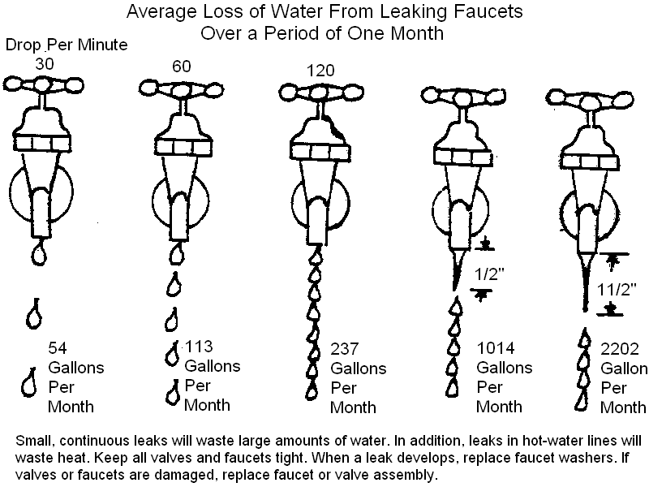

Table 4. Demand Reduction Response-Water Conservation
Voluntary Conservation  Phase I and  Normal conditions | Mandatory Conservation  Phase II | Restrictions  Phase III | Emergency  Phase IV
Voluntary Cutbacks  - Limit outside use to before 10 AM and after 6 PM  - Reduce indoor usage – see materials available | Mandatory Cutbacks  - The goal for average water use per capita should be ________ gallons.  - Ban on serving water in restaurants unless requested  - Encourage hotels and Bed and Breakfast to not change linens daily  - Ban on sprinklers  - Restrict outside watering to one day per week  - Prohibition on washing paved areas  - Prohibition on letting water run into the street  - Prohibition on filling out swimming pools and water fountains  - Ban on car washing, except for solid waste vehicles for public health reasons | Mandatory Restrictions  - Rationing. The goal for average water use per capita should be ________ gallons.  - Prohibition on new connections –Moratorium on new hookups  - Ban on use of water for air-conditioning  - Ban on use of water hoses  - Prohibition of all outdoor water use  - Ban on new landscaping with water from the utility | Restrictions and Bans  - In addition to all of the previous measures,  - Restriction on water uses other than residential domestic use.  - All residential customers are required to reduce consumption by ____percentage  - All commercial customers are required to reduce consumption by ____percentage  - All institutional and industrial customers are required to reduce consumption by ____percentage

Initiation and Termination Procedures

All decisions to implement this plan, to move from stage to another, and to terminate actions taken because of the drought conditions will be made through a resolution of the decisions makers, with or without input from the community.

