State of New Mexico

End User Training Guide

Capital Budget Forms

Budget Formulation and Management (BFM)



Contents

1. Capital Project Management Process 1

2. Budget Forms 1

3. Budget Forms Overview 1

4. Bond Sale Project Upload (8300) 3

4.1. Budget Form List Page 3

4.2. Budget Form Header Page 3

4.3. Budget Form Detail Page 4

4.4. Add New Project 7

4.5. Stage Advance/Submit and Bond Sales to Appropriation Validation 8

5. SHARE Capital Budget (8400) 10

5.1. Budget Form List Page 10

5.2. Budget Form Header Page 10

5.3. Budget Form Detail Page 10

5.4. Spread Validation / Budget Form Submit 12

6. SHARE Capital Budget—No Bonds (8900) 13

6.1. Budget Form List Page 13

6.2. Budget Form Header Page 13

6.3. Budget Form Detail Page 14

6.4. Spread Validation / Budget Form Submit 15

7. Payment Voucher (8500) 17

7.1. Budget Form List Page 17

7.2. Add New Form ID 17

7.3. Budget Form Header Page 17

7.4. Budget Form Detail Page 18

7.5. Add New Payment 19

7.6. Appropriation Balance Verification / Budget Form Submit 19

8. Drawdown Request (8600) 20

8.1. Budget Form List Page 20

8.2. Budget Form Header Page 20

8.3. Budget Form Detail Page 21

8.4. Add New Drawdown Request 22

8.5. Appropriation Balance Verification / Budget Form Submit 22

9. Reversion Journal (8700) 23

9.1. Budget Form List Page 23

9.2. Budget Form Header Page 23

9.3. Budget Form Detail Page 24

9.4. Add New Line 25

9.5. Appropriation Balance Verification / Budget Form Submit 25

10. Agency Reversion Request (BOF) (8800) 26

10.1. Budget Form List Page 26

10.2. Budget Form Header Page 26

10.3. Budget Form Detail Page 27

10.4. Add New Financial Class Line 28

11. Reauthorization (Budget Reduction) (9300) 29

11.1. Budget Form List Page 29

11.2. Budget Form Header Page 29

11.3. Budget Form Detail Page 30

11.4. Add New Reauthorization (Budget Reduction) Request 31

12. Reauthorization (Budget Increase) (9400) 32

12.1. Budget Form List Page 32

12.2. Budget Form Header Page 32

12.3. Budget Form Detail Page 33

12.4. Add New Reauthorization (Budget Increase) Request 34

13. Project Updates (9200) 35

13.1. Budget Form List Page 35

13.2. Budget Form Header Page 35

13.3. Budget Form Detail Page 37

13.4. Form 9200 Exports 38

The two form options are as shown below: 38

13.5. Form 9200 Admin Upload 42

14. Reporting 45

14.1. Budget Reports 45

# Capital Project Management Process

Capital budget forms are used to execute and manage capital projects after they have been requested, approved, and funded. This includes uploading bond-funded projects, creating payment vouchers and requests for drawdowns, reversions and reauthorizations, as well as submitting quarterly project updates.

# Budget Forms

The following are the budget forms that will be used for the capital project management process.

| **Capital Form Name** |
| --- |
| Bond Sale Project Upload (8300) |
| SHARE Capital Budget (8400) |
| SHARE Capital Budget – No Bonds (8900) |
| Payment Voucher (8500) |
| Drawdown Request (8600) |
| Reversion Journal (8700) |
| Agency Reversion Request (BOF) (8800) |
| Reauthorization (Budget Reduction) (9300) |
| Reauthorization (Budget Increase) (9400) |
| Project Updates (9200) |
| Form 9200 Export for Import |

# Budget Forms Overview

All budget forms have the same basic components, which are outlined in the table below. Depending on the information that needs to be provided by the users during the budget process, the structure of each form may be slightly different. Forms may not use all elements, and in some cases some elements may be labeled differently for specific forms, as noted in the table. Detailed descriptions and click-by-click instructions for each form element are provided in the NM End User Training Guide.

| **Form Element** | **Purpose** | **Detailed Description (See NM End User Training Guide)** |
| --- | --- | --- |
| **Form List** | Shows all budget forms available based on security profile. | Section 8.1 Budget Form List Page |
| **Header Tab** | Contains general information about the form instance such as organizational unit (i.e., Agency, PCode, and/or Department ID) and form name. | Section 8.2 Header Tab |
| **Detail Tab** | Contains detailed capital project information including Agency, Fund, Account, Amount, and Justification text; labels may vary depending on the form. | Section 8.3 Detail Tab |
| **Export / Import** | BFM feature that allows for budget form export to an Excel spreadsheet; users can enter data into the spreadsheet and then import it back into the system to populate the form. | Section 8.4 Excel Export/Import |
| **Attachments Tab** | Allows for files (PDF, Word, and Excel) to be uploaded as attachments on forms. | Section 8.13 Attachments Tab |

**Chart of Account Dimension Names**

To reduce clutter on the data entry screen, some columns are minimized to hide Chart of Account dimension names. These columns can be expanded to reveal the Chart of Account dimension names if needed. In the screenshot below, the blank spaces in the budget grid can be pulled to the right to reveal the names of the dimensions.

The screenshot below shows the BU Name and Fund Name columns expanded.

# Bond Sale Project Upload (8300)

Once capital projects have been approved for bond financing and the bonds have been sold, the financial classes funded with the bond sales need to be associated with a bond series in BFM. This will allow for tracking of the uses of the bond series by individual financial class.

Before financial classes can be associated with a bond series, the new bond series needs to be created in BFM through Chart of Accounts Maintenance and the new fund (to track the bond series proceeds) also needs to be created prior to the Bond Series being created through Chart of Accounts Maintenance. This process is described in the Capital System Implementation Guide.

There is a Bond Sale Project Upload form instance created for each bond series. Each form instance includes all the projects approved for that bond series.

## Budget Form List Page

## Budget Form Header Page

When new forms are created, the fund shown in the screen shot below is inferred from the Bond Series. This fund is also inferred on all lines on the detail tab of the form.

Most fields on the Header Page are pre-populated and read-only, but analysts can edit the Name and enter Notes and the Bond Sale Date. The Bond Sale Date, once entered, will populate the Bond Sale Date field on the Bond Series the Chart of Accounts master data. The checkbox denotes whether the 8400 SHARE Capital Budget forms have been created.

## Budget Form Detail Page

The top table includes read-only system data as well as the total amount of all bond sales entered in the form for the bond series. The lower table contains the bond series appropriation and sales amounts. Most columns contain read-only data; most of these columns are chart of accounts values inferred from the Bond Series or Financial Class. The column with an asterisk (*) is a data entry column, where users enter the bond sales amounts. The columns are described below.

| Screen: | Bond |
| --- | --- |
| **Field (Column Name)** | **Description** |
| Audit Trail | Magnifying Glass button. Opens a window to display the audit trail records for the selected row. |
| Bond Series | Read-Only. Bond Series name. |
| Fin Class | Read-Only. Financial Class number. |
| Appropriation Title | Read-Only. Title of the appropriation / Financial Class. |
| BU | Read-Only. Agency /Business Unit. |
| BU Name | Read-Only. Business Unit name. *This column is minimized, use double arrows to expand to see.* |
| Fund | Read-Only. Fund number. |
| Fund Name | Read-Only. Fund name. *This column is minimized, use double arrows to expand to see.* |
| Account | Read-Only. Account number. |
| Account Name | Read-Only*.* Account name. *This column is minimized, use double arrows to expand to see.* |
| 2023-24 Appropriated Amount | Read-Only. 2023-24 appropriation |
| **2023-24 Bond Sales\*** | Data-Entry. Enter 2023-24 Bond Sales amount. |
| **Comments / Notes\*** | Data-Entry. Enter any comments or notes. |

After the bond sale data has been loaded and the bond sale date entered on the form header, click the ***Update Bond Series Amount & Sale Date*** button to update the bond sales amounts and dates in the Chart of Accounts master data files. This includes both the Bond Series (amount and sale date) and Financial Class (sale date and bond series) dimensions. In addition, an 8400 form will be created for each business unit with amounts associated with the bond series so the agency can spread the appropriation across the available expenditure categories (and the “8400 Forms Created” checkbox will be checked to note that the forms have been created).

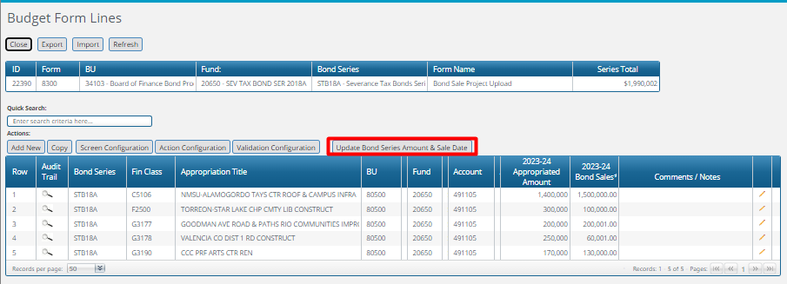

An 8400 Form is created and pre-populated with these projects for every agency included in the 8300 Form.

## Add New Project

When new projects are added directly in the form, users must select a Business Unit before selecting a Fin Class as that value help list is controlled by the value entered for the business unit. In addition to the Bond Sales amount, users may also enter Comments / Notes.

## Stage Advance/Submit and Bond Sales to Appropriation Validation

When users click the ***Submit*** button from either the budget form header or form list,

the Submit Budget Form popup opens.

When Stage 8304 – Bonds to Approp Verified is selected and the Submit button clicked, BFM compares the Bond Sales amounts entered to the Appropriated Amounts by Fin Class and if the Bond Sales amount exceeds the Appropriated Amount for any row, the user will receive a validation error requiring them to adjust the amount and try to submit the form again:

# SHARE Capital Budget (8400)

The SHARE Capital Budget form is used to transmit bond-funded appropriation amounts to the State’s financial system. There is one form instance for each bond series created with the 8300 form and for each agency. (Note: Capital projects not funded by bonds are included in Form 8900 and are discussed later.)

## Budget Form List Page

## Budget Form Header Page

Most fields on the Header Page are pre-populated and read-only, but users can edit the Business Unit Name and enter Notes.

## Budget Form Detail Page

The top table displays a read-only summary of the appropriations less the AIPP (Art in Public Places), the appropriation amounts assigned to categories, and the appropriation amounts not assigned to categories. The amount for appropriations less AIPP should equal the amount assigned to categories, and the amount not assigned should be “0” to submit the form. There is a validation to ensure the amount not assigned is 0 to submit the form.

The lower table contains the project appropriation data. Some columns contain read-only data; this data is either system data, imported from another source such as the financial system, or calculated based on other values in the form. Columns with an asterisk (*) are data entry columns where users enter the appropriate data. The columns are described below.

| **Screen:** | **Capital Project Appropriations** |
| --- | --- |
| **Field (Column Name)** | **Description** |
| Audit Trail | Magnifying Glass button. Opens a window to display the audit trail records for the selected row. |
| Fin Class | Read-Only. Financial Class number. |
| Appropriation Title | Read-Only. Title of the project appropriation. |
| BU | Read-Only. Agency /Business Unit. |
| BU Name | Read Only. Business Unit name. *This column is minimized, use double arrows to expand to see.* |
| Fund | Read-Only. Fund number. |
| Fund Name | Read Only. Fund name. *This column is minimized, use double arrows to expand to see.* |
| ACode | Read-Only. Appropriation code. |
| 2023-24 Appropriated Amount | Read-Only. Project appropriation for 2023-24. |
| 2023-24 Approp Less AIPP | Read-Only. Project appropriation for 2023-24 less AIPP funding. |
| **2023-24 Category 300 Approp\*** | Data Entry. Enter amount of the 2023-24 project appropriation less AIPP funding allocated to the “300” account grouping. |
| **2023-24 Category 400 Approp\*** | Data Entry. Enter amount of the 2023-24 project appropriation less AIPP funding allocated to the “400” account grouping. |
| **2023-24 Category 500 Approp\*** | Data Entry. Enter amount of the 2023-24 project appropriation less AIPP funding allocated to the “500” account grouping. |
| 2023-24 AIPP Set Aside | Read-Only. 2023-024 AIPP Set Aside. |
| **2023-24 Requested AIPP Changes\*** | Data Entry. Enter requested 2023-24 AIPP changes. |
| 2023-24 AIPP Revised Amount | Read-Only. 2023-24 AIPP revised amount. |
| **Comments / Notes** | Data Entry. Enter any comments or notes. |

If the Department of Finance and Administration (DFA) approves an agency’s request to change the AIPP amount, then they will click the “Accept AIPP Changes” button (see below) and the changes will be reflected in the 2023-24 AIPP Revised Amount column. The new AIPP amount will need to be considered in the allocation of the appropriation to the account categories so that the total amount allocated is in balance with the amount in the 2023-24 Approp Less AIPP column. DFA can either send the form back to the agency to adjust the account category amounts or the agency can indicate in the Comments / Notes text box how the requested AIPP change should be reflected in the account categories.

Users cannot add new Financial Classes to this form. They may copy an existing Financial Class if they need to spread the appropriation across multiple funds.

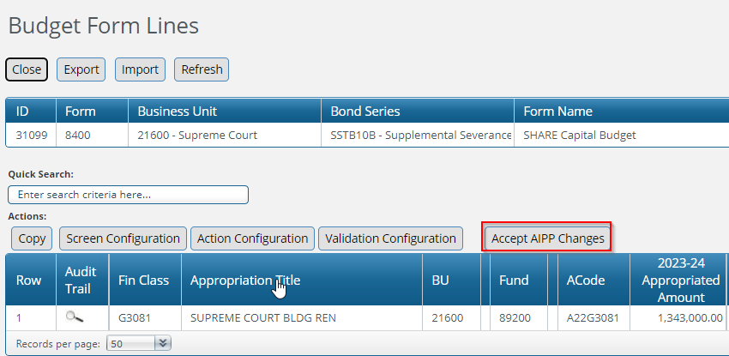

## Spread Validation / Budget Form Submit

When agencies complete the spreads of their appropriations less AIPP, they will submit the form to the Capital Group by advancing the stage to 8604. When users click the Submit button, the Amount not Assigned total displayed at the top of the Detail tab is verified to ensure the amount is “0.” Users will be the following message if this amount is not “0”:

# SHARE Capital Budget—No Bonds (8900)

The SHARE Capital Budget—No Bonds form is used to transmit capital project appropriation amounts to the State’s financial system. There is one form instance for each agency that manages capital projects that are not funded by bonds.

## Budget Form List Page

## Budget Form Header Page

Most fields on the Header Page are pre-populated and read-only, but users can edit the Business Unit Name and enter Notes.

## Budget Form Detail Page

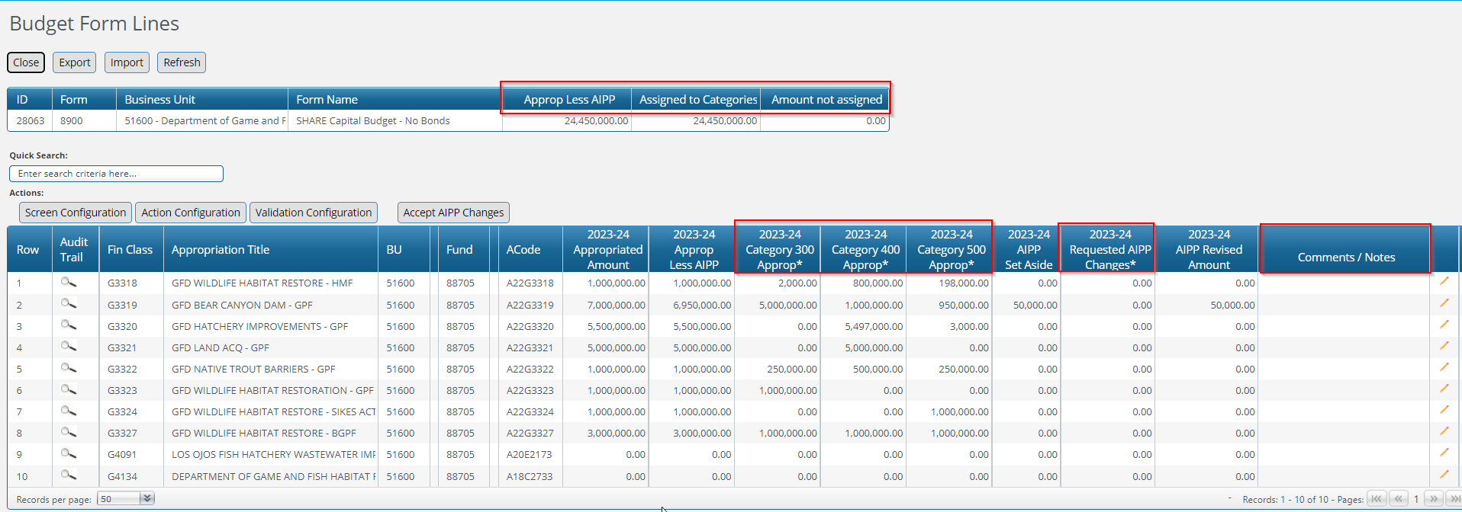

The top table shows a read-only summary of the appropriations less the AIPP (Art in Public Places), the appropriation amounts assigned to categories, and the appropriation amounts not assigned to categories. The amount for appropriations less AIPP should equal the amount assigned to categories, and the amount not assigned should be “0” to submit the form.

The lower table contains the project appropriation data. Some columns contain read-only data; this data is either system data, imported from another source such as the financial system, or calculated based on other values in the form. Columns with an asterisk (*) are data entry columns where users enter the appropriate data. The columns are described below.

Users cannot add new lines to this form as the list includes all financial classes from the most recent legislative session.

| **Screen:** | **Capital Project Appropriations** |
| --- | --- |
| **Field (Column Name)** | **Description** |
| Audit Trail | Magnifying Glass button. Opens a window to display the audit trail records for the selected row. |
| Fin Class | Read-Only. Financial Class number. |
| Appropriation Title | Read-Only. Title of the project appropriation. |
| BU | Read-Only. Agency number. |
| BU Name | Read Only. Business Unit name. *This column is minimized, use double arrows to expand to see.* |
| Fund | Read-Only. Fund number. |
| Fund Name | Read Only. Fund name. *This column is minimized, use double arrows to expand to see.* |
| ACode | Read-Only. Appropriation code. |
| 2023-24 Appropriated Amount | Read-Only. Project appropriation for 2023-24. |
| 2023-24 Approp Less AIPP | Read-Only. Project appropriation for 2023-24 less AIPP funding. |
| **2023-24 Category 300 Approp\*** | Data Entry. Enter amount of the 2023-24 project appropriation less AIPP funding allocated to the “300” account grouping. |
| **2023-24 Category 400 Approp\*** | Data Entry. Enter amount of the 2023-24 project appropriation less AIPP funding allocated to the “400” account grouping. |
| **2023-24 Category 500 Approp\*** | Data Entry. Enter amount of the 2023-24 project appropriation less AIPP funding allocated to the “500” account grouping. |
| 2023-24 AIPP Set Aside | Read-Only. 2023-024 AIPP Set Aside. |
| **2023-24 Requested AIPP Changes\*** | Data Entry. Enter requested 2023-24 AIPP changes. |
| 2023-24 AIPP Revised Amount | Read-Only. 2023-24 AIPP revised amount. |
| **Comments / Notes** | Data Entry. Enter any comments or notes. |

If the Department of Finance and Administration (DFA) approves an agency’s request to change the AIPP amount, then they will click the “Accept AIPP Changes” button (see below) and the changes will be reflected in the 2023-24 AIPP Revised Amount column. The new AIPP amount will need to be considered in the allocation of the appropriation to the account categories so that the total amount allocated is in balance with the amount in the 2023-24 Approp Less AIPP column. DFA can either send the form back to the agency to adjust the account category amounts or the agency can indicate in the Comments / Notes text box how the requested AIPP change should be reflected in the account categories.

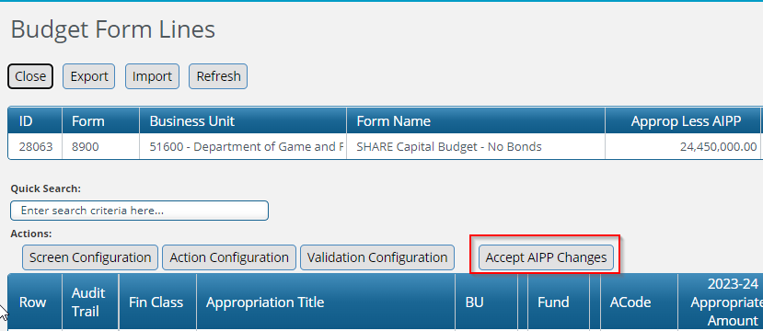

## Spread Validation / Budget Form Submit

When agencies complete the spreads of their appropriations less AIPP, they will submit the form to the Capital Group by advancing the stage to 8904. When users click the Submit button, the Amount not Assigned total displayed at the top of the Detail tab is verified to ensure the amount is “0.” Users will be the following message if this amount is not “0”:

# Payment Voucher (8500)

Form 8500 is used to create payment vouchers to reimburse entities that are outside the State’s financial system (SHARE). DFA creates the form instances based on requests from such outside entities. Each payment request is a separate form instance.

## Budget Form List Page

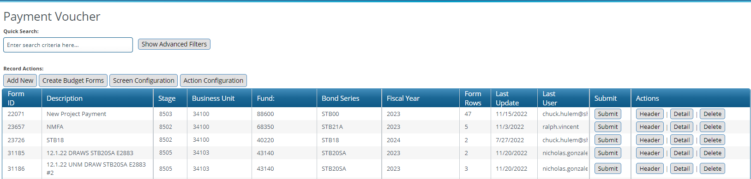

## Add New Form ID

When new form IDs are created, users may only select Business Unit 34103 and then select a Bond Series. The fund associated with the payment voucher is inferred from the Bond Series.

## Budget Form Header Page

Most fields on the Header Page are pre-populated and read-only, but users must select the appropriate PV Period and PV Fiscal Year from the dropdown list. Users can also edit the Payment Voucher Name and enter Notes.

## Budget Form Detail Page

The top table displays the information from the form header together with the total of all Payment Amounts in the lower table.

The lower table contains the payment voucher data. The columns identified with an asterisk are data enterable either through the Add New button or by entering the data directly in the cell or through Import. The columns are described below. There is also an Update Balances button that will update the Appropriation Balance for the associated Financial Class including the amount entered in the current budget form ID.

| **Screen:** | **Payment Voucher** |
| --- | --- |
| **Field (Column Name)** | **Description** |
| Audit Trail | Magnifying Glass button. Opens a window to display the audit trail records for the selected row. |
| Bond Series | Read-Only. Bond Series. |
| Fin Class* | Read-Only. Financial Class number. |
| Appropriation Title | Read-Only. Appropriation title. |
| ACode | Read-Only. Appropriation code. |
| Bud Ref | Read-Only. Budget Reference number – inferred from Fin Class |
| BU | Read-Only. Business Unit. |
| BU Name | Read-Only. Business Unit name. *This column is minimized, use double arrows to expand to see.* |
| Fund | Read-Only. Fund number – inferred from Bond Series |
| Fund Name | Read Only. Fund name. *This column is minimized, use double arrows to expand to see.* |
| Account | Read-Only. Account number. |
| Account Name | Read-Only*.* Account name. *This column is minimized, use double arrows to expand to see.* |
| Balance including this form when Update Bal Clicked | Read-Only. Displays the appropriation balance include amounts in this form once the Update Balances button has been clicked. |
| **Payment Amount\*** | Data Entry. Enter the requested payment amount. |
| **Comments / Notes** | Data Entry. Enter any comments or notes. |
| Document Number | Read-Only. Auto-generated document number comprised of the PV FY selected on the form header together with the form ID (first 6 digits). |

## Add New Payment

To add a new payment request, users select the Fin Class and Account and then enter the Payment Amount. They may also enter Comments / Notes.

## Appropriation Balance Verification / Budget Form Submit

When the payment voucher form is complete and agencies submit the payment voucher to Board of Finance for approval by submitting the form to Stage 8504, the appropriation balance is automatically calculated and if the requested payment amount generates a negative appropriation balance, users are notified and instructed to adjust the requested amounts and try again:

# Drawdown Request (8600)

Form 8600 is used to create drawdown requests to reimburse state entities that are in SHARE for capital project expenses. DFA creates the form instances based on requests from such state entities.

## Budget Form List Page

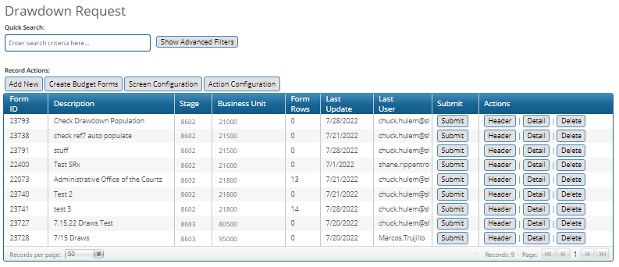

## Budget Form Header Page

The Stage Code and Business Unit on the Header Page are pre-populated and read-only, but users must indicate whether the drawdown request is “Out of Cycle” as well as select the Drawdown Period and the Drawdown FY. In addition, users can edit the Name and enter Notes.

## Budget Form Detail Page

The top table displays the information from the form header together with the total of all Drawdown Request Amounts in the lower table.

The lower table contains the payment voucher data. The columns identified with an asterisk (*) are data enterable either through the Add New button or by entering the data directly in the cell or through Import. The columns are described below. There is also an Update Balances button that will update the Appropriation Balance for the associated Financial Class including the amount entered in the current budget form ID.

| **Screen:** | **Drawdown Request** |
| --- | --- |
| **Field (Column Name)** | **Description** |
| Audit Trail | Magnifying Glass button. Opens a window to display the audit trail records for the selected row. |
| Class* | Read-Only. Financial Class number. |
| Class Name | Read-Only. Financial Class name. |
| ACode | Read-Only. Appropriation code. |
| BudRef | Read-Only. Budget Reference number. |
| Req BU* | Read-Only. Requesting Business Unit number. |
| Req Fund* | Read-Only. Requesting Fund number. |
| Req Account* | Read-Only. Requesting Account number. |
| Req Account Name | Read-Only. Requesting Account name. *This column is minimized, use double arrows to expand to see.* |
| Prov BU | Read-Only. Providing Business Unit number. |
| Prov Fund | Read-Only. Providing Fund number. |
| Prov Acct* | Read-Only. Providing Account number. |
| Prov Account Name | Read-Only. Providing Account name. *This column is minimized, use double arrows to expand to see.* |
| Balance including this form when Update Bal Clicked | Read-Only. Displays the appropriation balance include amounts in this form once the Update Balances button has been clicked. |
| **Drawdown Request\*** | Data Entry. Enter the requested drawdown amount. |
| **Justification\*** | Data Entry. Enter any justification. |
| Document Number | Read-Only. Auto-generated document number. |

## Add New Drawdown Request

To add a new drawdown request, users select the Requesting Fund, Fin Class, Requesting Account, and Providing Account and enter the Drawdown Request amount and optional Justification. The Requesting BU field is automatically populated with the BU entered on the form header.

## Appropriation Balance Verification / Budget Form Submit

When the drawdown request form is complete, and agencies submit the request to the Board of Finance for approval and processing by submitting the form to Stage 8603, the appropriation balance is automatically calculated and if the Drawdown Period or Drawdown FY fields are not populated on the form header or any requested payment amount generates a negative appropriation balance, users are notified and instructed to adjust the request and try again:

# Reversion Journal (8700)

The purpose of the Reversion Journal form is to revert unused and unneeded funding for completed capital projects to the State Treasurer.

## Budget Form List Page

## Budget Form Header Page

The Stage Code and Business Unit on the Header Page are pre-populated and read-only, but users may edit the Name and enter Notes.

## Budget Form Detail Page

The top table displays the information from the form header together with the total of all Reversion Request Amounts in the lower table. The lower table contains the reversion request voucher data. The columns identified with an asterisk (*) are data enterable either through the Add New button or by entering the data directly in the cell or through Import. The columns are described below. There is also an Update Balances button that will update the Appropriation Balance for the associated Financial Class including the amount entered in the current budget form ID.

| **Screen:** | **Reversion Journal** |
| --- | --- |
| **Field (Column Name)** | **Description** |
| Audit Trail | Magnifying Glass button. Opens a window to display the audit trail records for the selected row. |
| Class* | Read-Only. Financial Class number. |
| Class Name | Read-Only. Financial Class name. |
| ACode | Read-Only. Appropriation code. |
| Send BU | Read-Only. Business Unit number. |
| Send Fund | Read-Only. Fund number. |
| Send Bud Ref | Read-Only. Budget Reference number. |
| Send Acct | Read-Only. Account number. |
| Send Account Name | Read-Only. Account name. *This column is minimized, use double arrows to expand to see.* |
| Rec BU | Read-Only. Business Unit number for the Treasury Department. |
| Rec Fund | Read-Only. Fund number for the Treasury Department fund. |
| Rec Bud Ref | Read-Only. Budget Reference number for the Treasury Department. |
| Rec Acct | Read-Only. Receiving Account number for the Treasury Department account. |
| Balance including this form when Update Bal Clicked | Read-Only. Displays the appropriation balance include amounts in this form once the Update Balances button has been clicked. | |
| **Reversion Request Amount\*** | Data-Entry. Enter the reversion request amount. |
| **Justification\*** | Data Entry. Enter any justification. |
| Document Number | Read-Only. Auto-generated document number. |

## Add New Line

To add a new reversion journal request, users only need to select the Fin Class to revert funds from and the Reversion Request Amount together with any Justification desired. The other chart of account fields used in the reversion request are all inferred from either attributes on the Financial Class or default values for this budget form (additional information relating to these default values is detailed in the Capital Implementation Guide).

## Appropriation Balance Verification / Budget Form Submit

When the reversion request form is complete, and the request is submitted to either the Board of Finance or Capital Group for approval and processing by submitting the form to Stage 8703 or 8704, the appropriation balance is automatically calculated and if the reversion request generates a negative appropriation balance, users are notified and instructed to adjust the request and try again:

# Agency Reversion Request (BOF) (8800)

At the end of each fiscal year one form instance is created for each agency that manages capital projects to determine whether the agency’s various bond-funded projects can be reverted.

## Budget Form List Page

## Budget Form Header Page

The Stage Code and Business Unit on the Header Page are pre-populated and read-only, but users may edit the Name and enter Notes.

## Budget Form Detail Page

The table contains the data related to the reversion request. Some columns contain read-only data; this data is either system data or imported from another source such as the financial system. Columns with an asterisk (*) are data entry columns, where users enter the appropriate data. The columns are described below.

| **Screen** | **Agency Reversion Request (BOF)** |
| --- | --- |
| **Field (Column Name)** | **Description** |
| Audit Trail | Magnifying Glass button. Opens a window to display the audit trail records for the selected row. |
| BU | Read-Only. Business Unit number. |
| Fin Class | Read-Only. Financial Class number. |
| Appropriation Title | Read-Only. Appropriation Title. |
| ACode | Read-Only. Appropriation code. |
| BudRef | Read Only. Budget Reference number. |
| Appropriated Amount | Read-Only. Project appropriation. |
| Balance as of 11/28/2022 | Read-Only. Project appropriation balance as of MM/DD/YYYY. |
| Reversion Year | Read-Only. Reversion Year. |
| **Correct Reversion Date: 06/30/ Enter Year\*** | Data Entry. Enter the year in order to correct the reversion date. |
| OK to Revert Proceeds | This field is pre-populated with “No”; in order to change to “Yes” users must export the table, change the entry in the Excel spreadsheet, and import the spreadsheet back into BFM. |
| **Reversion Amount\*** | Data Entry: Enter the reversion amount. |
| Contract in Place 6/30/23 | This field is pre-populated with “Yes”; in order to change to “No” users must export the table, change the entry in the Excel spreadsheet, and import the spreadsheet back into BFM. |
| **Contract Balance 06/30/2023\*** | Data entry: Enter the contract balance as of 6/30/2023. |
| **Expenses Prior to Reversion Date\*** | Data entry: Enter expenses incurred prior to the reversion date. |
| **GO Bond Encumbrance Amount 06/30/2023\*** | Data entry. Enter the GO bond encumbrance amount as of 6/30/2023. |
| **Estimated Completion Date (MM/DD/YYYY)\*** | Data entry. Enter the project’s estimated completion date. |
| **Project Status / Agency Comments** | Data entry. Enter any project status / agency comments. |

## Add New Financial Class Line

New rows cannot be added to this form.

# Reauthorization (Budget Reduction) (9300)

Form 9300 is used to identify funding for capital projects that is no longer needed and that is proposed to be transferred to another project or projects. Form 9300 identifies the budget reductions; Form 9400 is used in tandem with this form to identify those projects where the funding will be transferred.

## Budget Form List Page

## Budget Form Header Page

Most fields on the Header Page are pre-populated and read-only, but users can edit the Name and enter Notes.

## Budget Form Detail Page

The table contains the reauthorization data. Some columns contain read-only data; this data is either system data or imported from another source such as the financial system. Columns with an asterisk (*) are data entry columns, where users enter the appropriate data. The columns are described below.

| **Screen:** | **Reauthorization (Budget Reduction)** |
| --- | --- |
| **Field (Column Name)** | **Description** |
| Audit Trail | Magnifying Glass button. Opens a window to display the audit trail records for the selected row. |
| BU | Read-Only: Business Unit number. |
| Class | Read-Only: Financial Class number. |
| Class Name (Reduction) | Read-Only: Financial Class name. |
| ACode (Reduce) | Read-Only: Appropriation code. |
| Fund (Reduce) | Read-Only: Fund number. |
| Acct (Reduce) | Read-Only: Account code. |
| Rev Acct (Reduce) | Read-Only: Revenue account code. |
| Class to Increase | Read-Only: Financial Class number. |
| **Reauthorization Reduction\*** | Data Entry: Enter Reauthorization reduction amount. |
| **Justification\*** | Data Entry: Enter any justification. |

## Add New Reauthorization (Budget Reduction) Request

To add a new reauthorization request, users select the Fund to reduce, the Fin Class to reduce, the Fin Class to increase, the Revenue Account to reduce, and enter the amount of the requested Reauthorization Reduction and optional Justification.

# Reauthorization (Budget Increase) (9400)

Form 9400 is used to identify where funding from capital projects that is no longer needed (from Form 9300) will be transferred. Form 9300 identifies the budget reductions; Form 9400 is used in tandem with that form to identify those projects where the funding will be transferred.

## Budget Form List Page

## Budget Form Header Page

Most fields on the Header Page are pre-populated and read-only, but users can edit the Name and enter Notes.

## Budget Form Detail Page

The table contains the reauthorization data. Some columns contain read-only data; this data is either system data or imported from another source such as the financial system. Columns with an asterisk (*) are data entry columns, where users enter the appropriate data. The columns are described below.

| **Screen:** | **Reauthorization (Budget Increase)** |
| --- | --- |
| **Field (Column Name)** | **Description** |
| Audit Trail | Magnifying Glass button. Opens a window to display the audit trail records for the selected row. |
| BU* | Read-Only: Business Unit number. |
| Class* | Read-Only: Financial Class number. |
| Class Name (Increase) | Read-Only: Financial Class name. |
| ACode (Increase) | Read-Only: Appropriation code. |
| Fund (Increase) | Read-Only: Fund number. |
| Acct (Increase) | Read-Only: Account code. |
| Rev Acct (Increase) | Read-Only: Revenue account code. |
| Class Reduced | Read-Only: Financial Class number. |
| **Reauthorization Increase\*** | Data Entry: Enter Reauthorization increase amount. |
| **Justification\*** | Data Entry: Enter any justification. |

## Add New Reauthorization (Budget Increase) Request

To add a new reauthorization request, users select the Fund to increase, the Fin Class to increase, the Fin Class that is reduced, the Revenue Account to increase, and enter the amount of the requested Reauthorization Increase and optional Justification.

# Project Updates (9200)

Form 9200 is used to provide quarterly status updates for all active projects. All such projects will be loaded into BFM.

## Budget Form List Page

## Budget Form Header Page

Some fields on the Header Page are pre-populated and read-only, including fields containing instructions; all other fields are required to be completed to provide narrative and other nonfinancial project information.

**Narrative Fields**

(Note: Instructions for completing some of the narrative fields are detailed above the applicable text boxes).

*Project Goals and Intended Public Benefit:*

Recipient of funding must describe the purpose and goals of the project and how it is expected to serve the public upon completion. This field is required to be completed once the funding for the appropriation becomes active. Quarterly updates are only required if the status has changed.

*Project History:*

Provide a record of major milestones reached and challenges confronted in the project to date. Previous entries to the “Recent Developments” field may be moved here to complete that record. Please include MM/YYYY date notations if you choose to copy previous entries into this field.

*Recent Developments:*

Summarize progress made on the project and major challenges in the last quarter, including any detail on assistance needed or efforts in progress to resolve challenges.

*Goal for Next Quarter:*

Summarize steps public entity or contractors expect to take next quarter to advance the project.

*Stage Agency Comments:*

Enter any other explanatory comments.

*DFA/LFC Comments:*

DFA and LFC may enter any comments here.

**Nonfinancial Project Information Fields**

*OK to Close Fin Class?*

Check box (Yes or No).

*Project Phase:*

Select the appropriate project phase from the dropdown list.

*Current Challenge:*

Select the appropriate current challenge from the dropdown list.

*Is Project Fully Funded?*

Select the appropriate response from the dropdown list.

*Project Outcome:*

Select the appropriate project outcome from the dropdown list.

## Budget Form Detail Page

The table contains the project current status data. Some columns contain read-only data; this data is either system data or imported from another source such as the financial system. Columns with an asterisk (*) are data entry columns, where users enter the appropriate data. The columns are described below.

| **Screen:** | **Project Updates** |
| --- | --- |
| **Field (Column Name)** | **Description** |
| Audit Trail | Magnifying Glass button. Opens a window to display the audit trail records for the selected row. |
| BU | Read-Only: Business Unit number. |
| Fin Class | Read-Only: Financial Class name. |
| ACode | Read-Only: Appropriation code. |
| Appropriated Amount | Read-Only: Project appropriation amount. |
| AIPP Amount | Read-Only: Project AIPP amount. |
| **Obligated Amount\*** | Data Entry: Enter amount obligated for the project. |
| BOF Expenses | Read-Only: Board of Finance expenses. |
| SHARE Expenses | Read-Only: SHARE expenses. |
| Reversions | Read-Only: Reversion amount. |
| Net ReAuth | Read-Only: Net reauthorization amount. |
| **Approp Expenses\*** | Data Entry: Enter appropriation expenses. |
| Approp Balance | Read-Only: Appropriation balance. |
| **Planned Reversions\*** | Data Entry: Enter planned reversion amount. |
| **Other Funding Amount\*** | Data Entry: Enter other funding amount. |
| **Other Appropriations or Funding Sources\*** | Data Entry: Enter amount of other appropriations or funding sources. |
| **Additional Funding Needed\*** | Data Entry: Enter any additional funding needed for the project. |
| **Uses of Additional Funding\*** | Data Entry: Enter the uses of the additional funding needed. |

## Form 9200 Exports

Because each individual project is a separate Form 9200 instance with only one data entry row, there is no need, and therefore no option, to export/import. However, there are two form options and two report options to export data by agency in order to make changes to master data.

### Form Exports

## The two form options are as shown below:

*Note: For both form options the data that is exported is the data that the user is allowed to access according to their security profile. If, for example, the user has access to all data then all Form 9200 data will be included in the form export.*

***Form 9200 Export.*** This option varies from the ***Form 9200 Export for Import*** in two important ways: First, the Header data related to Project Phase, Current Challenge, and Project Outcome displays the related text, not the codes.

Second, all master data fields are included in the export, including fields not shown in Form 9200.

***Form 9200 Export for Import.*** As noted above, this file includes codes, and not the related text, for the Header fields highlighted below.

This export also includes only those fields that are included on Form 9200, and not the additional fields shown above.

### Report Exports

An additional option to export data related to Form 9200 is to export the Form 9200 report. (See Section 14 below for information regarding accessing reports.) The related reports for Form 9200 can be found here:

There is a report that corresponds to each choice for form export. Once the report has been opened, the appropriate prompt values selected, and the report has been executed, select Export and indicate the desired file type (Excel for example).

## Form 9200 Admin Upload

Once Form 9200 master data has been updated it will be provided to a system administrator to be uploaded using the Admin Upload function.

Navigate to Admin Uploads.

Select “CAP_PROJSTATUS” and click “Active Uploads.”

Click “Upload.” There is no need to create a new upload because the existing data is not being deleted, it is being replaced.

Click “Browse” to find the appropriate file and click “Load Selected File” to upload the data.

# Reporting

Reports can be accessed under Links > BFM Reporting.



There is a folder within BFM Reporting for Capital.

## Budget Reports

Reports that have been developed for capital include:

* 9200 Form Export
* 9200 Form Import File
* Appropriations by Agency
* Appropriations by Agency with Reversion Date
* Appropriations by Series/Agency
* Bond Sale Project Upload (8300)
* Capital Budget to SHARE
* Drawdown Request (Form 8600 View)
* Drawdown Request to SHARE
* Payment Voucher
* Payment Voucher (Form 8500 View)
* Reversion Journal (Form 8700 View)
* Reversions to SHARE
* SHARE Capital Budget (8400)
* SHARE Capital Budget No Bonds (8900)
* Transaction by Series/Document within Dates
* Transaction Detail
* Transaction Extract
* Transaction Summary by Series Summary